# A PROJECT REPORT ON

**BIGMART SALES PREDICTION**

Submitted in partial fulﬁlment for the requirement of the award of TRAINING

IN

Data Analytics, Machine Learning and AI using Python



*Submitted By*

# ARGHYA BISWAS

(MTech 2nd Year Student at Indian Institute of Technology, Roorkee).

*Under the guidance of*

# Mr Bandenawaz Bagwan

**ACKNOWLEDGEMENT**

My sincere gratitude and appreciations towards my project paper guide Mr Bandenawaz Bagwan. It was only with his help and support that I could complete the report. He provided me with proper assistance. He has my utmost gratitude. Last but not the least, I acknowledge parents for being such a nice source of encouragement and moral support that helped me tremendously in this aspect. I also declare to the best of my knowledge and belief that the Project Work has not been submitted anywhere else.

# ABSTRACT

To implement an outlet sales prediction model for BIGMART, based on the dataset given by them. It’s a Machine Learning project which integrates Data Science and Web Development. The major focus of this project is on predicting outlet sales using genuine factors as considered from the dataset that is given. It is intended to base an evaluation on all basic norm that is taken into account when establishing the sales. This project is a part of my training and internship in Data Analytics, Machine Learning and AI using Python at Diginique TechLabs.

## INTRODUCTION

**Context**

This project is the final deliverable for the training and internship at Diginique TechLabs for Data Science Machine Learning and AI using Python. My supervisor was Mr Bandenawaz Bagwan, and I had one month to ﬁnish the task. We had two weeks of training sessions where we studied everything from the ground up.

## Objective

To make it as detailed as possible by dealing with all the stages of the machine learning process and trying to understand it well.

The data scientists at BigMart have collected 2013 sales data for 1559 products across 10 stores in different cities. Also, certain attributes of each product and store have been defined. The aim is to build a predictive model and find out the sales of each product at a particular store. Create a model by which Big Mart can analyze and predict the outlet production sales.

I have completed the project following a proper structure which is as follows:

Problem Statement

Hypothesis Generation

Loading Packages and Data

Data Structure and Content

Exploratory Data Analysis- Univariate Analysis

Bivariate Analysis

Missing Value Treatment

Feature Engineering

Encoding Categorical Variables

Label Encoding

One Hot Encoding

Pre-Processing Data

Modeling

Linear Regression

Regularized Linear Regression

Random Forest

XGBoost

**METHODOLOGY**

## Data Collection

## BigMart has collected sales data from the year 2013, for 1559 products across 10 stores in different cities. Where the dataset consists of 12 attributes like Item Fat, Item Type, Item MRP, Outlet Type, Item Visibility, Item Weight, Outlet Identifier, Outlet Size, Outlet Establishment Year, Outlet Location Type, Item Identifier and Item Outlet Sales. Out of these attributes response variable is the Item Outlet Sales attribute and remaining attributes are used as the predictor variables.

## The data-set is also based on hypotheses of store level and product level. Where store level involves attributes like: city, population density, store capacity, location, etc and the product level hypotheses involves attributes like: brand, advertisement, promotional offer, etc.

## Linear Regression

Linear regression is a supervised learning technique. It is responsible for predicting the value of a dependent variable (Y) based on a given independent variable (X). It is the connection between the input (X) and the output (Y). It is one of the most well-known and well-understood machine learning algorithms. Simple linear regression, ordinary least squares, Gradient Descent, and Regularization are the linear regression models.

## Decision Tree Regression

It is an object that trains a tree-structured model to predict data in the future in order to provide meaningful continuous output. The core principles of decision trees, Maximizing Information Gain, Classiﬁcation trees, and Regression trees are the processes involved in decision tree regression. The essential notion of decision trees is that they are built via recursive partitioning. Each node can be divided into child nodes, beginning with the root node, which is known as the parent node. These nodes have the potential to become the parent nodes of their resulting offspring nodes. The nodes at the informative features are speciﬁed as the maximizing information gain, to establish an objective function that is to optimize the tree learning method.

## Classiﬁcation Trees

Classiﬁcation trees are used to forecast the object into classes of a categorical dependent variable based on one or more predictor variables.

## Regression Trees

It supports both continuous and categorical input variables. Regression trees are regarded as research with various machine algorithms for the regression issue, with the Decision Tree approach providing the lowest loss. The R-Squared value for the Decision Tree is 0.998, indicating that it is an excellent model. The Decision Tree was used to complete the web development.

## Random Forest Regression

It is an essential learning approach for classiﬁcation and regression to create a large number of decision trees. Preliminaries of decision trees are common approaches for a variety of machine learning problems. Tree learning is required for serving n off the self-produce for data mining since it is invariant despite scaling and several other changes. The trees are grown very deep in order to learn a high regular pattern. Random forest is a method of averaging several deep decision trees trained on various portions of the same training set. This comes at the price of a slight increase in bias and some interoperability.

**XGBoost Regression**

Extreme Gradient Boosting (XGBoost) is an open-source library that provides an efficient and effective implementation of the gradient boosting algorithm.

Shortly after its development and initial release, XGBoost became the go-to method and often the key component in winning solutions for a range of problems in machine learning competitions.

Regression predictive modeling problems involve predicting a numerical value such as a dollar amount or a height. **XGBoost** can be used directly for **regression predictive modeling**.

## Problem Statement

**PROJECT**

Create a model by which Big Mart can analyze and predict the outlet production sales.

## Data

The data is the most important aspect of a machine learning assignment, to which special attention should be paid. Indeed, the data will heavily affect the ﬁndings depending on where we found them, how they are presented, if they are consistent, if there is an outlier, and so on. Many questions must be addressed at this stage to ensure that the learning algorithm is efficient and correct.

To obtain, clean, and convert the data, many steps are required. I'll go through each one to illustrate how they've been used in my project and why they're helpful for the machine learning section.

## Dataset

Dataset: <https://www.kaggle.com/aakash2016/big-mart-sales-dataset/download>

## Project Architecture

## Data Science

The ﬁrst stage is standard data science work, in which we take a data set named ‘BigMart Sales Prediction’. We will do signiﬁcant data cleaning on it to guarantee that it provides reliable predictions throughout prediction.

This Jupyter notebook, ‘BigMart-Sales-Prediction-Model.ipynb,' is where we do all of our data science work, since the Jupyter notebook is self-explanatory. In terms of data cleansing, our dataset needs a signiﬁcant amount of effort. In fact, 70% of the notebook is dedicated to data cleaning, in which we eliminate empty rows and remove superﬂuous columns that will not aid in prediction.

The process of obtaining valuable and signiﬁcant information from a dataset that will contribute the most to a successful prediction is the next stage.

The ﬁnal stage is to deal with outliers. Outliers are abnormalities that do massive damage to data and prediction. There is a lot to comprehend conceptually from the dataset in order to discover and eliminate these outliers.

Finally, the original dataset of over 8500 rows and 12 columns is reduced to much less.

## Machine Learning

The resulting data is fed into a machine learning model. To ﬁnd the optimal procedure and parameters for the model, we will mostly employ K-fold Cross-Validation and the GridSearchCV approach.

It turns out that the linear regression model produces the best results for our data, with a score of more than 80%, which is not terrible.

Now, we need to export our model as a pickle ﬁle (bigmartsales.pkl), which transforms Python objects into a character stream. Also, in order to interact with the locations(columns) from the frontend, we must export them into a JSON (columns.json) ﬁle.

## Frontend

The front end is built up of straightforward HTML. To receive an estimated pricing, the user may ﬁll-up the form with the proper details of the product the outlet sale of which is to be predicted. and click on the ‘Predict’ button. The JavaScript ﬁle is in charge of connecting with the backend ﬂask server routes as well as the frontend HTML. It takes the form data entered by the user and executes the function, which employs the prediction model to calculate the projected outlet sales of the specific product and displays it in rupees after navigating to another html file that was linked to this file. The file that displays the prediction result will have a navigation link leading back to the first page.

# MODEL

**Steps to create the model are:**

* + - Hypotheses and Data Exploration
    - Handling Missing Values
    - Univariate and Bivariate Analysis
    - Feature Engineering
    - Fitting a Linear Regression Model
    - Decision Tree Regression Model
    - Random Forest Regression Model
    - XGBoost Regression Model

The steps are well defined in the following pages in the order given above.

**Hypotheses and Data Exploration**

Project Description: The data scientists at BigMart have collected 2013 sales data for 1559 products across 10 stores in different cities. Also, certain attributes of each product and store have been defined. The aim of this data science project is to build a predictive model and find out the sales of each product at a particular store. Using this model, BigMart will try to understand the properties of products and stores which play a key role in increasing sales. The data has missing values as some stores do not report all the data due to technical glitches. Hence, it will be required to treat them accordingly.

Store Level Hypotheses:

City type: Stores located in urban or Tier 1 cities should have higher sales because of the higher income levels of people there.

Population Density: Stores located in densely populated areas should have higher sales because of more demand.

Store Capacity: Stores which are very big in size should have higher sales as they act like one-stop-shops and people would prefer getting everything from one place

Competitors: Stores having similar establishments nearby should have less sales because of more competition.

Marketing: Stores which have a good marketing division should have higher sales as it will be able to attract customers through the right offers and advertising.

Location: Stores located within popular marketplaces should have higher sales because of better access to customers.

Customer Behavior: Stores keeping the right set of products to meet the local needs of customers will have higher sales.

Ambiance: Stores which are well-maintained and managed by polite and humble people are expected to have higher footfall and thus higher sales.

Product Level Hypotheses:

Brand: Branded products should have higher sales because of higher trust in the customer. Packaging: Products with good packaging can attract customers and sell more.

Utility: Daily use products should have a higher tendency to sell as compared to the specific use products. Display Area: Products which are given bigger shelves in the store are likely to catch attention first and sell more.

Visibility in Store: The location of product in a store will impact sales. Ones which are right at entrance will catch the eye of customer first rather than the ones in back.

Advertising: Better advertising of products in the store will should higher sales in most cases. Promotional Offers: Products accompanied with attractive offers and discounts will sell more.

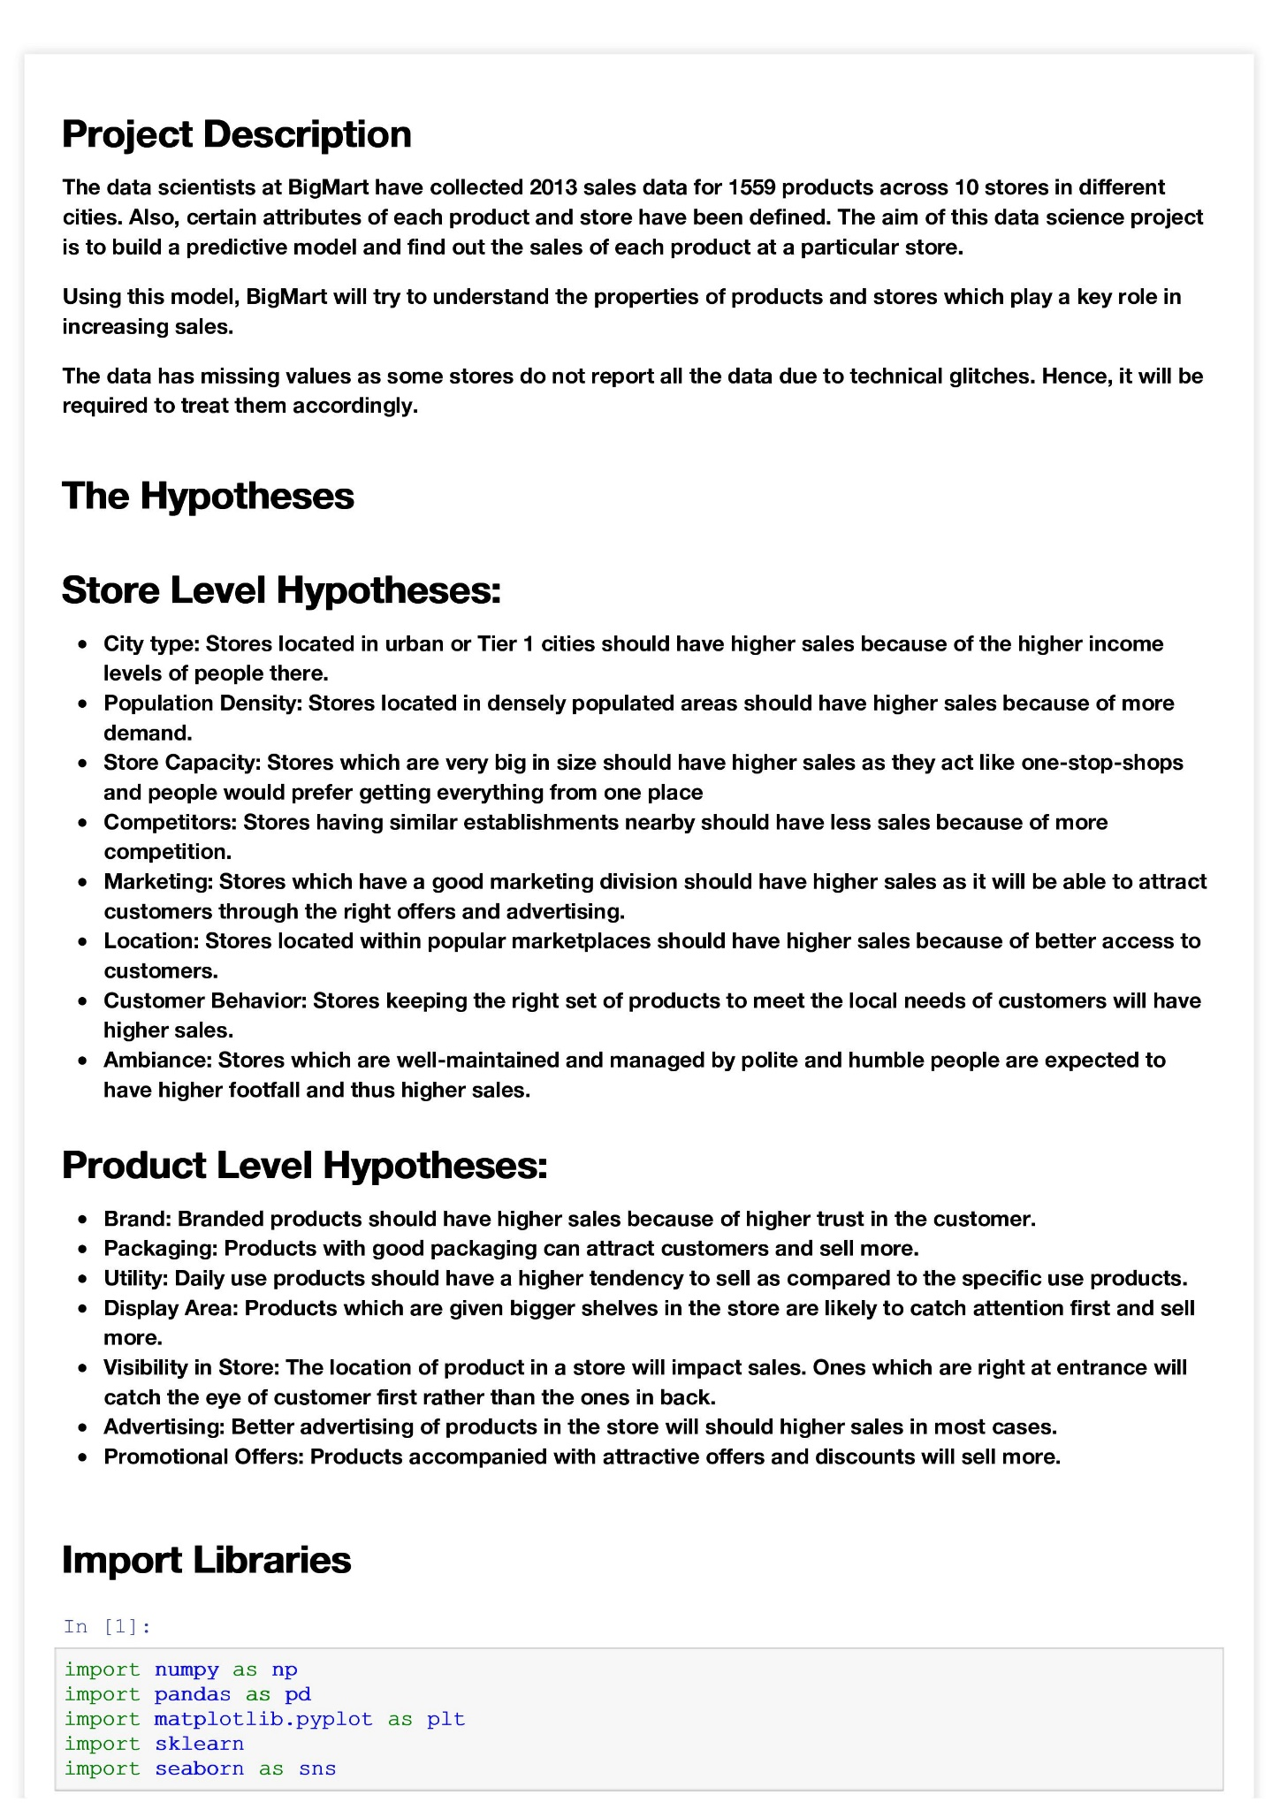

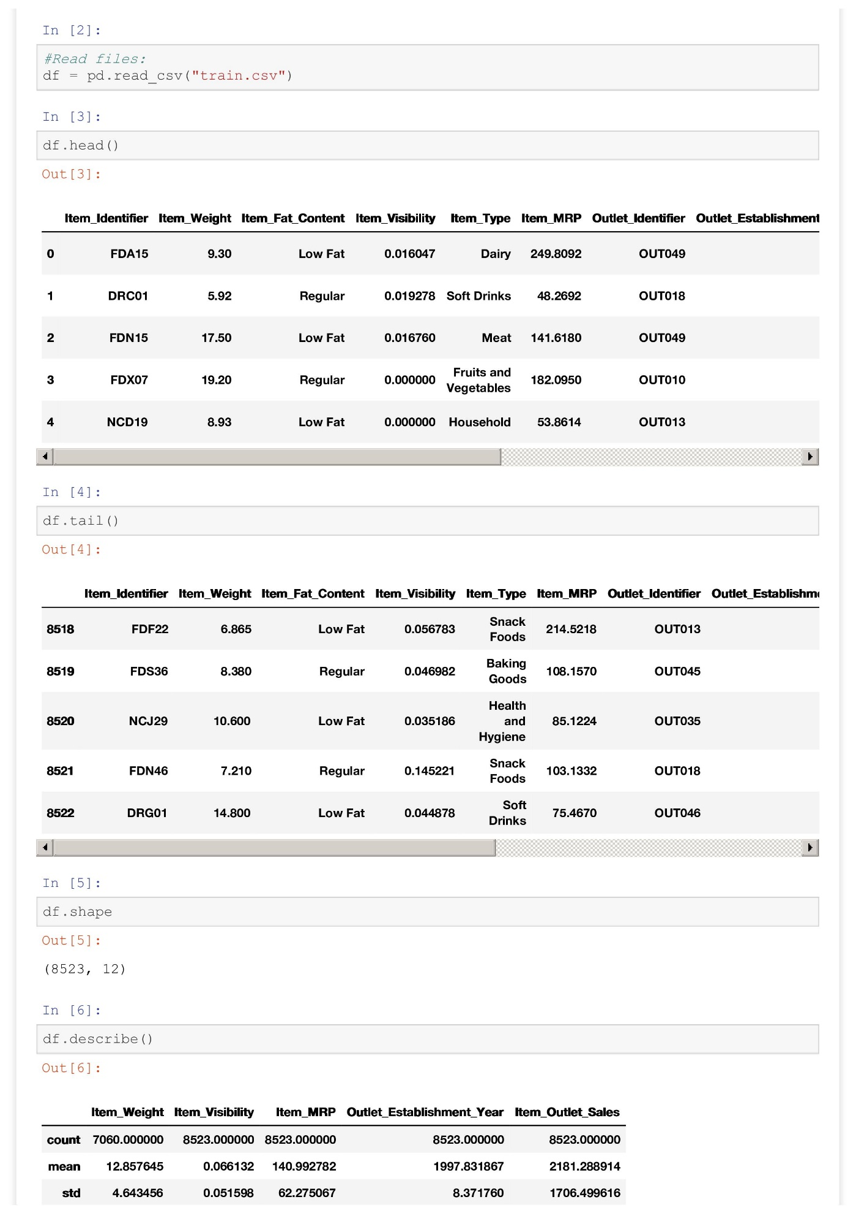

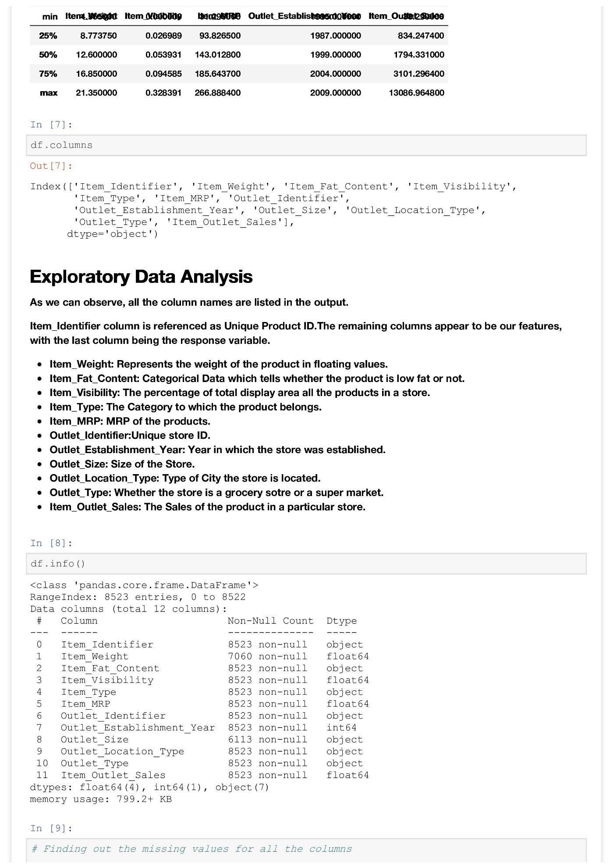

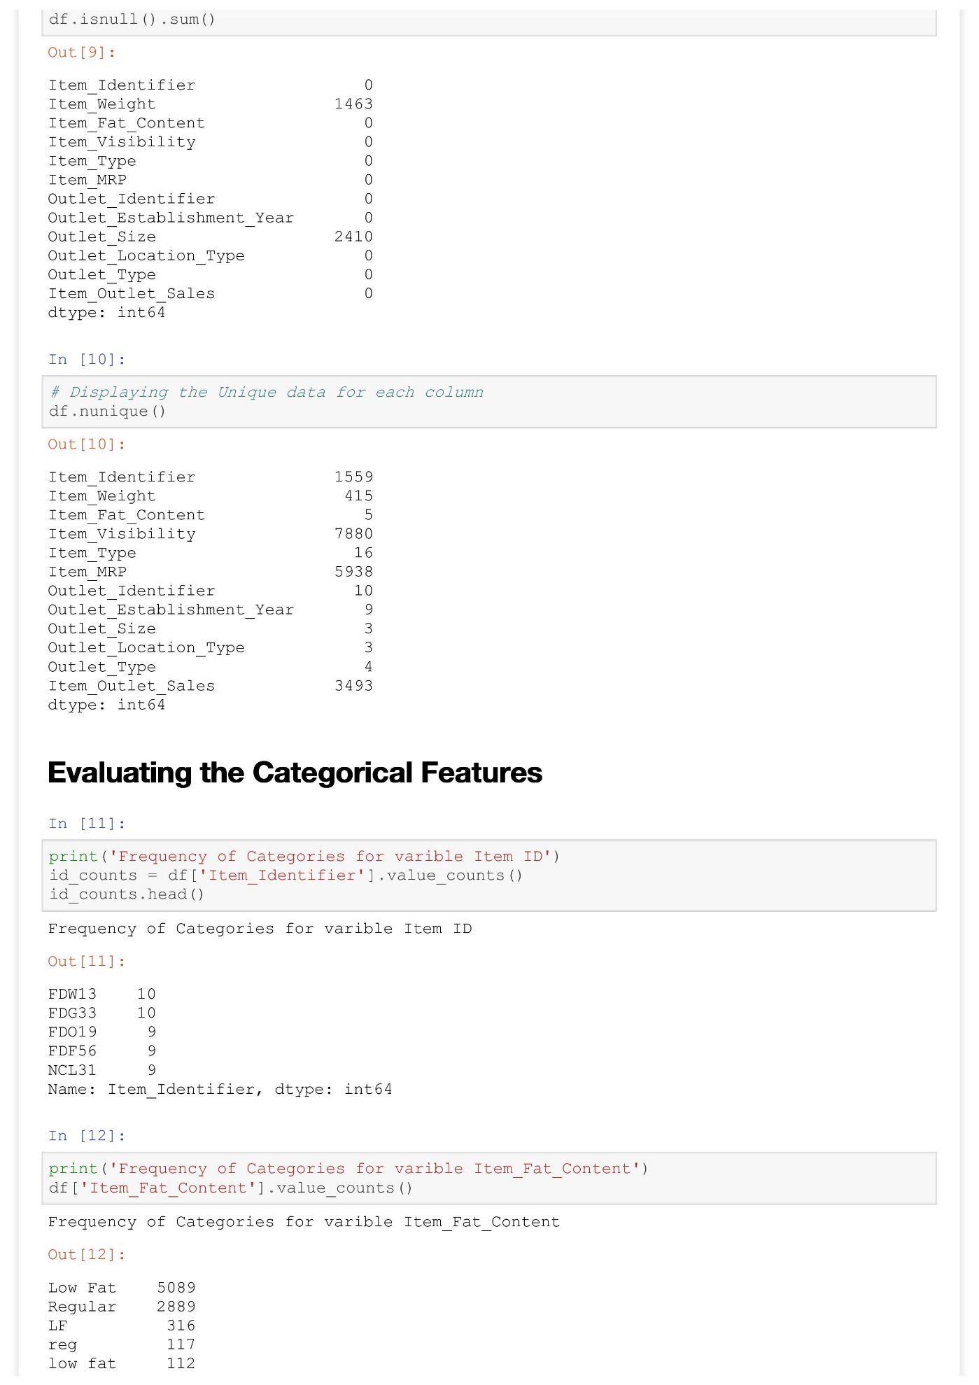

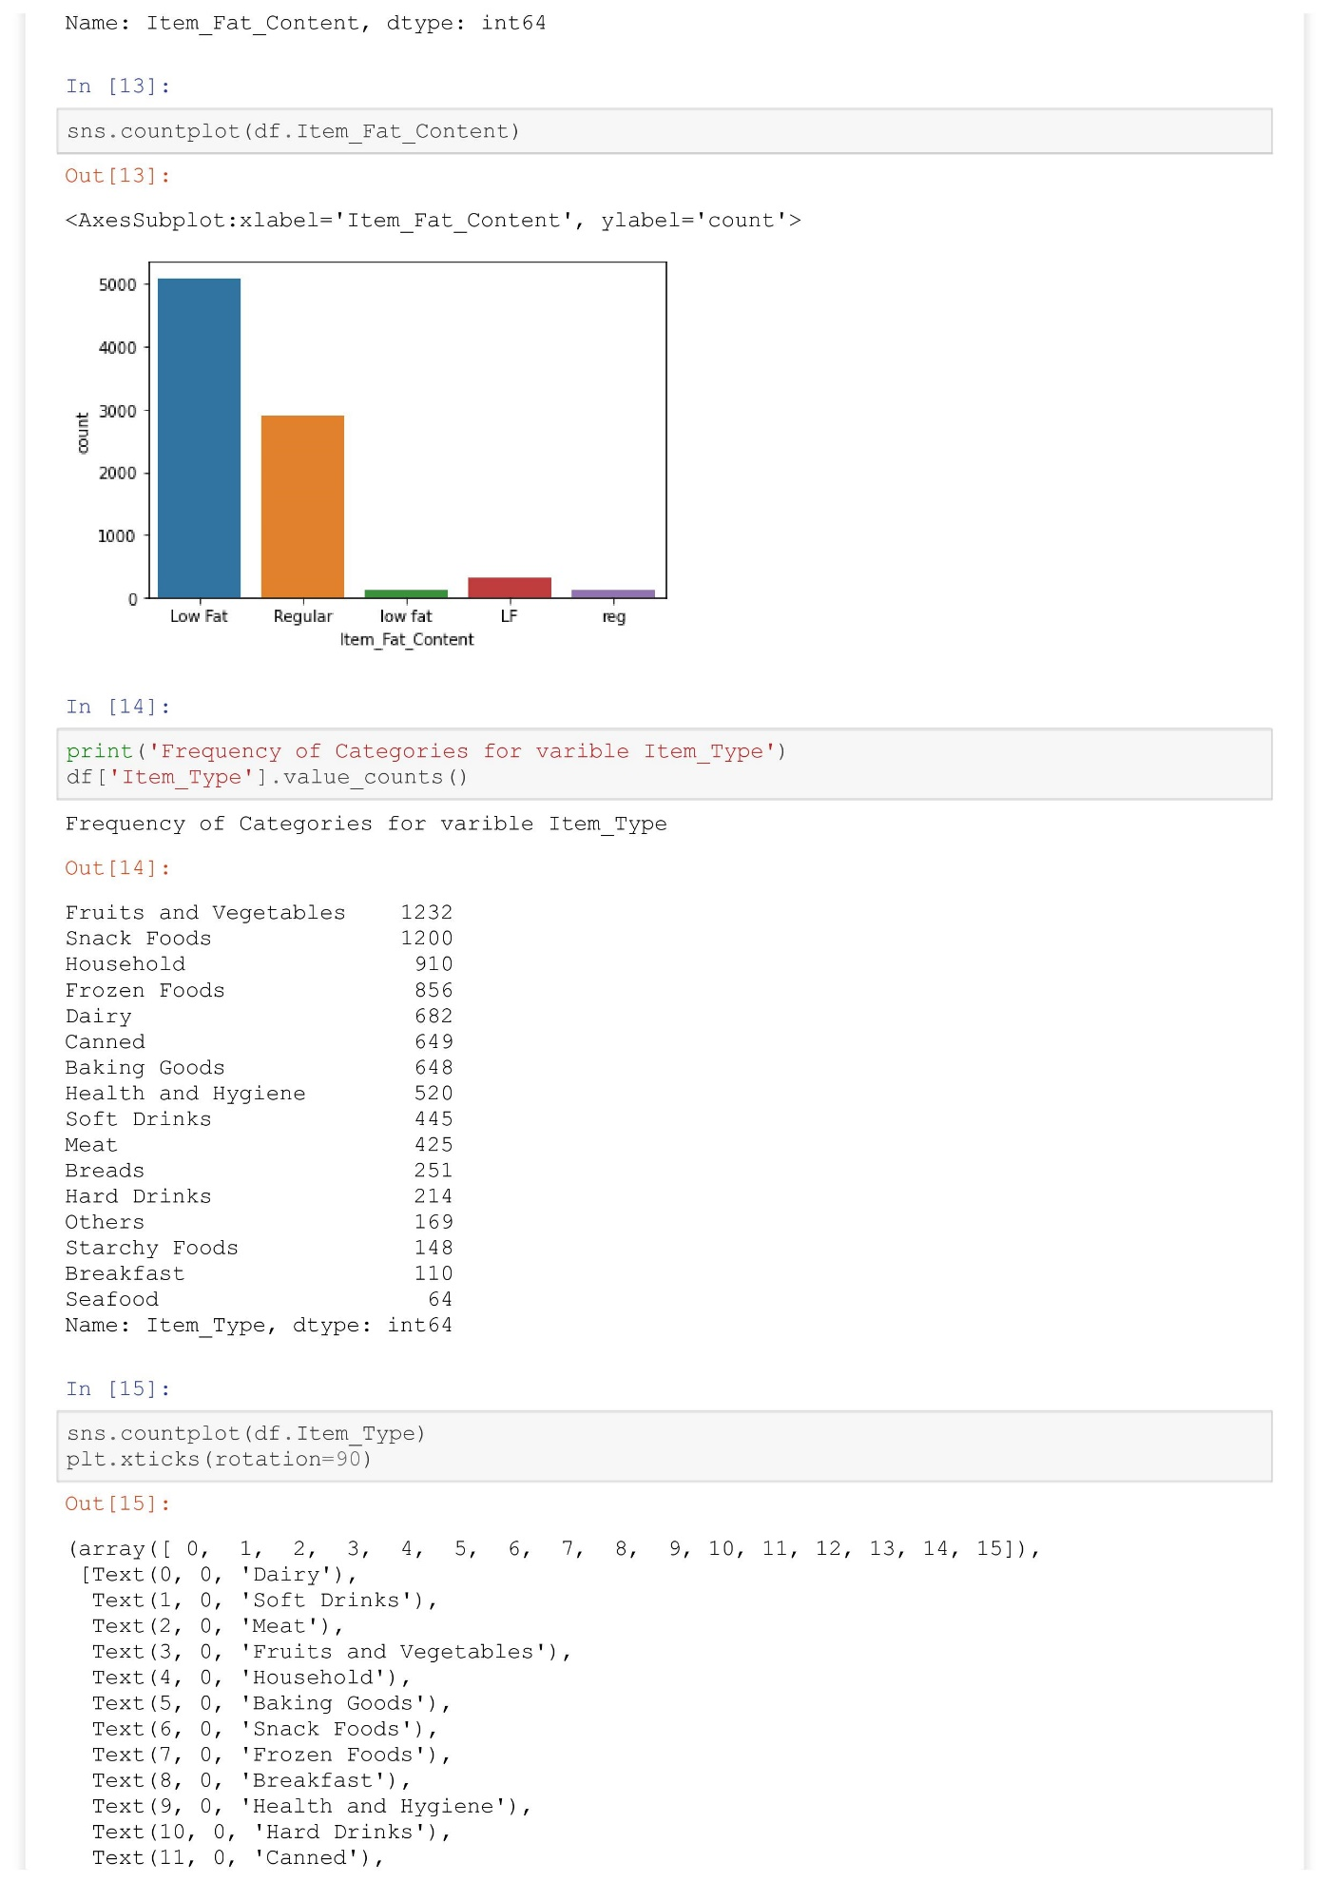

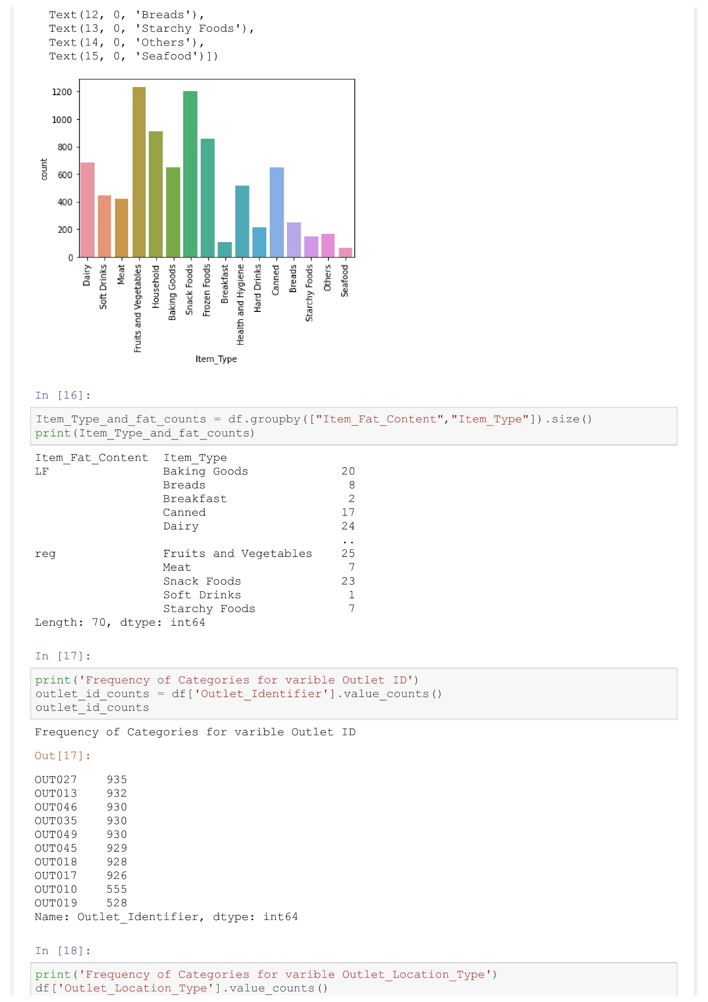

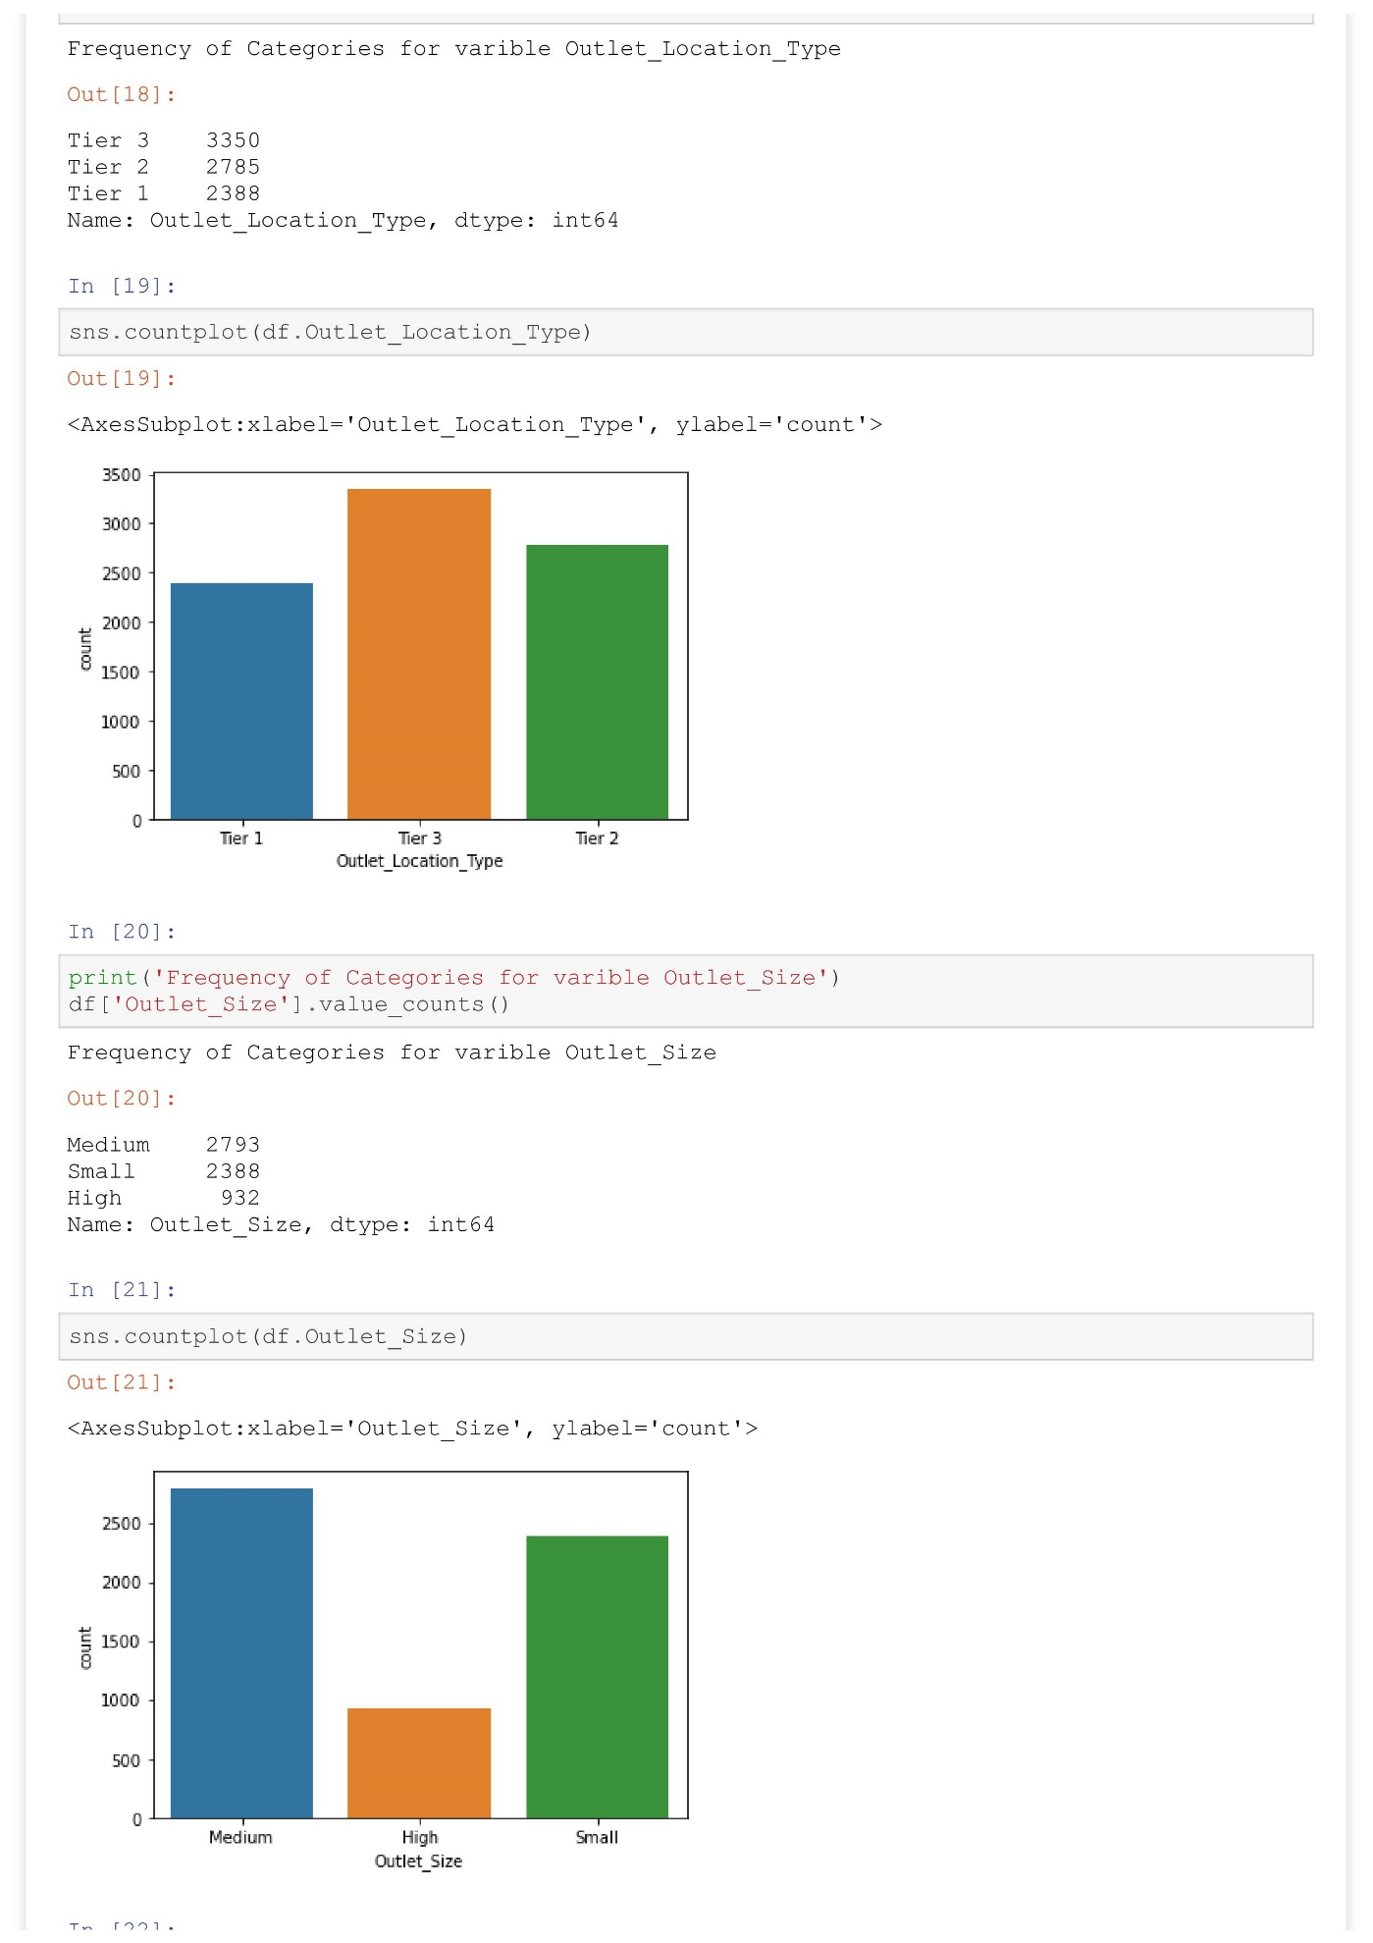

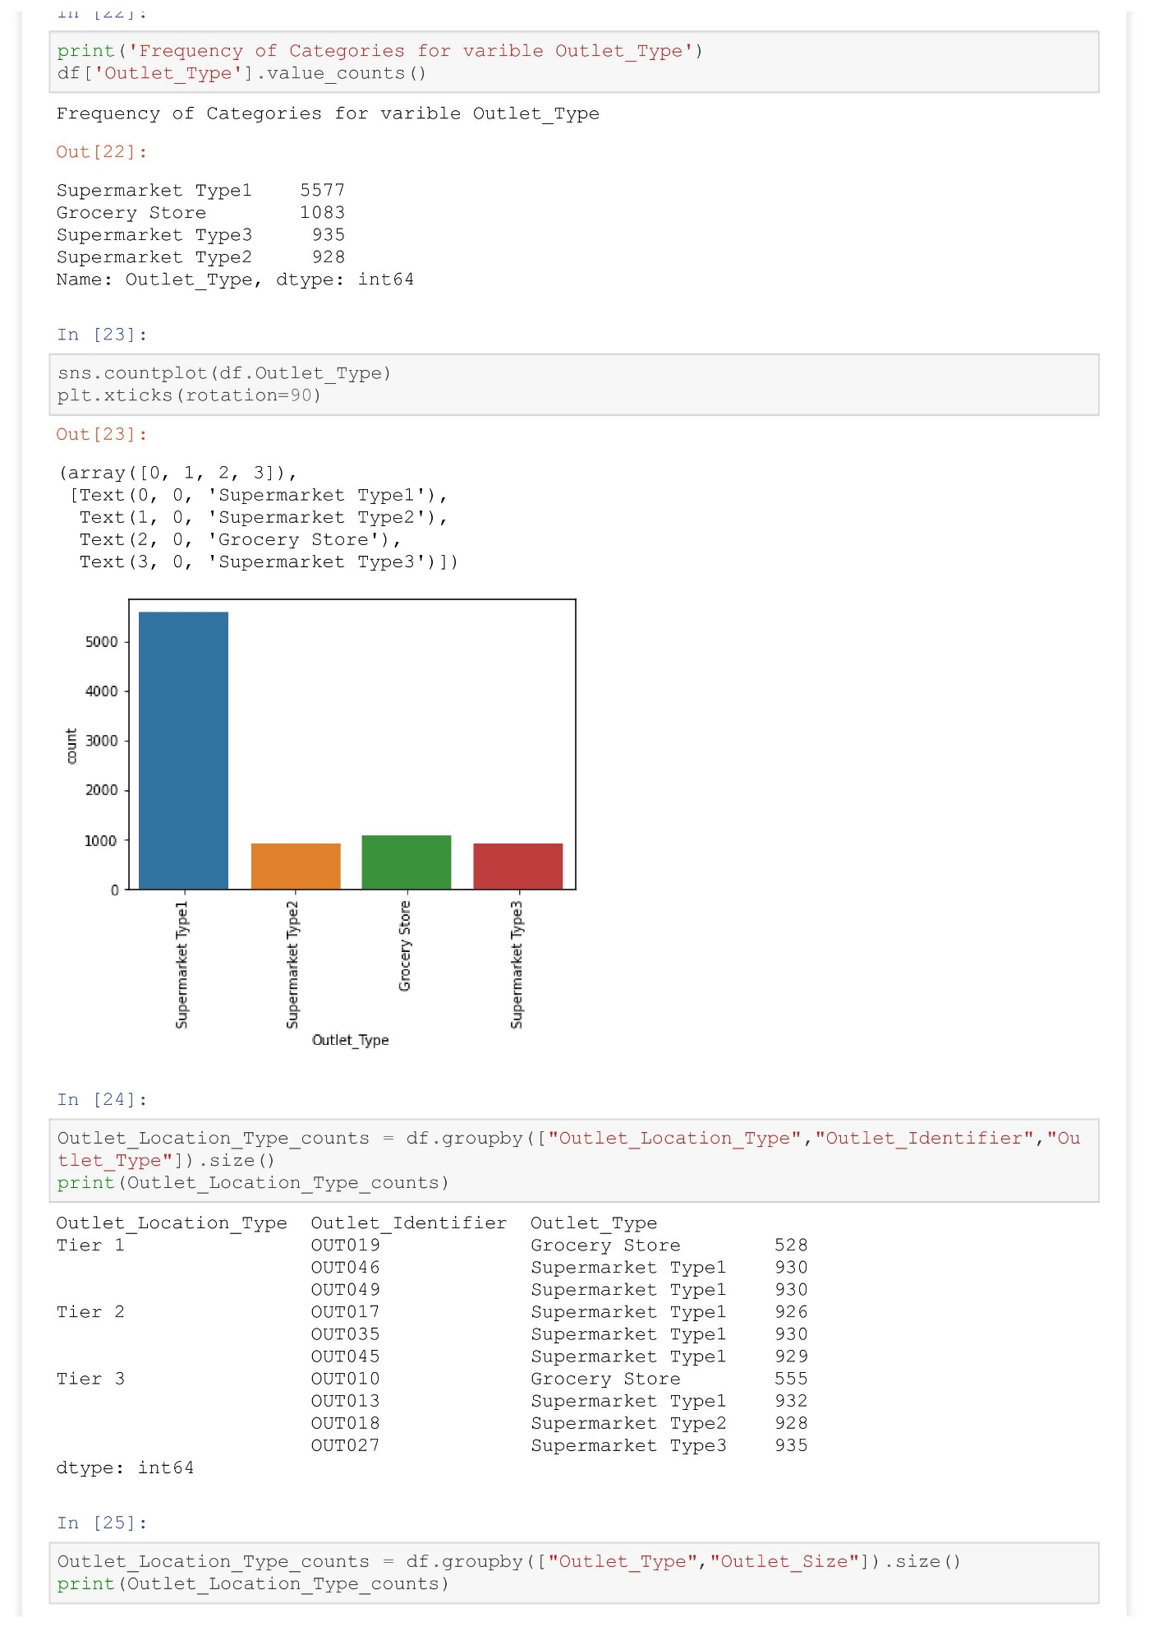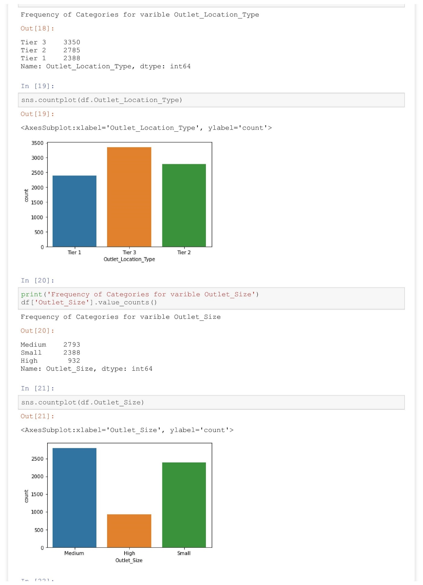

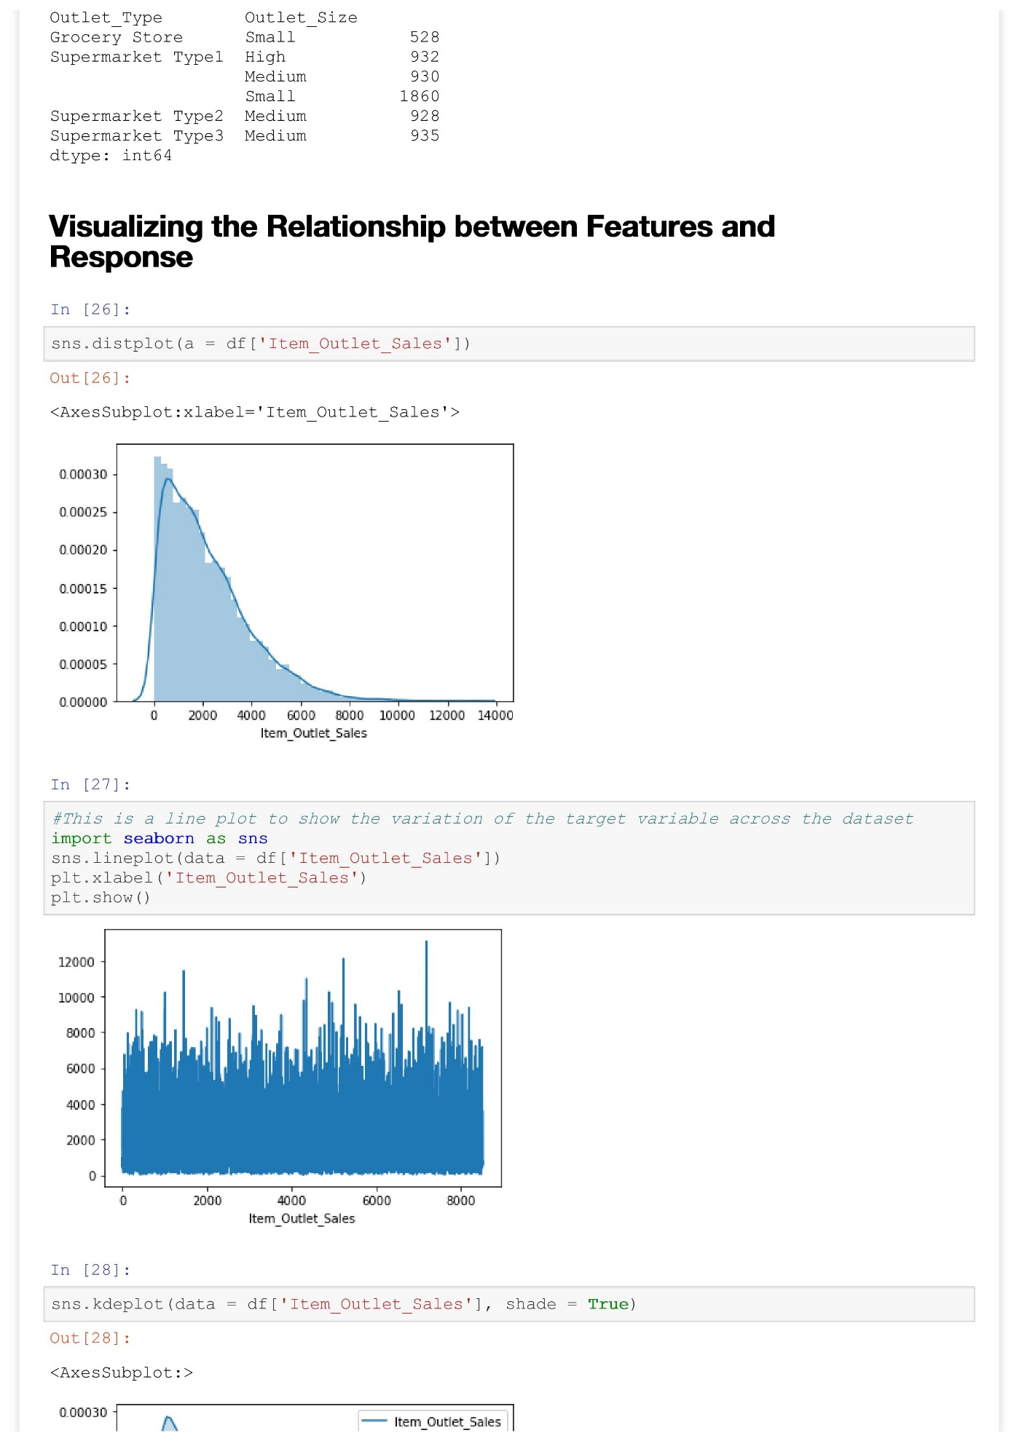

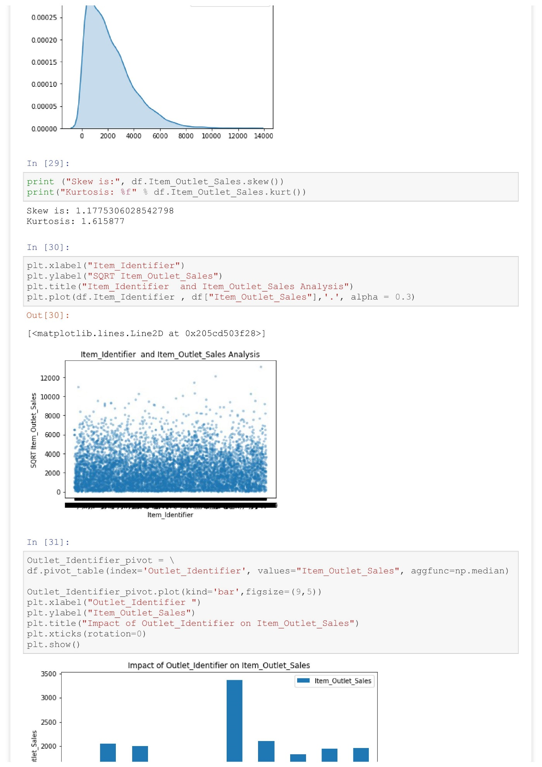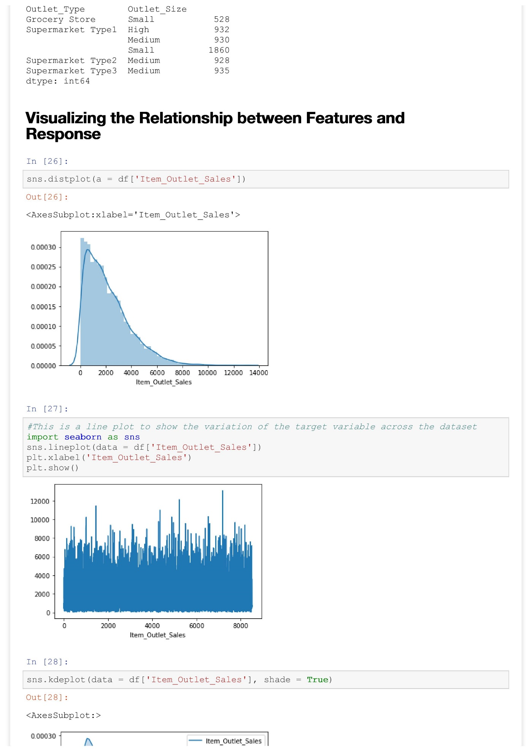

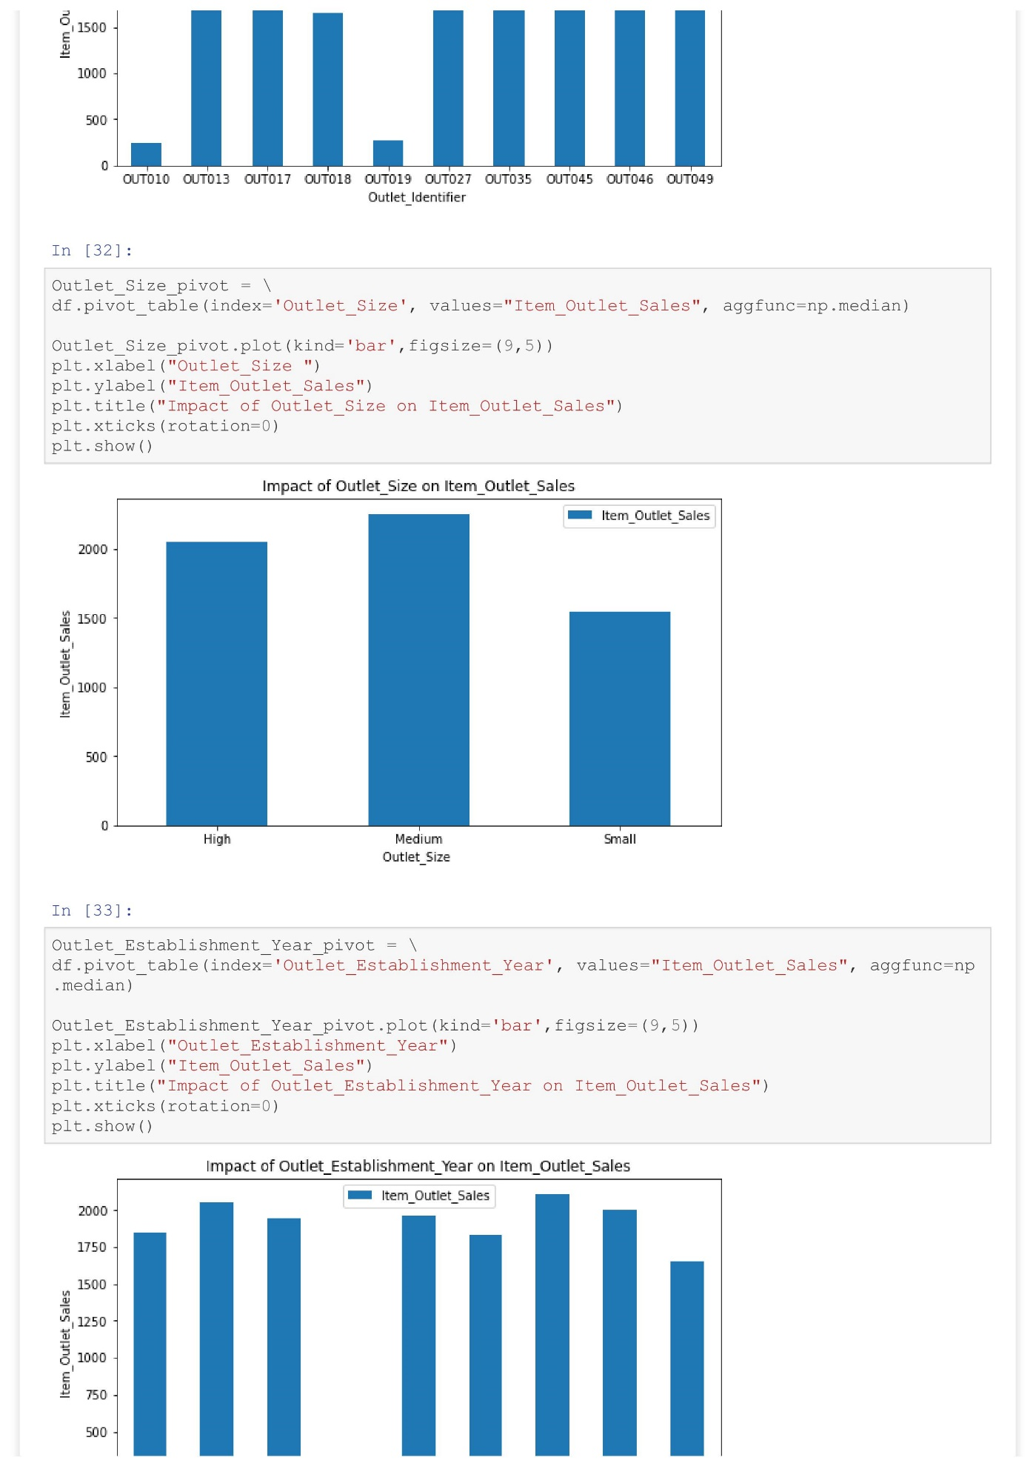

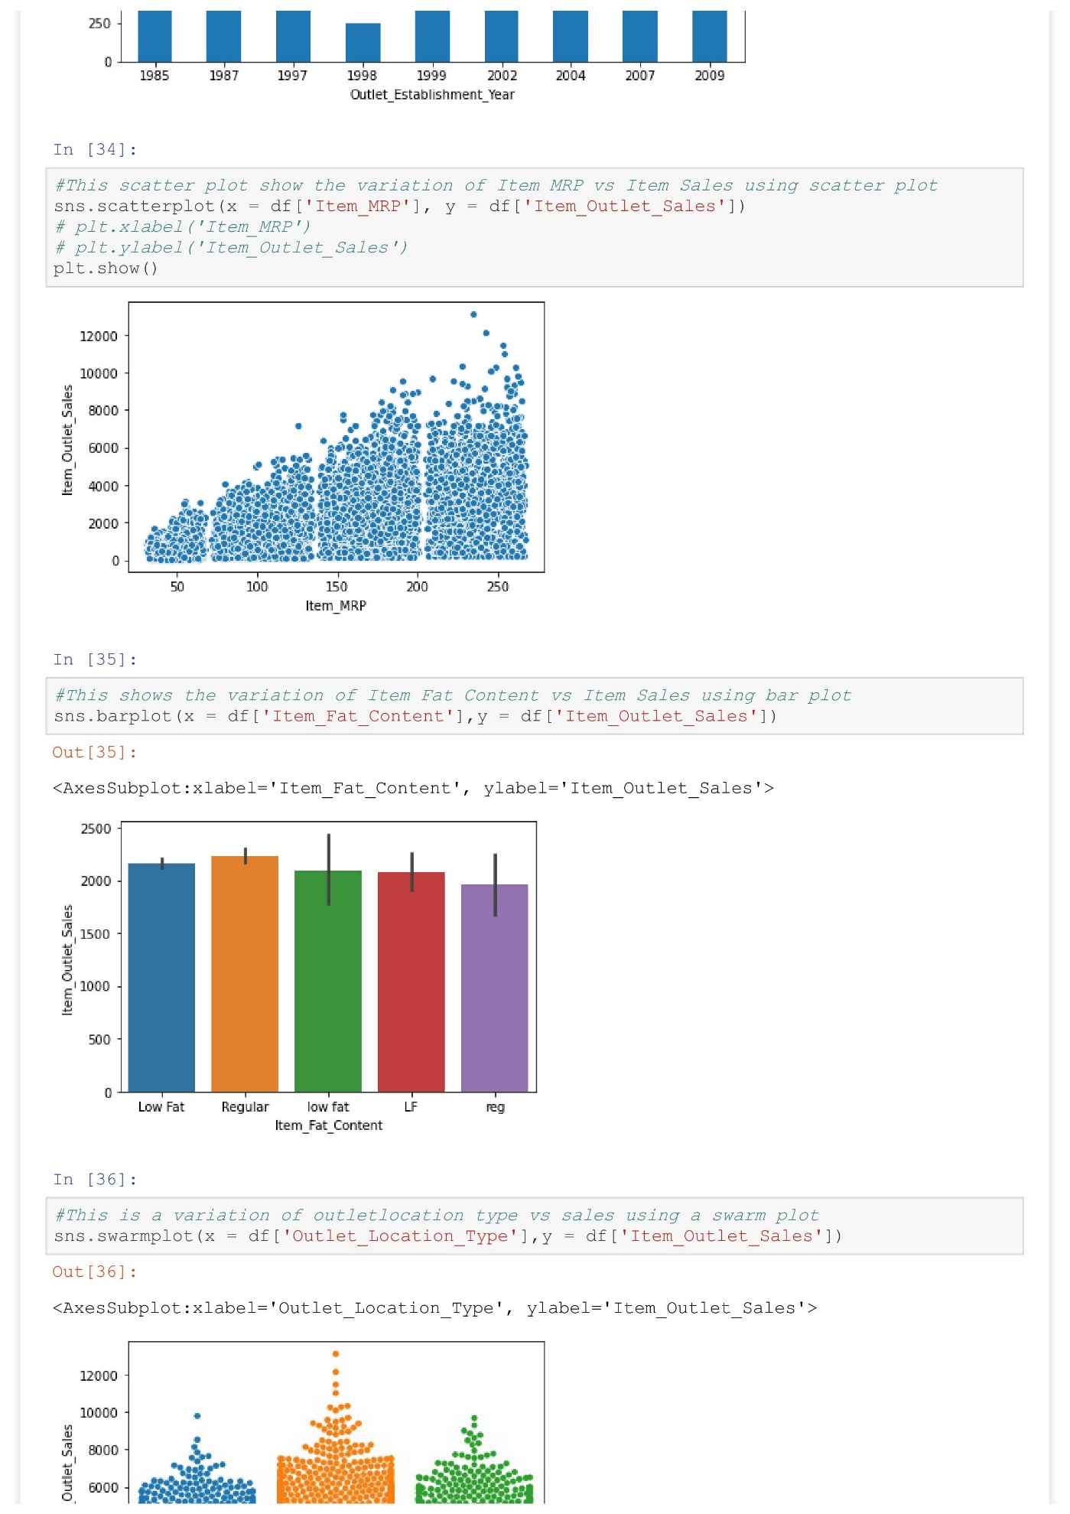

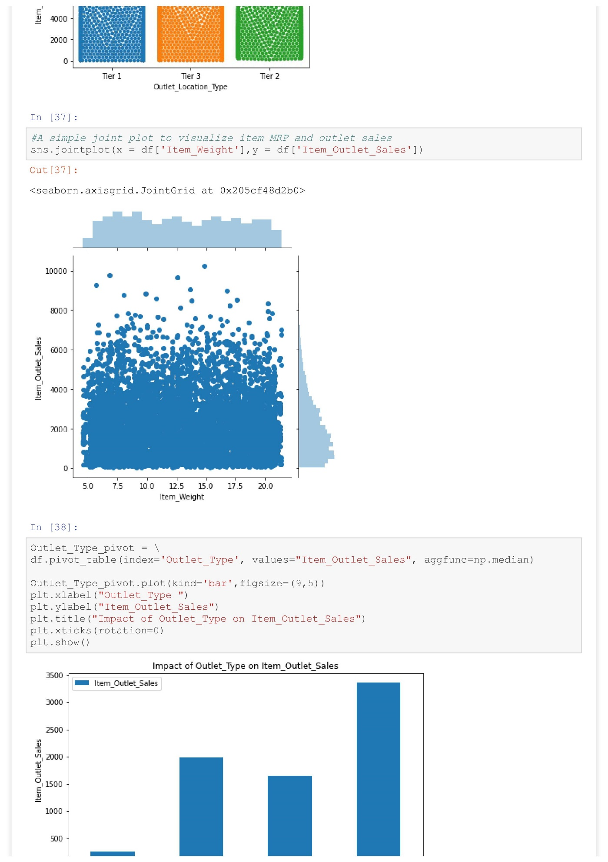

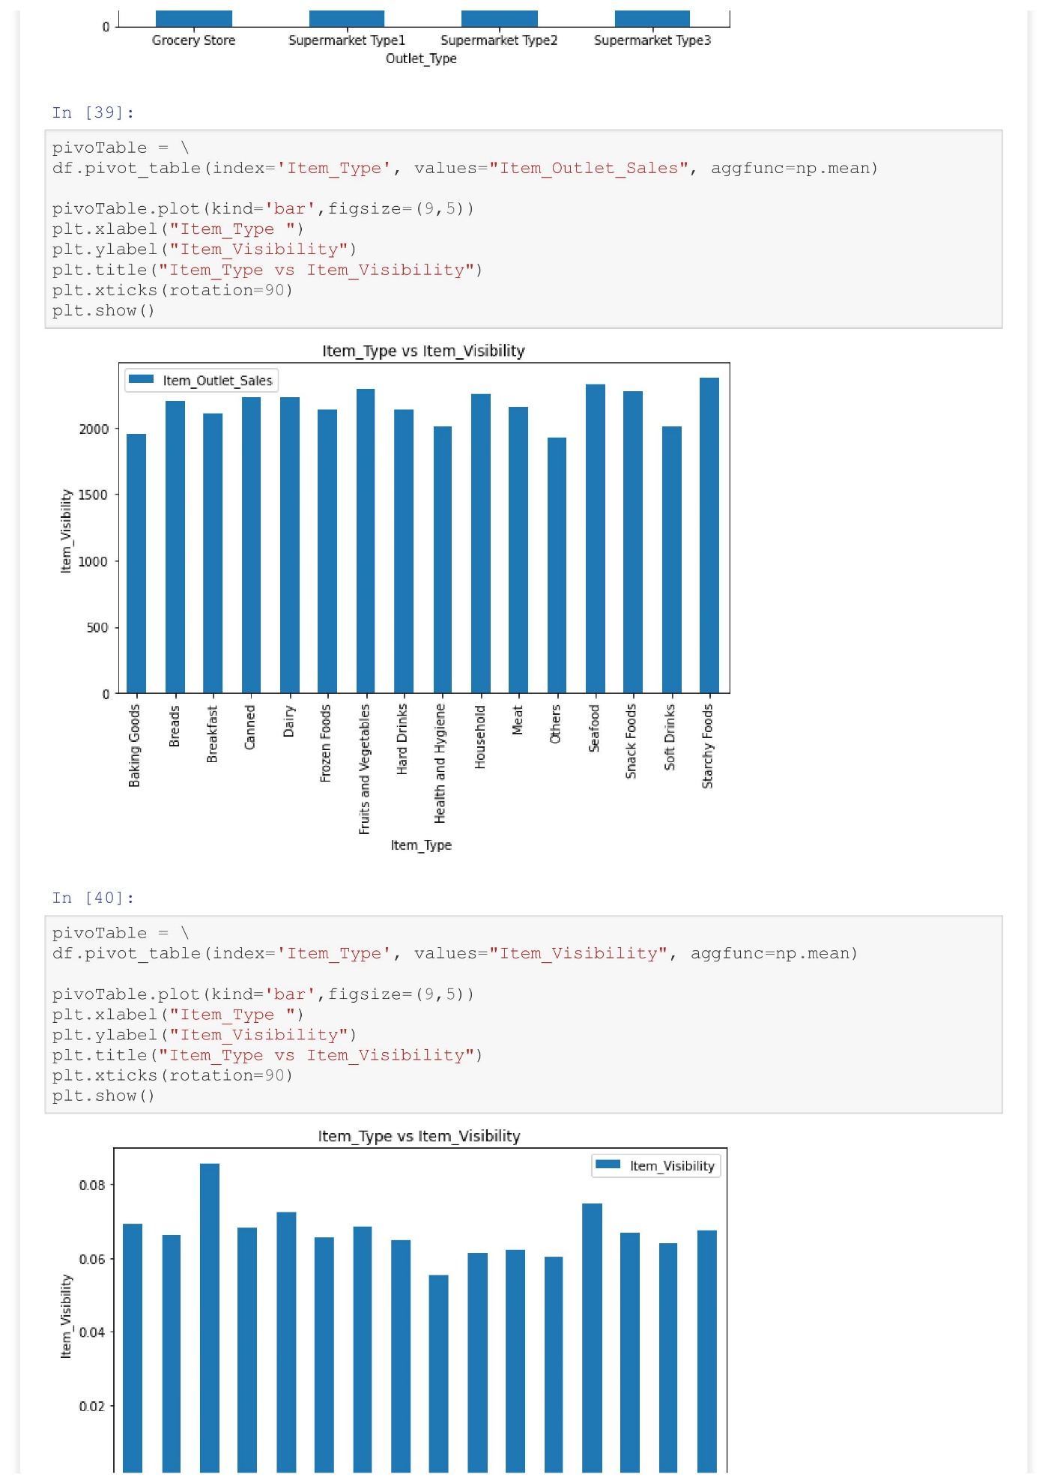

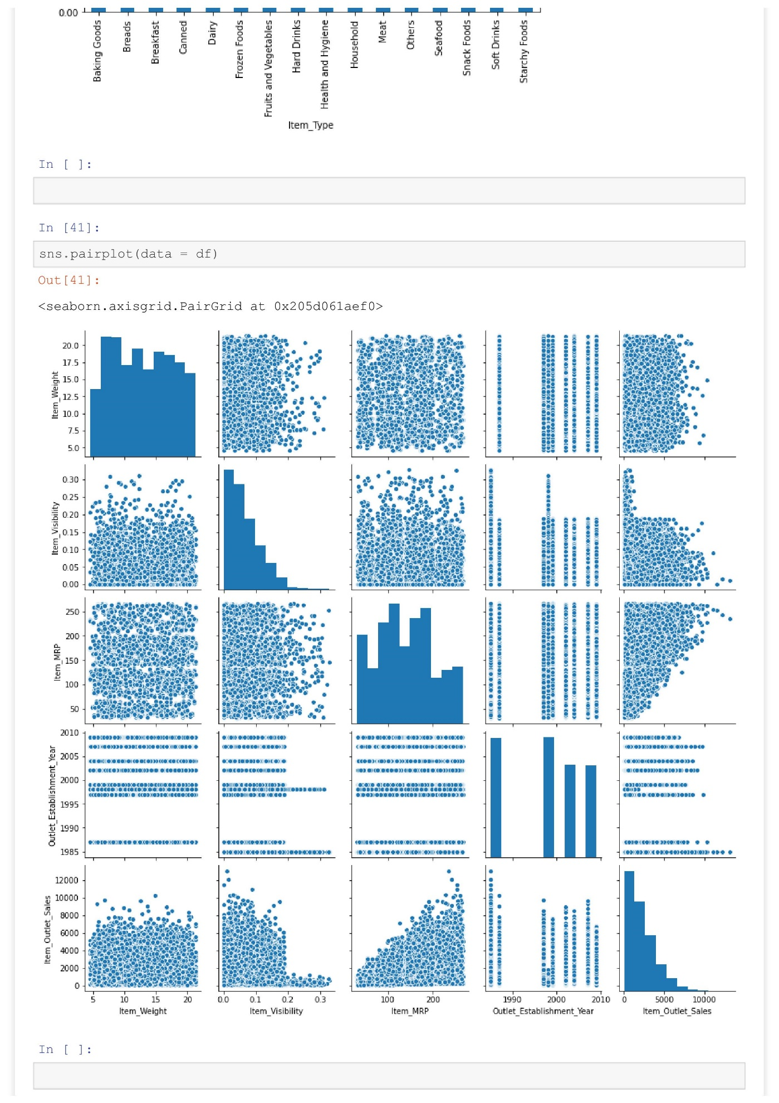



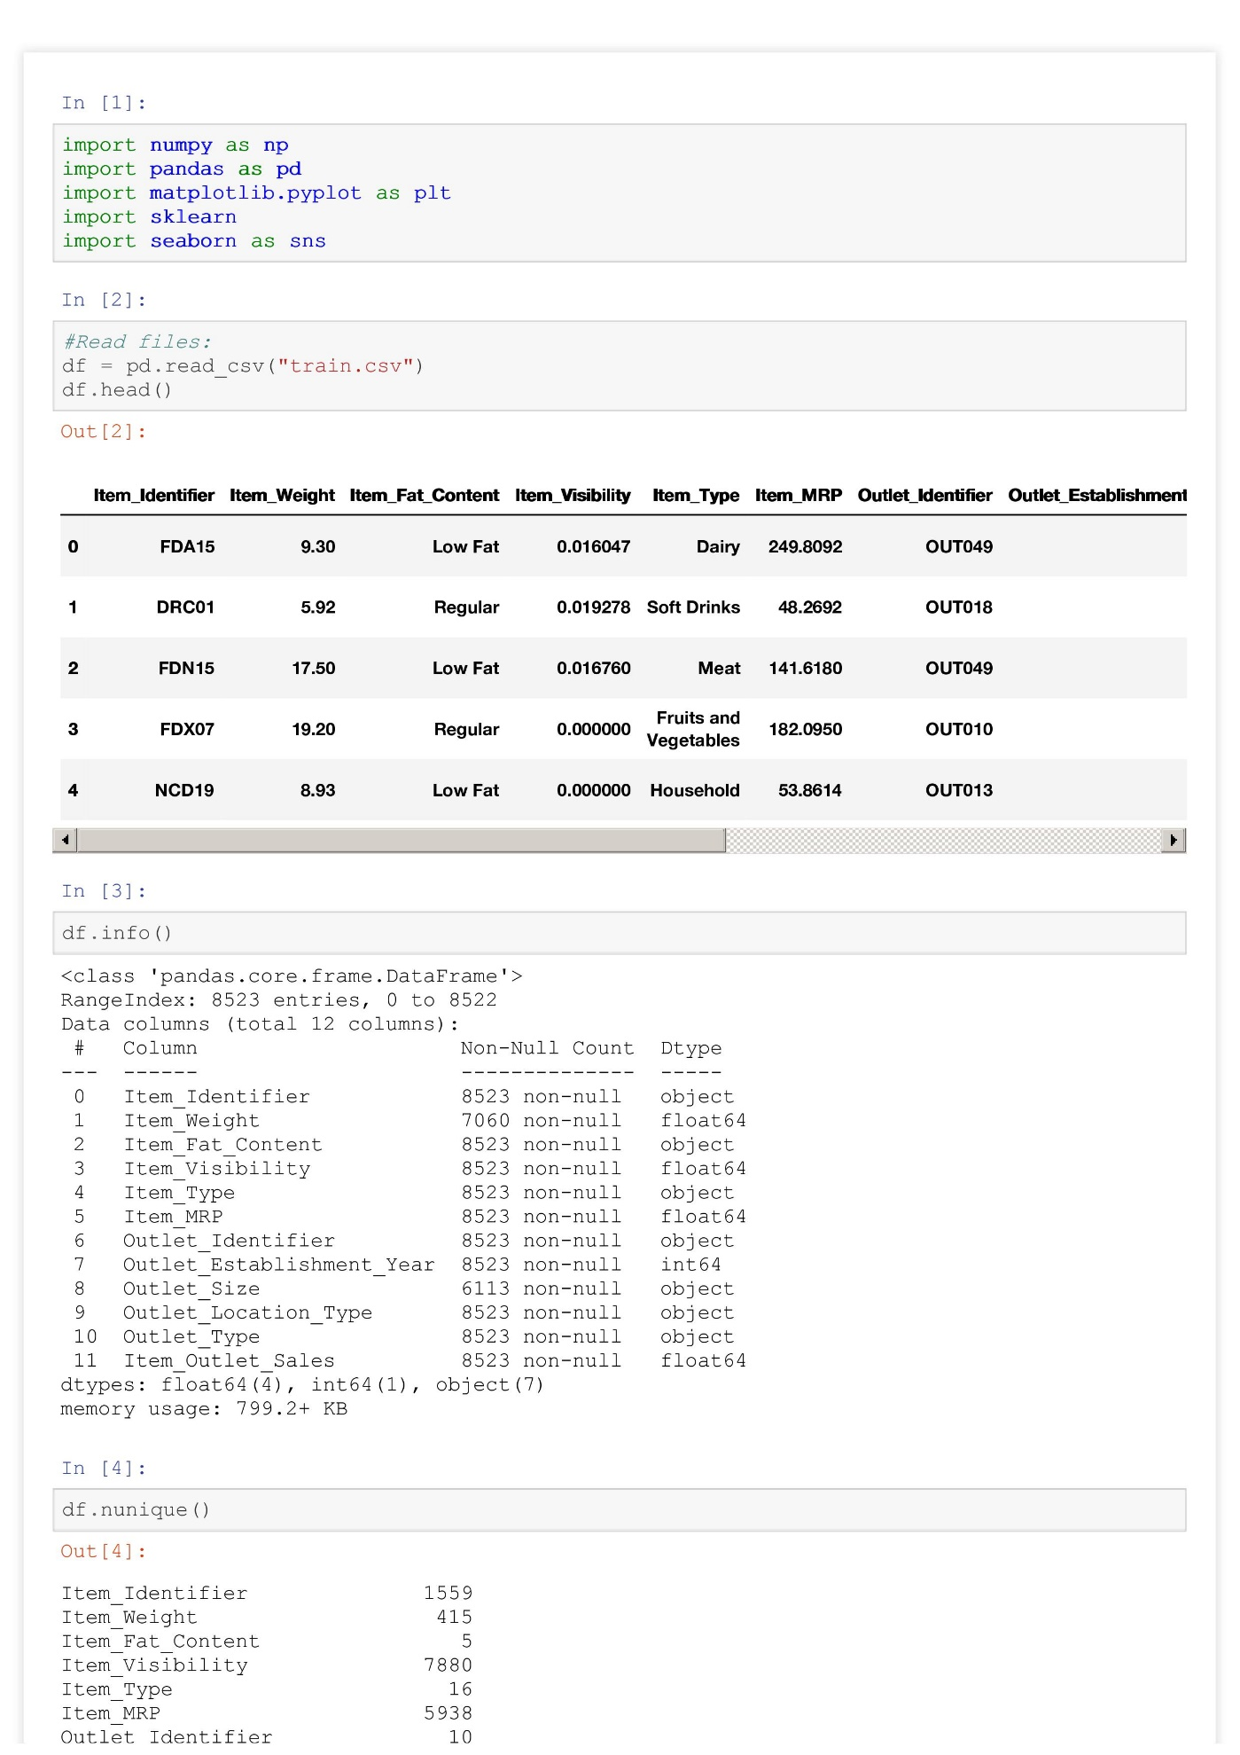**Handling Missing Values**

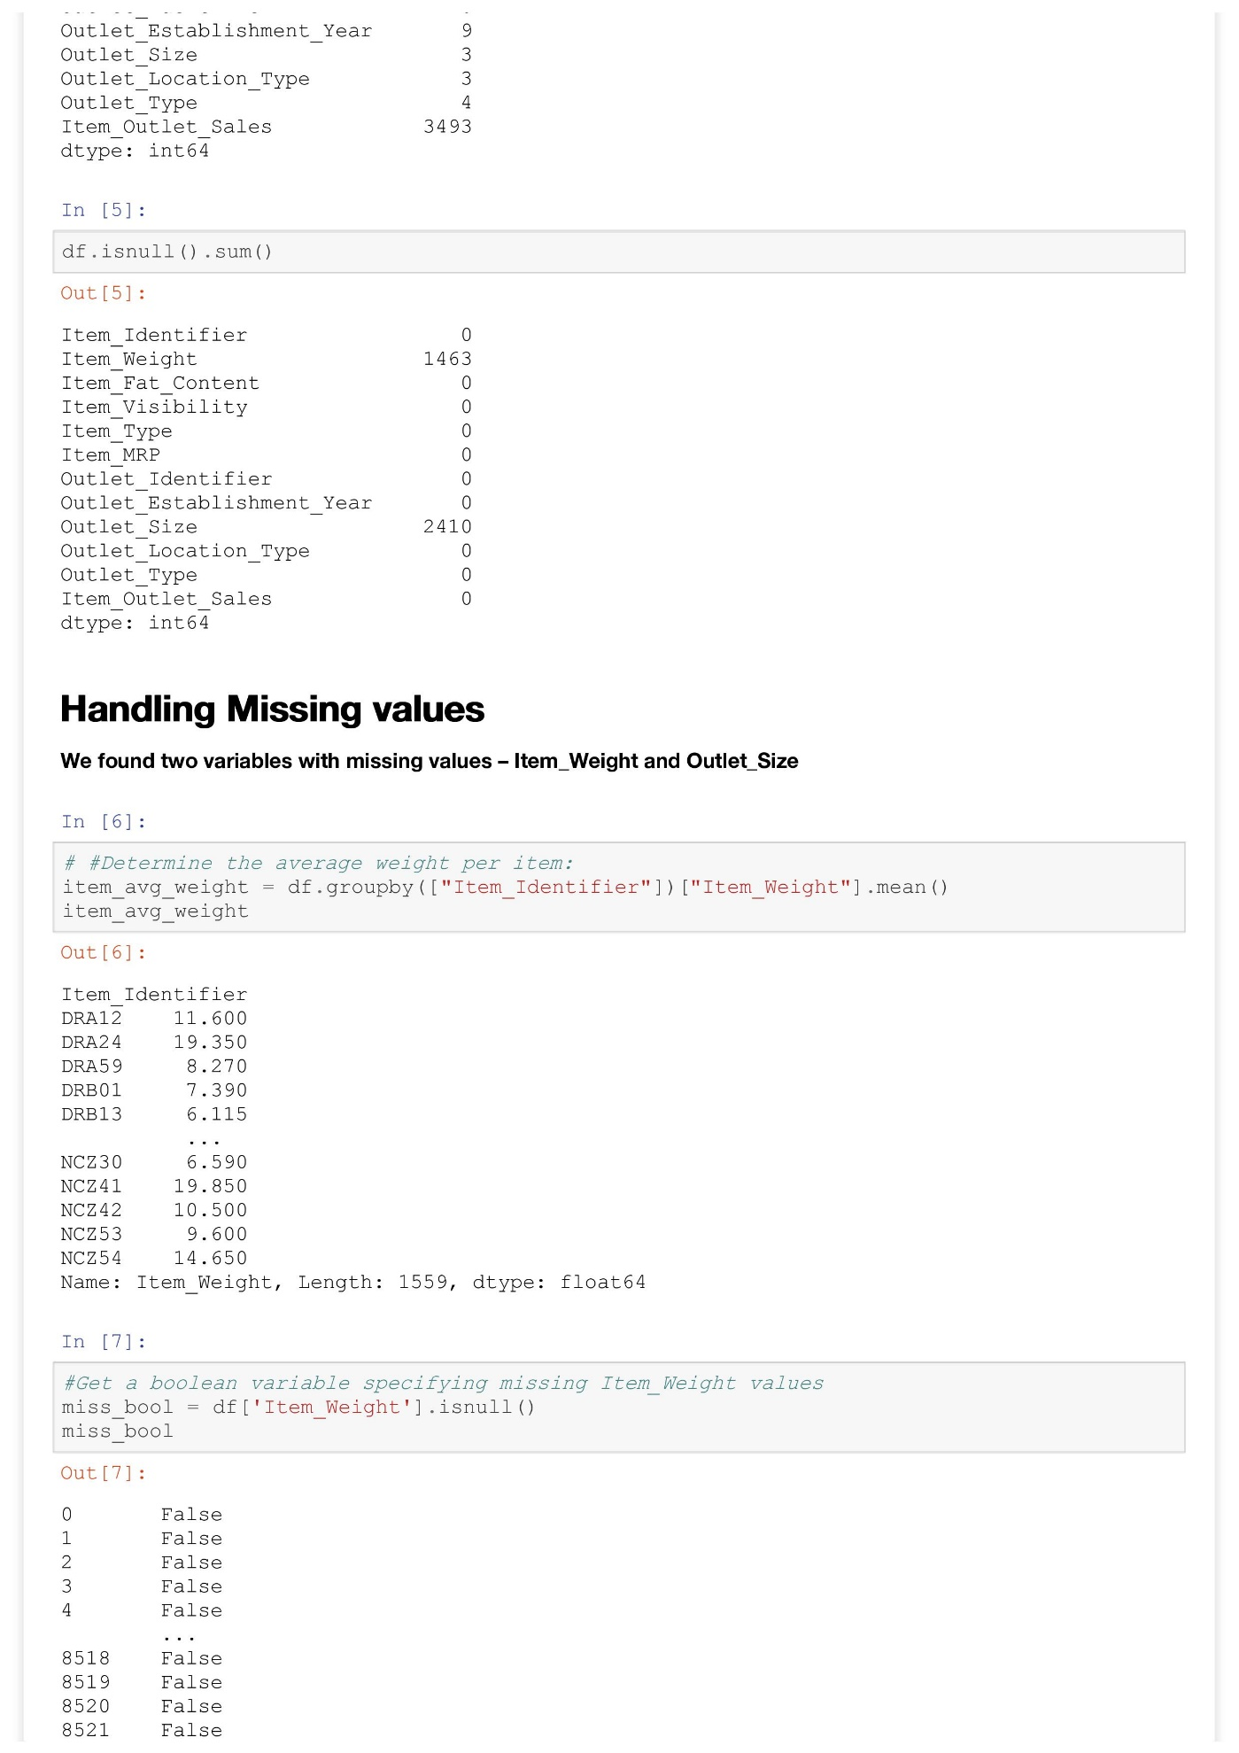

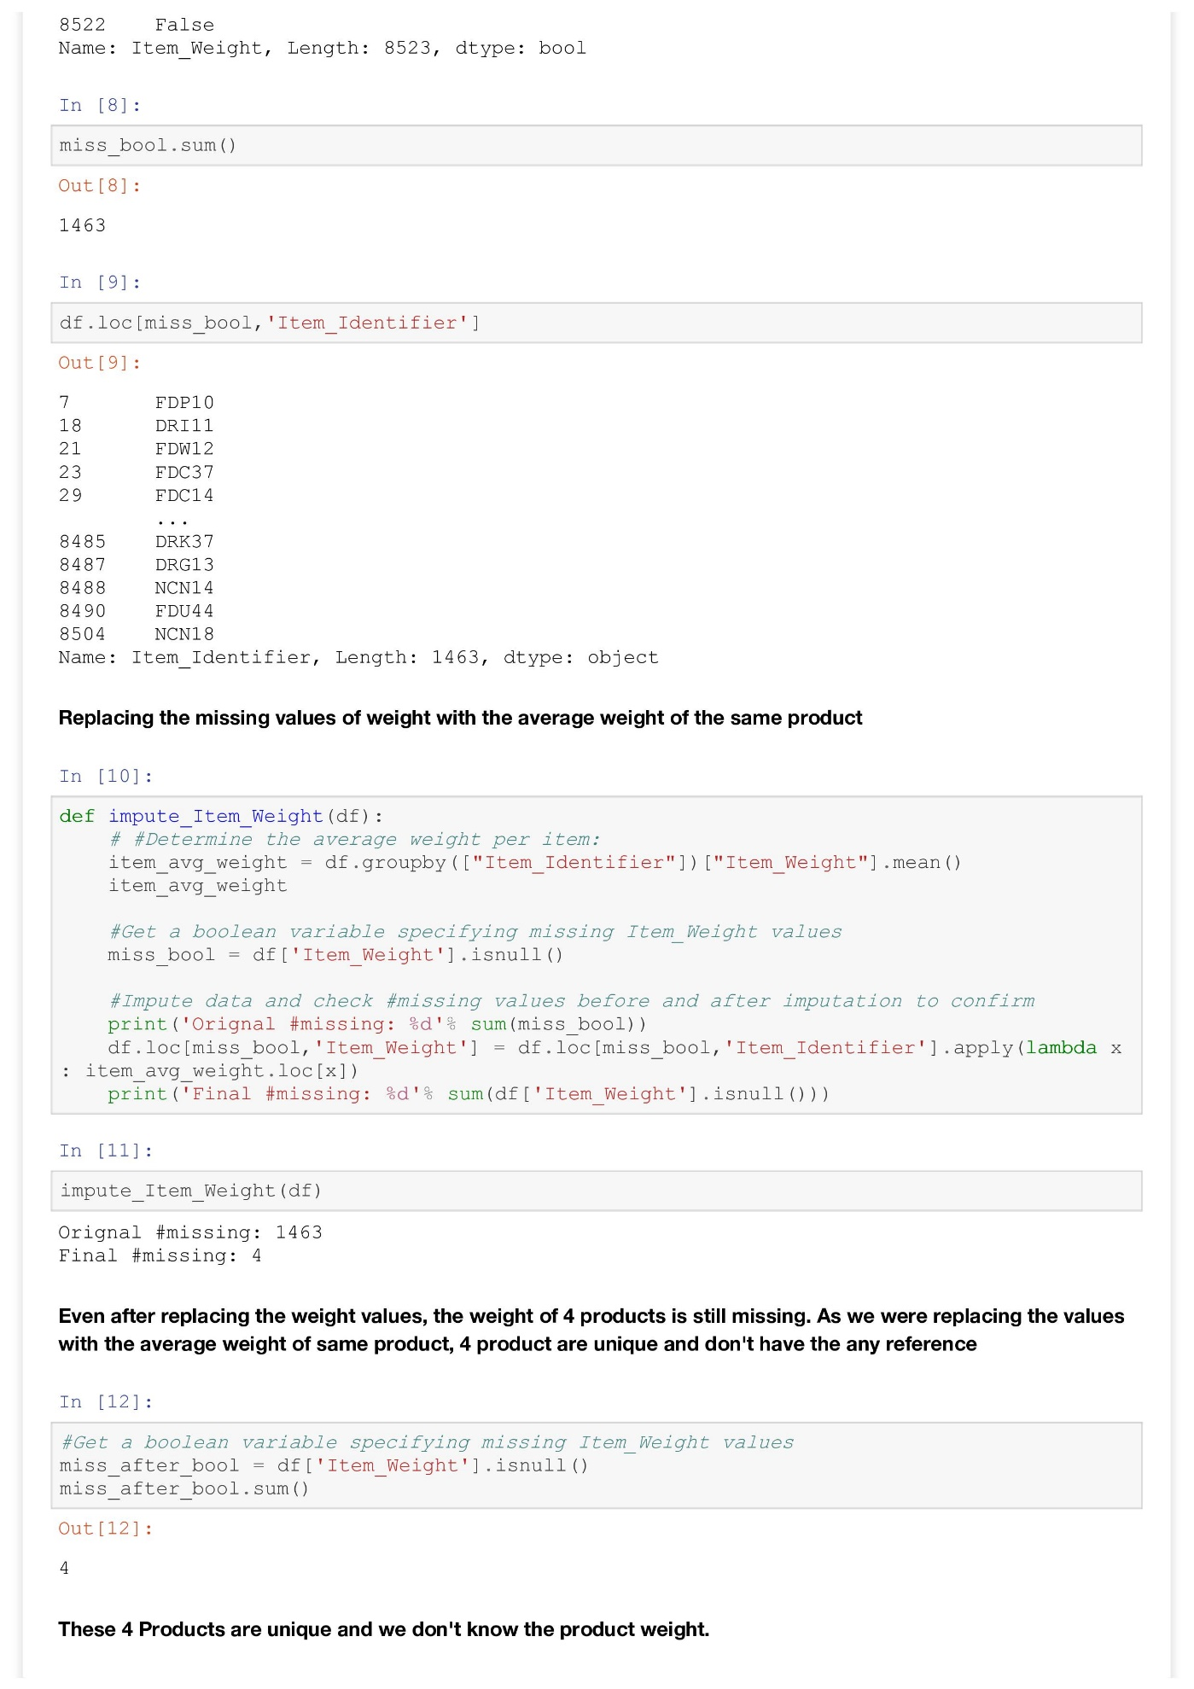

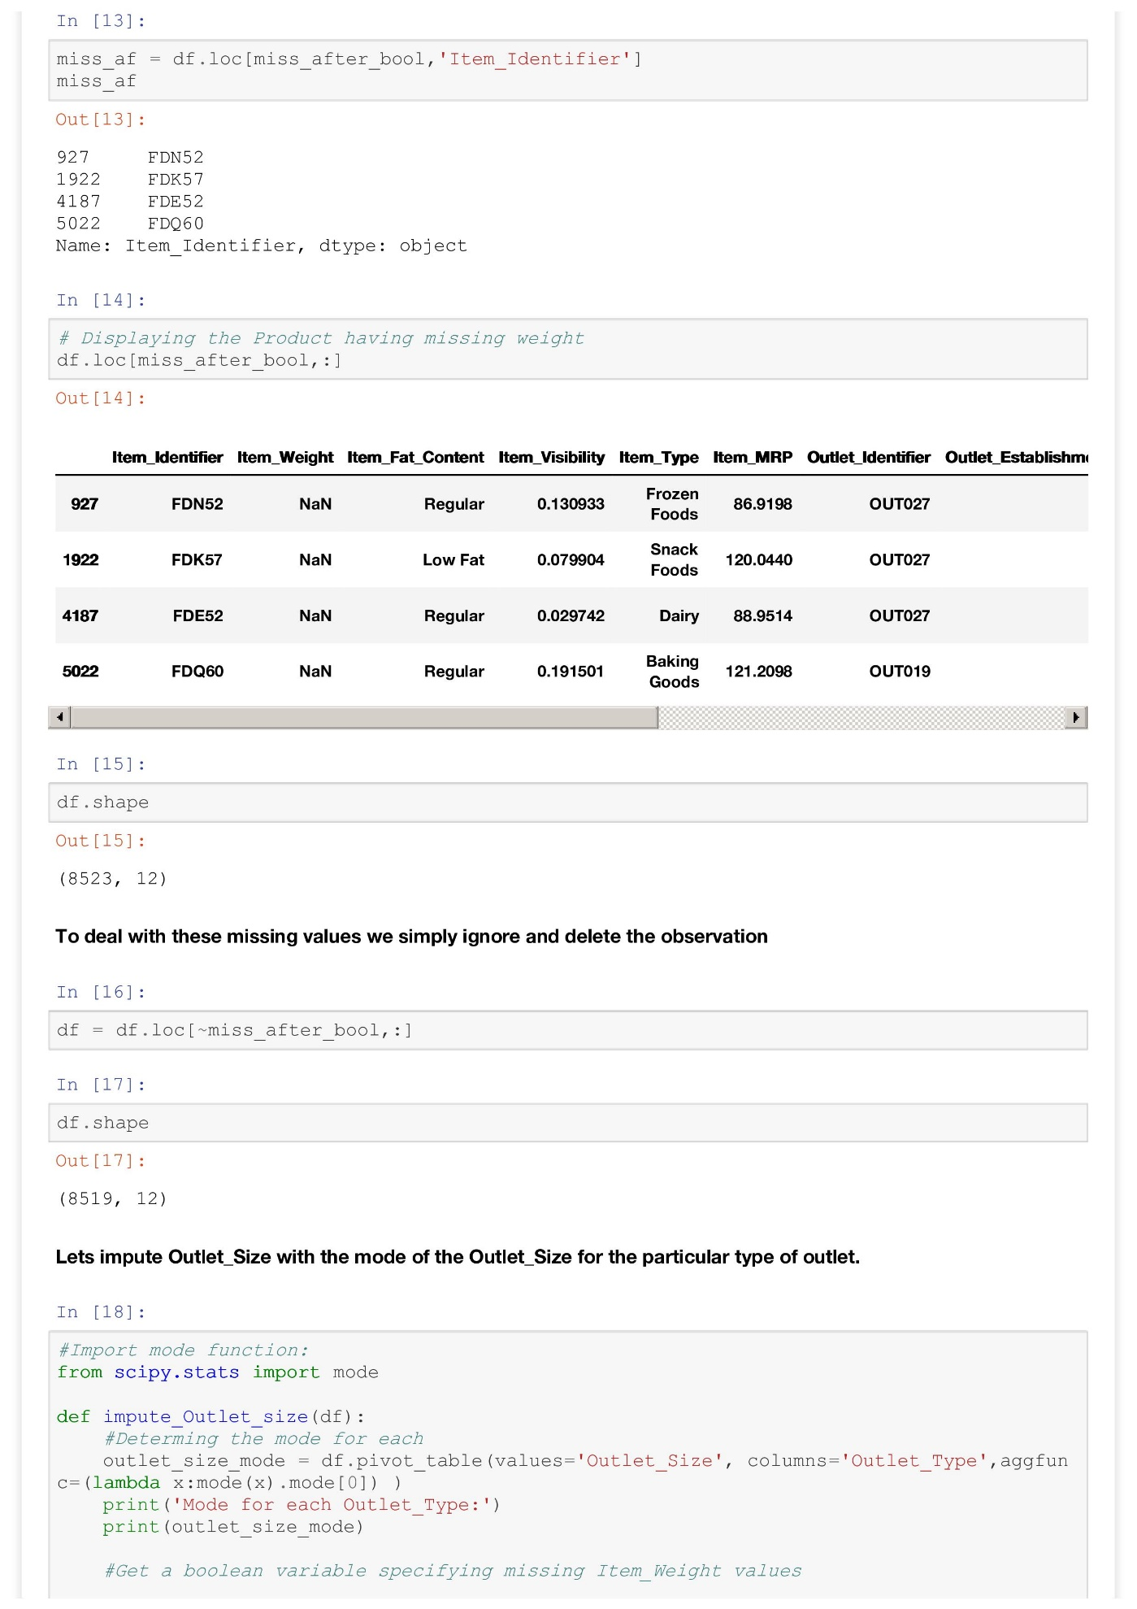

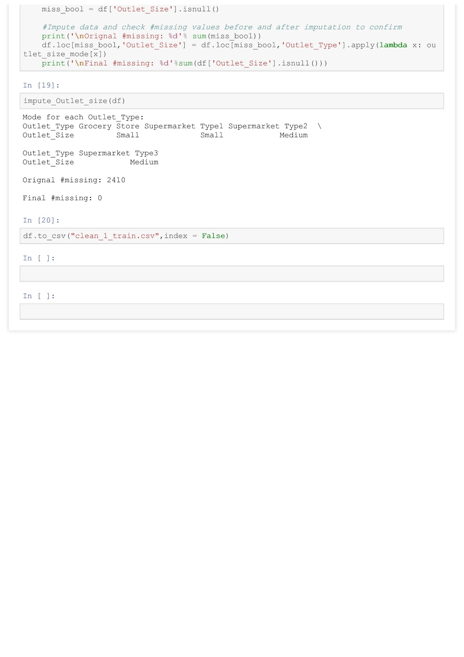

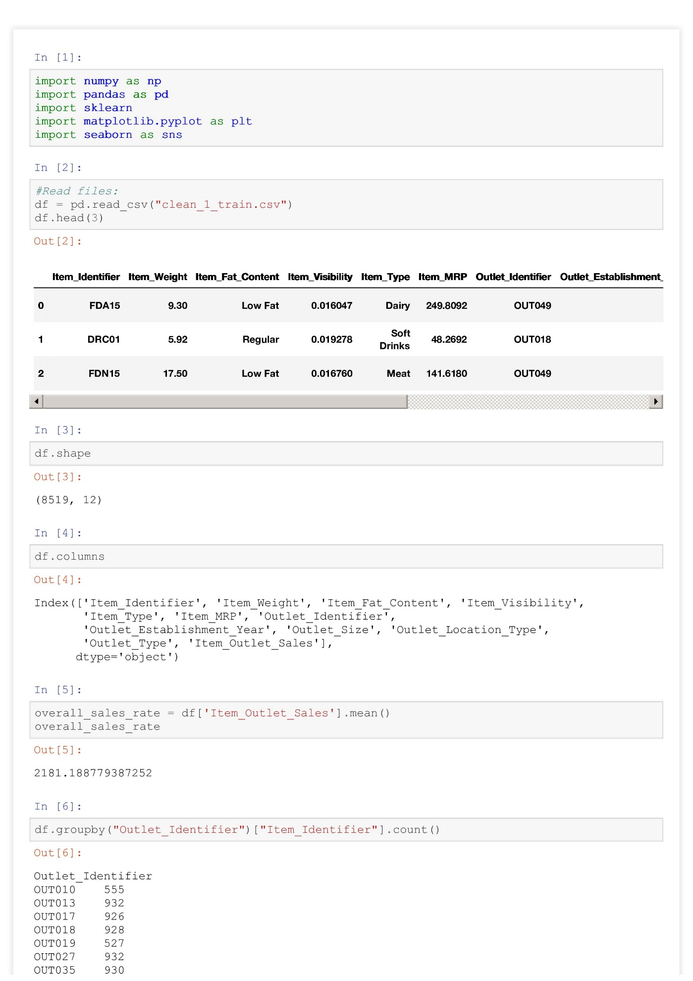**Univariate and Bivariate Analysis**

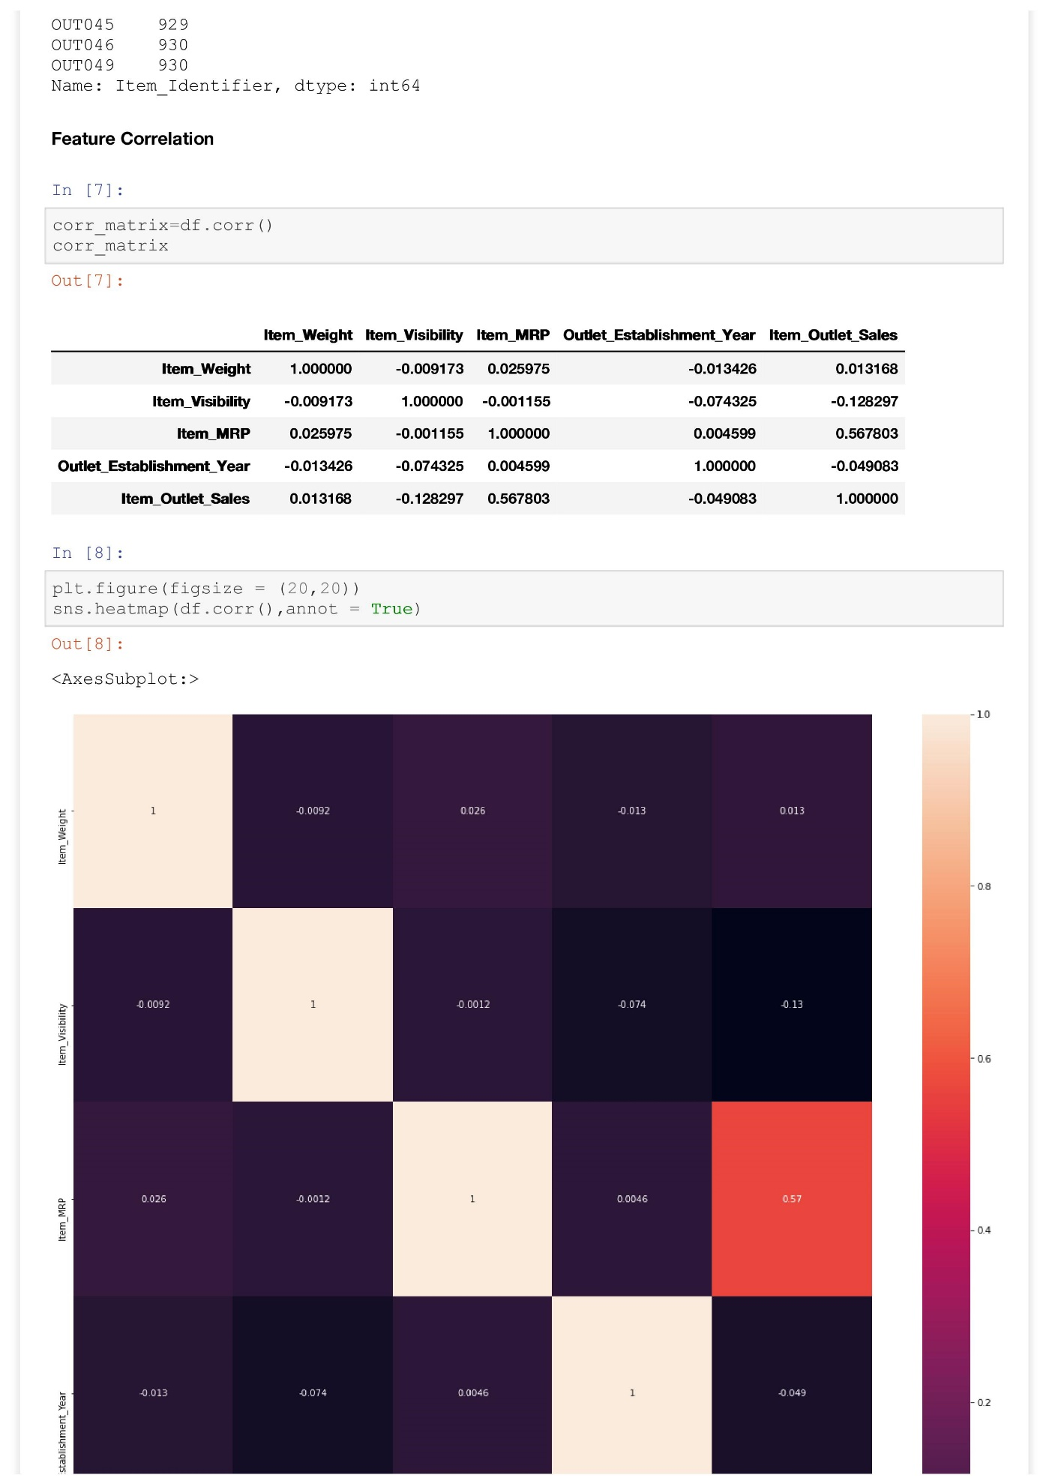

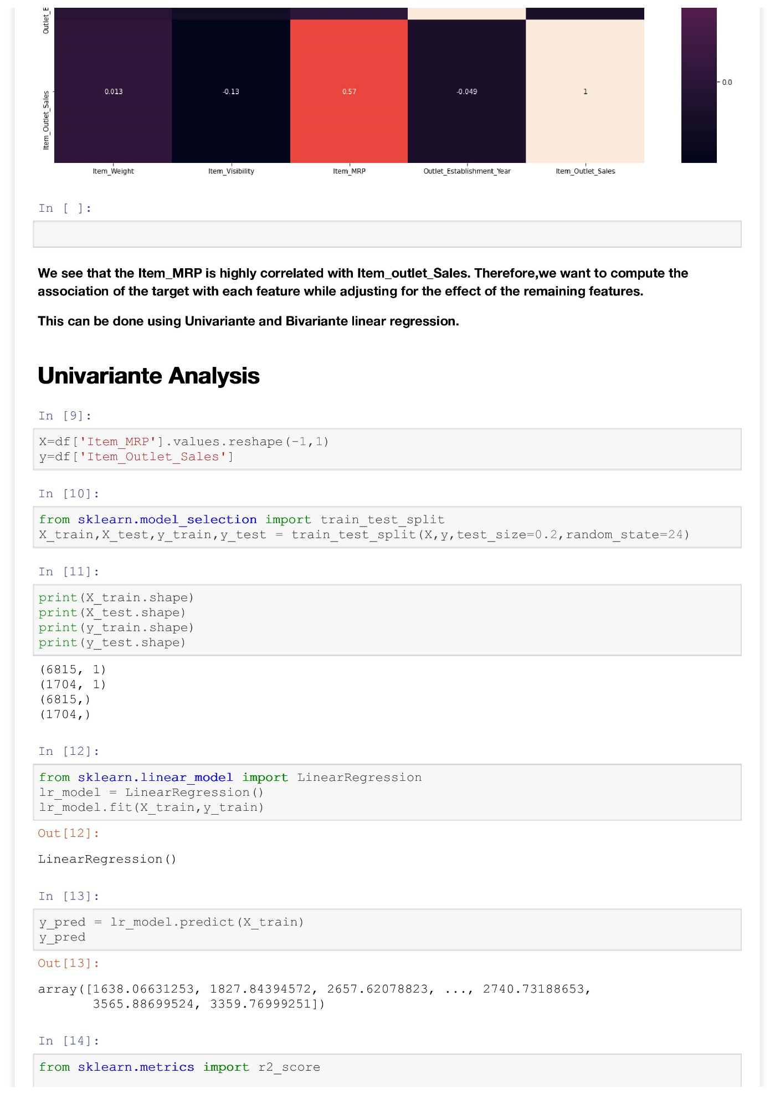

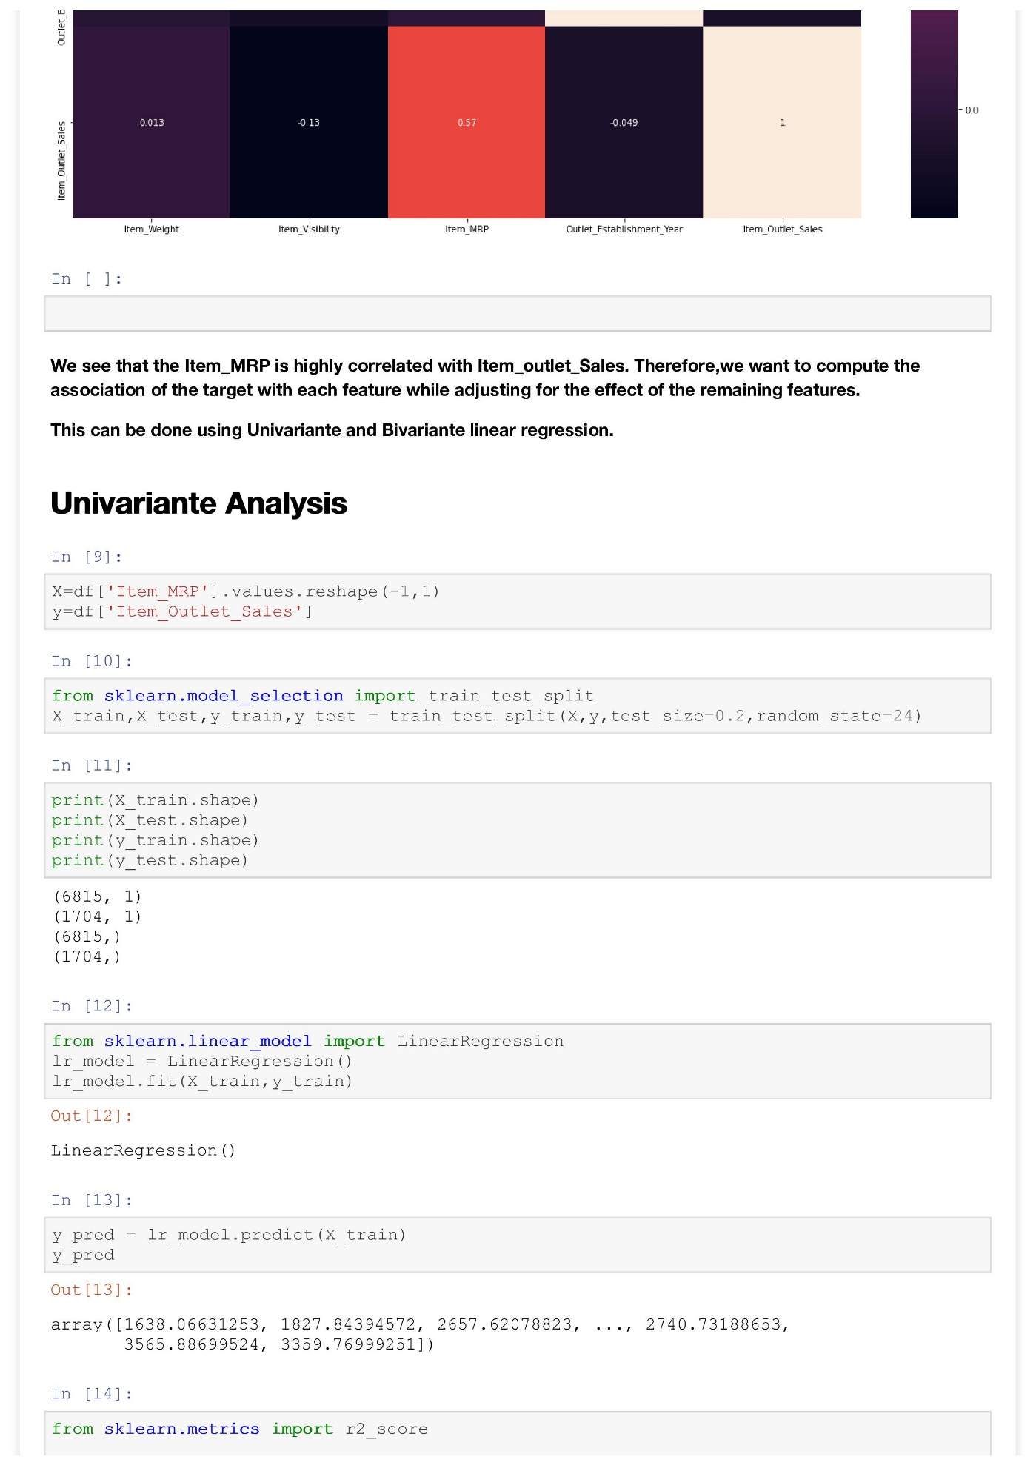

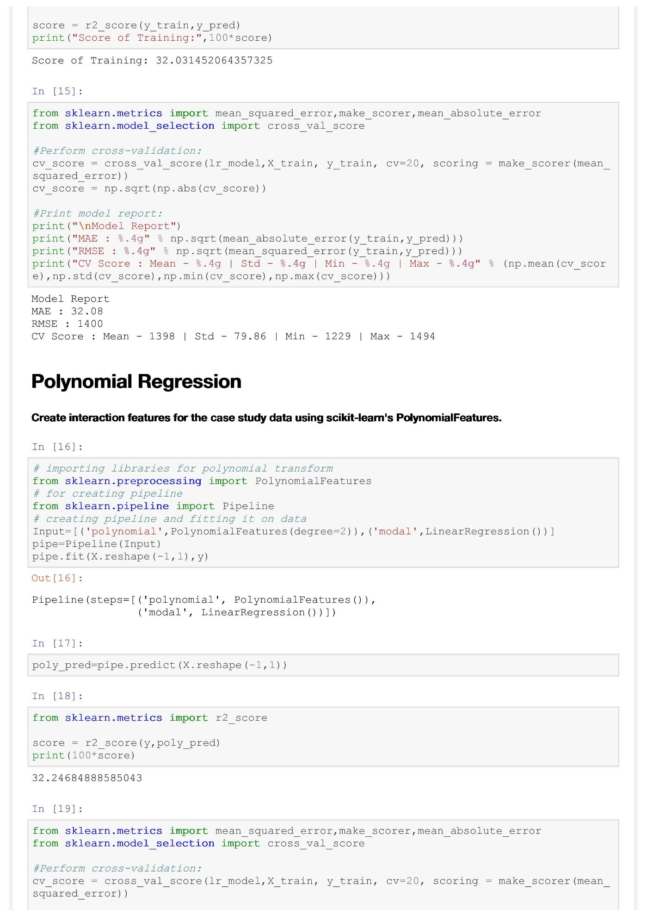

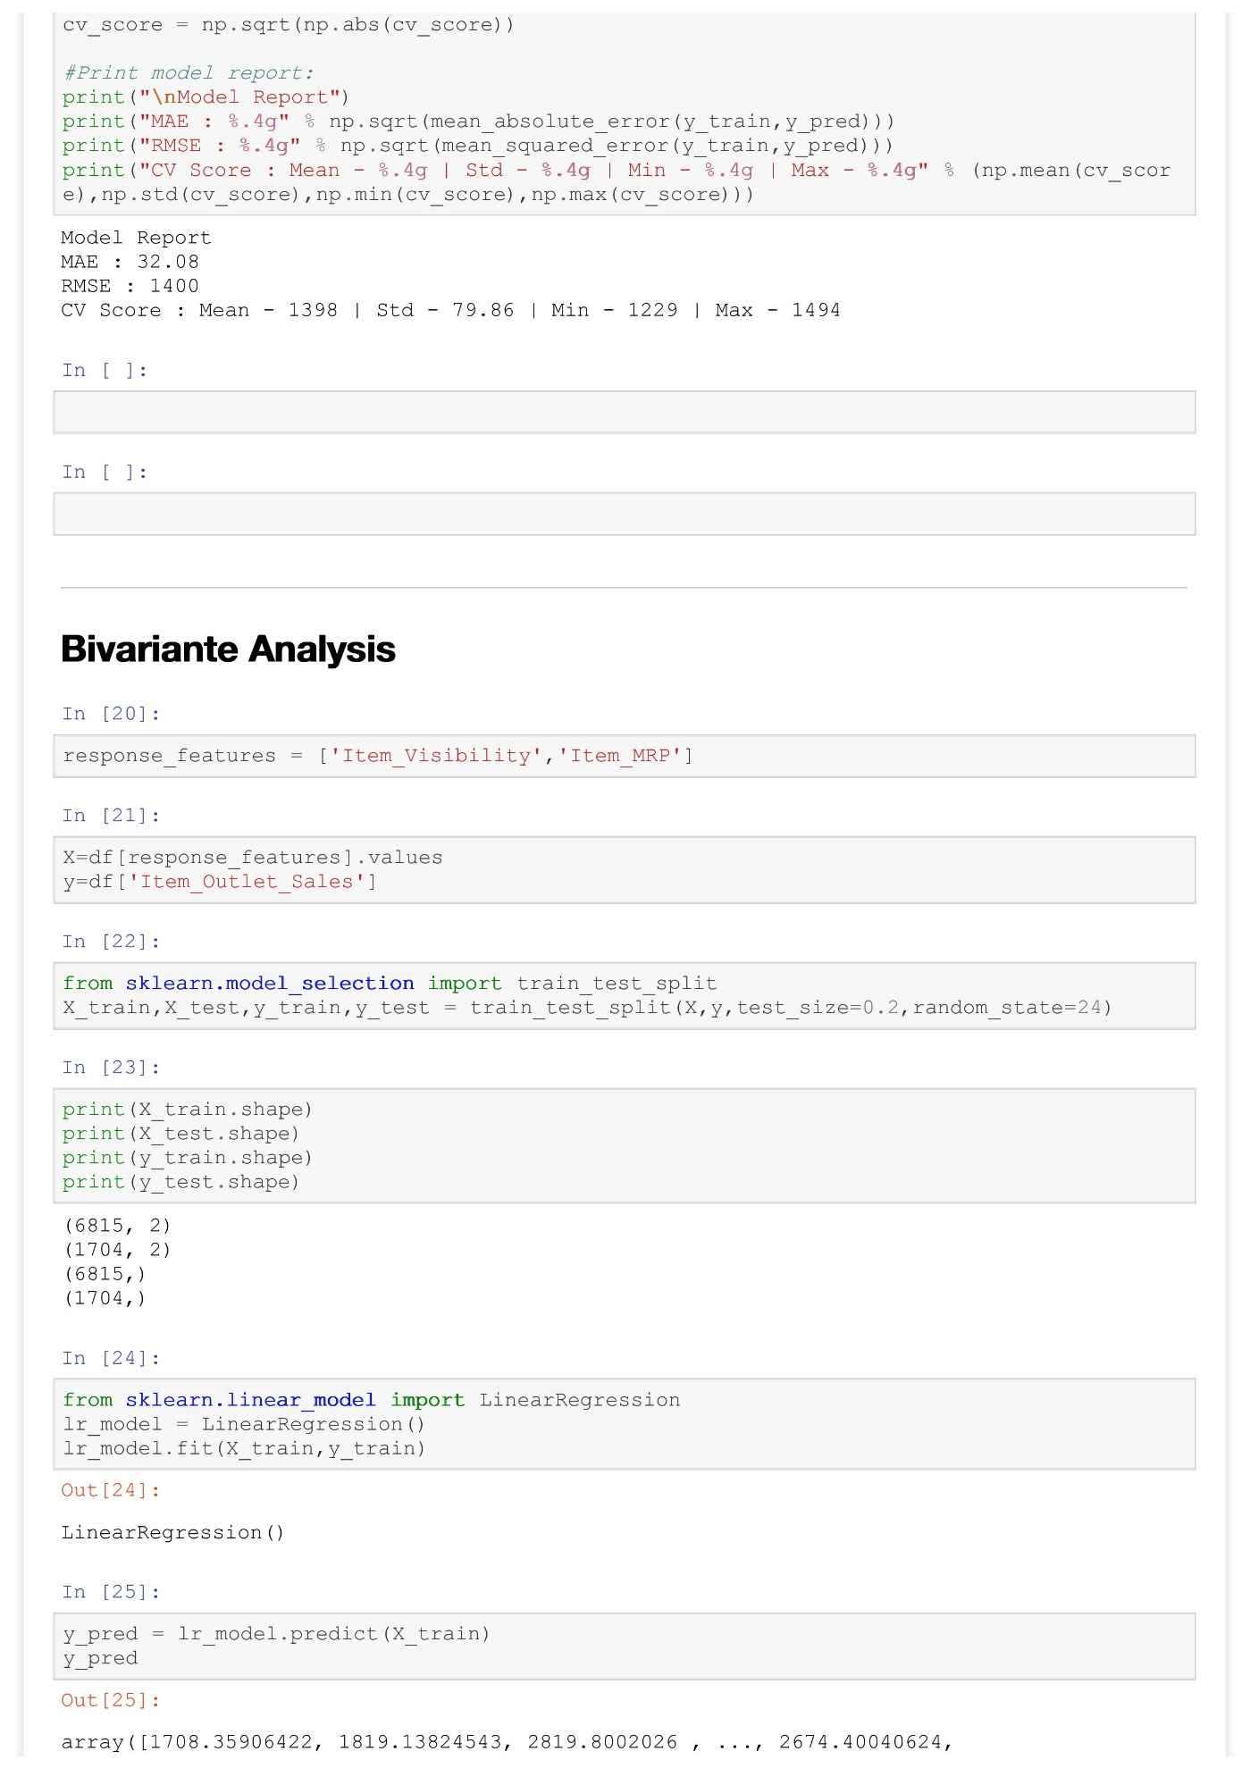

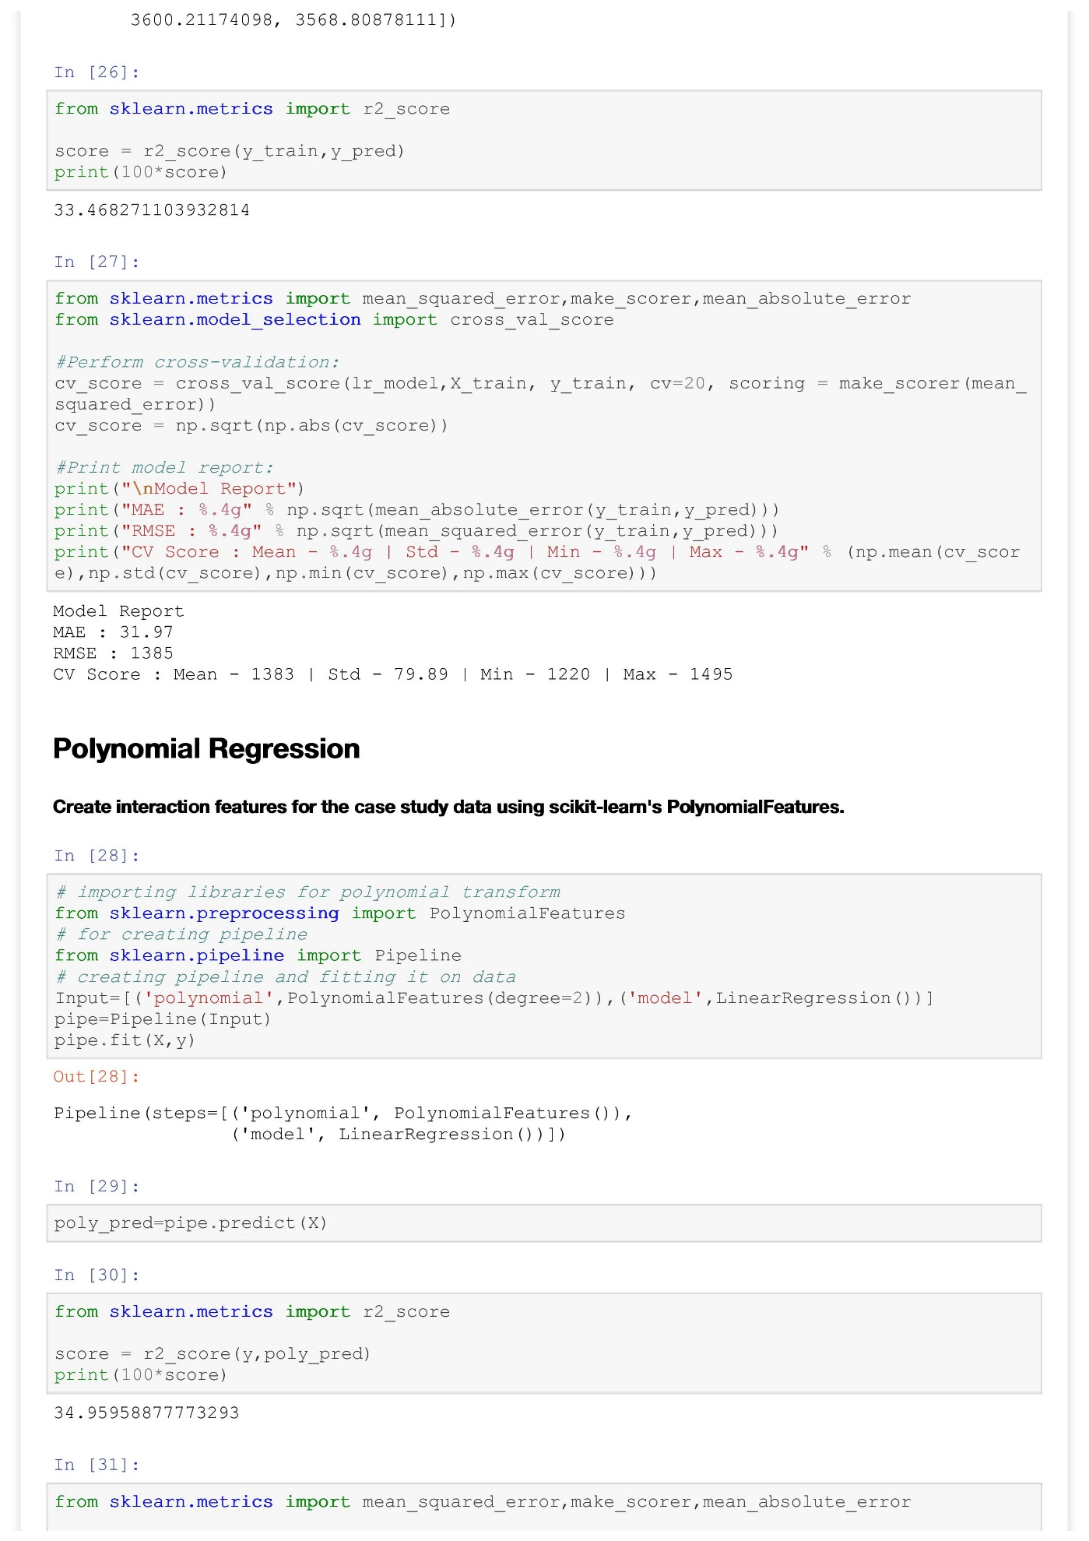

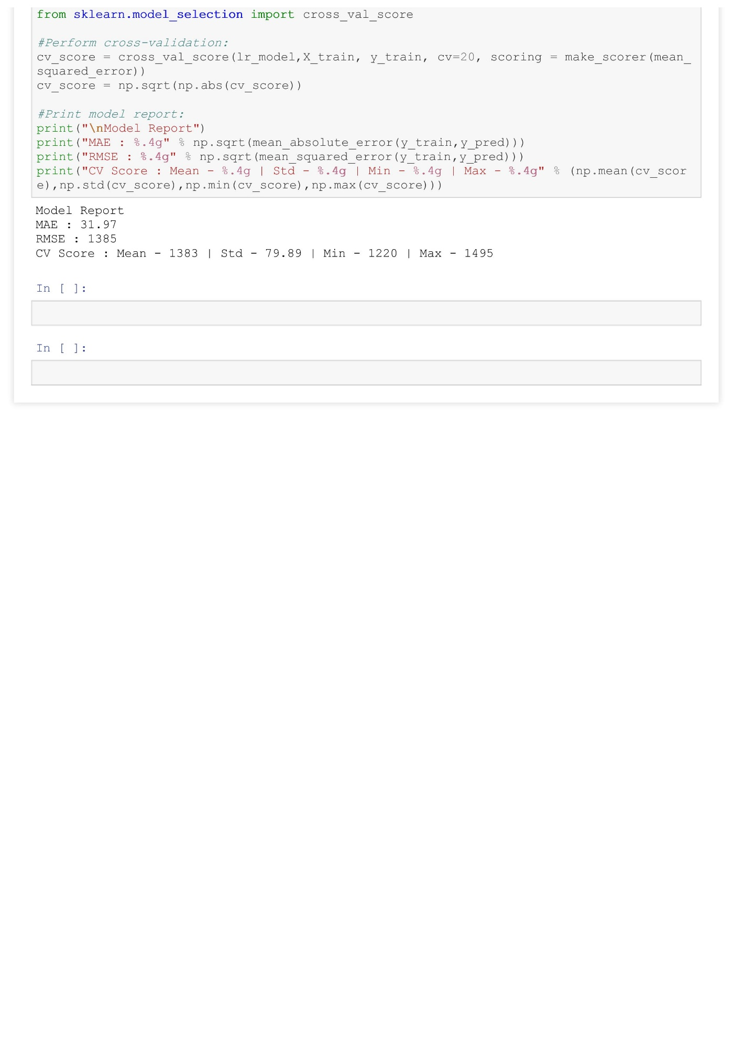

**Feature Engineering**

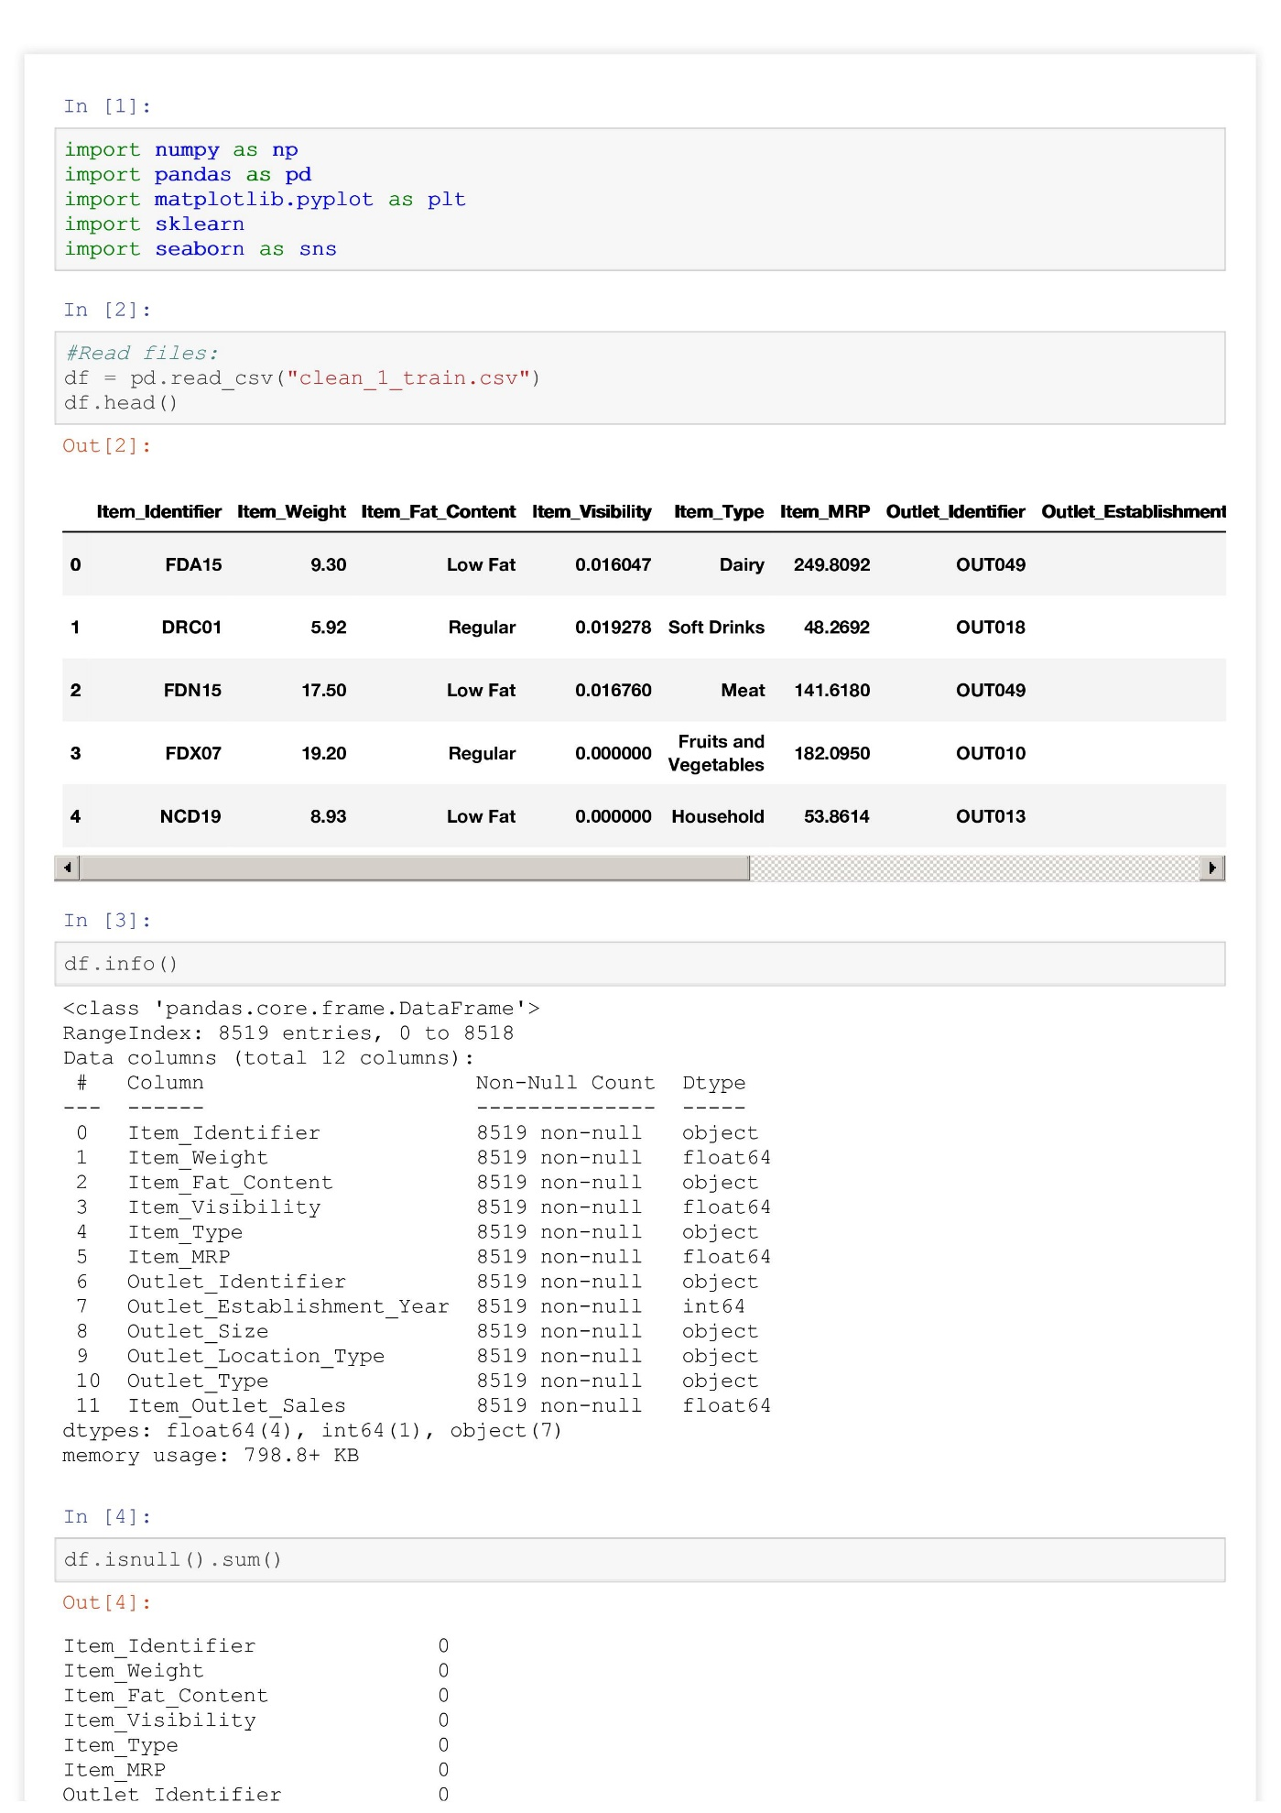

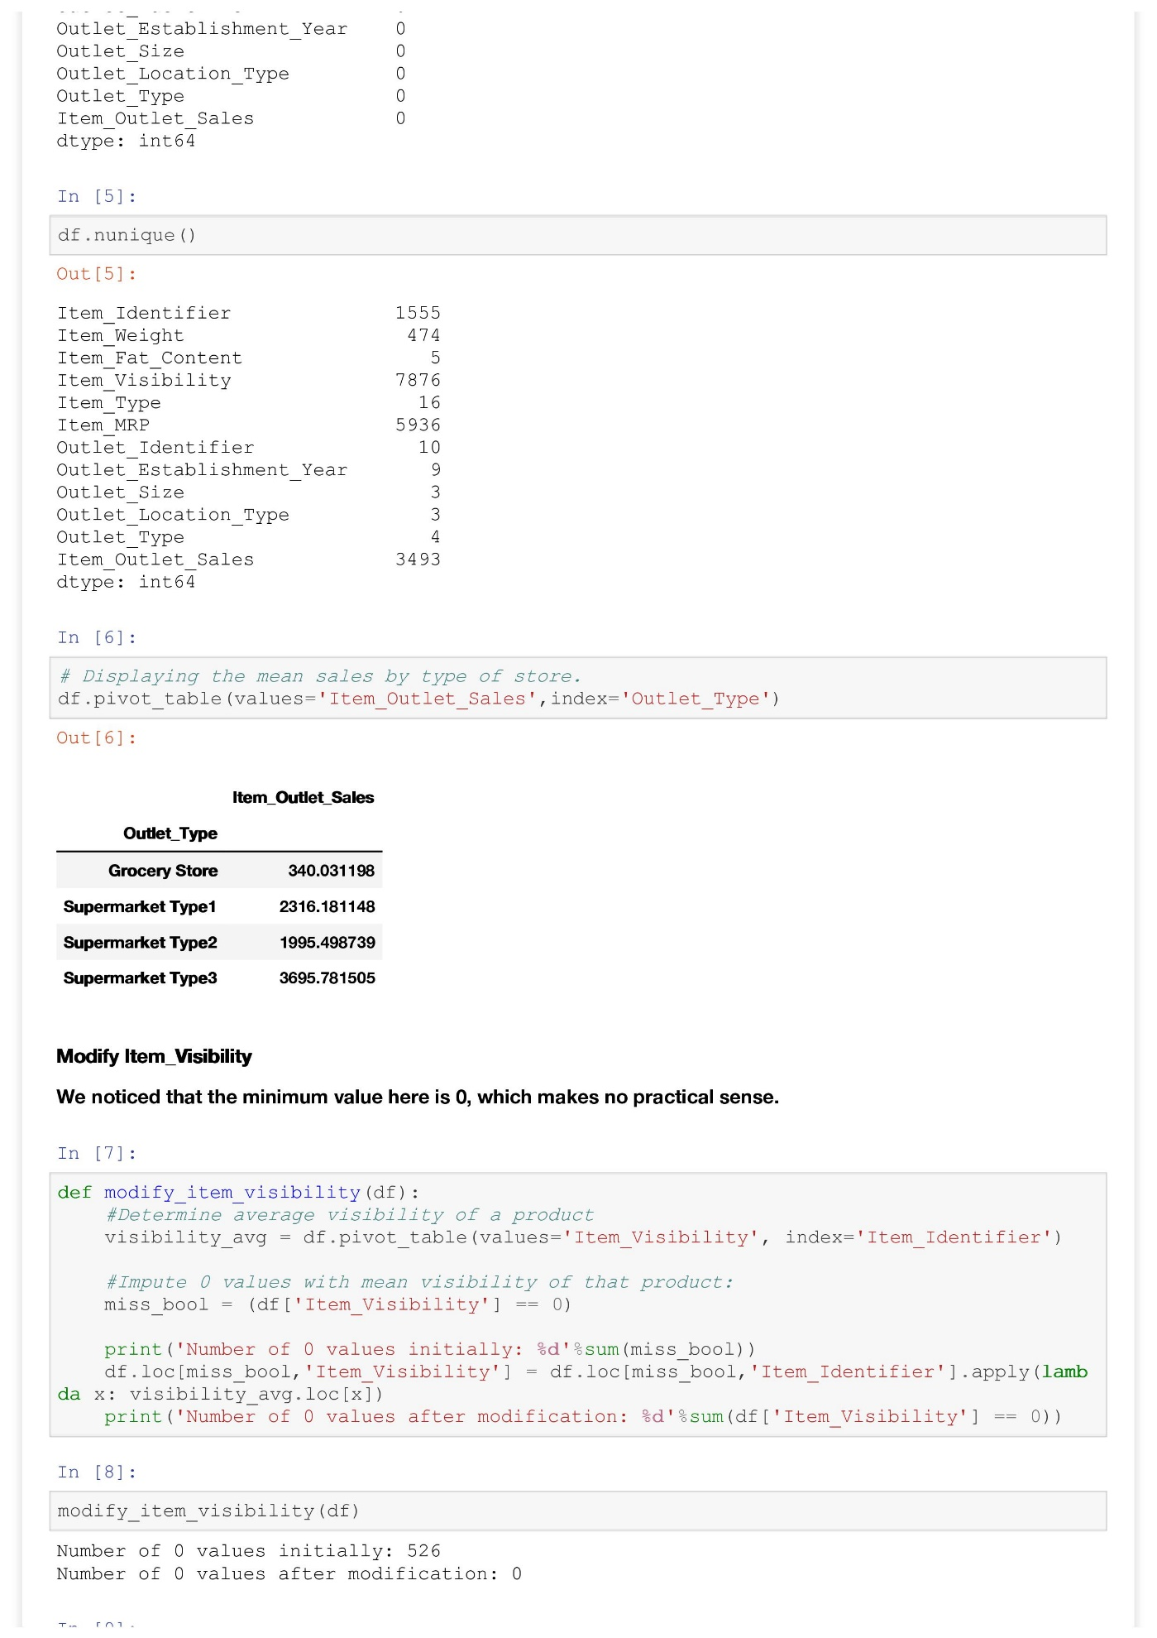

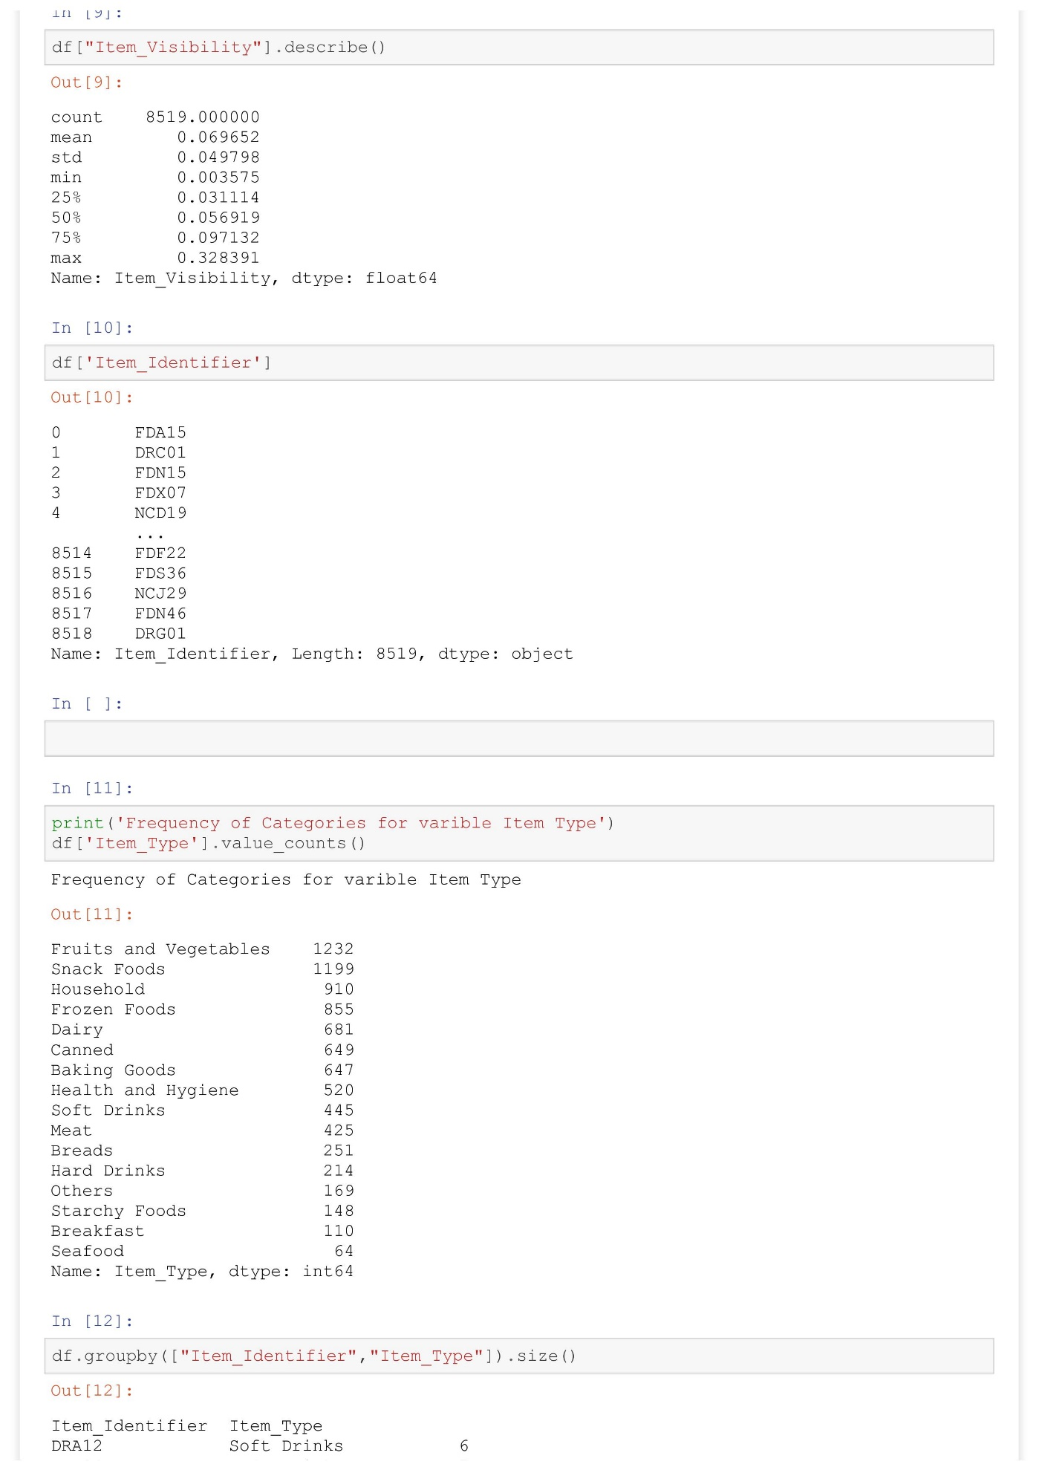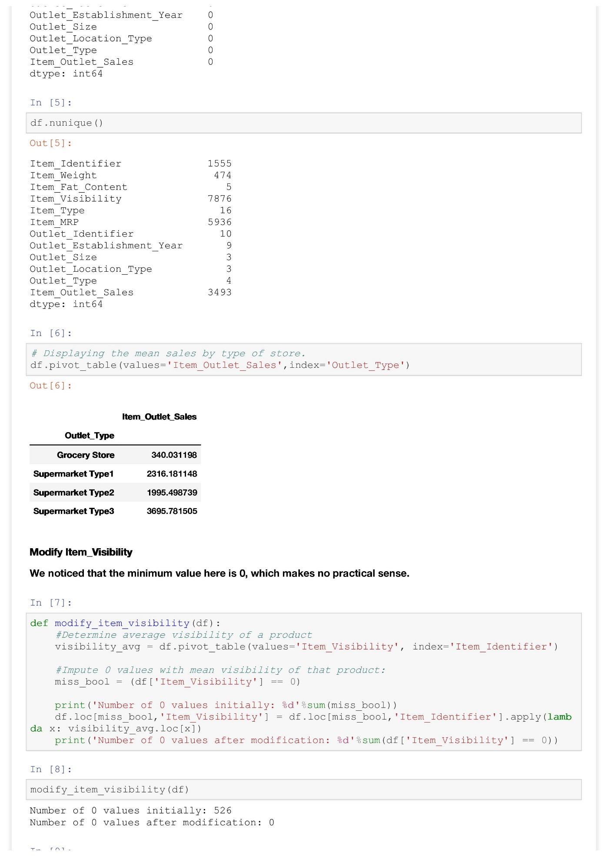

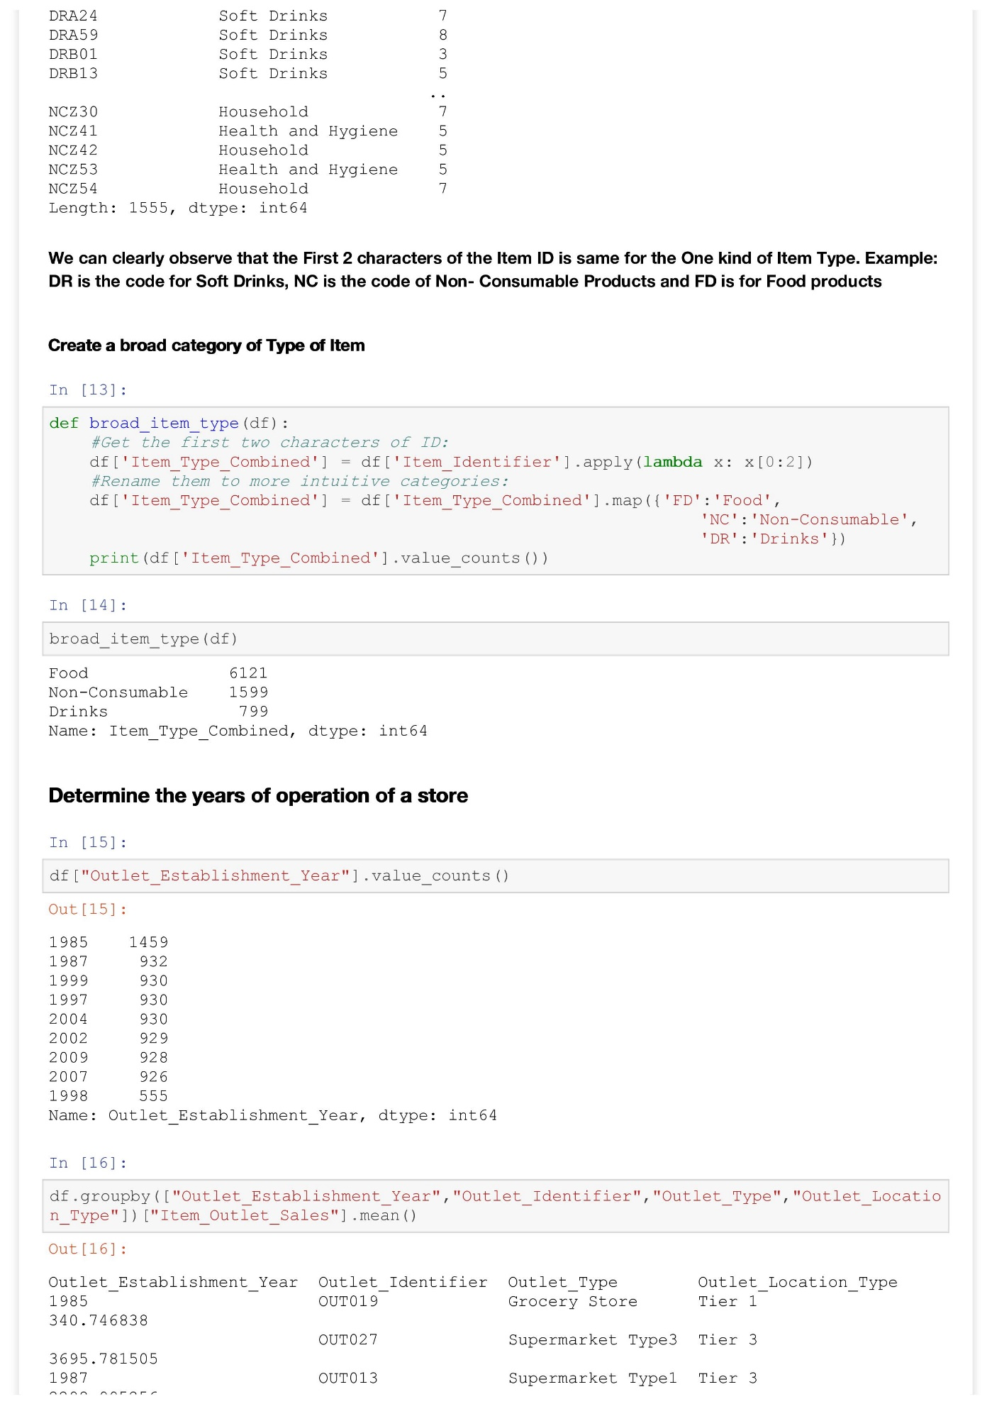

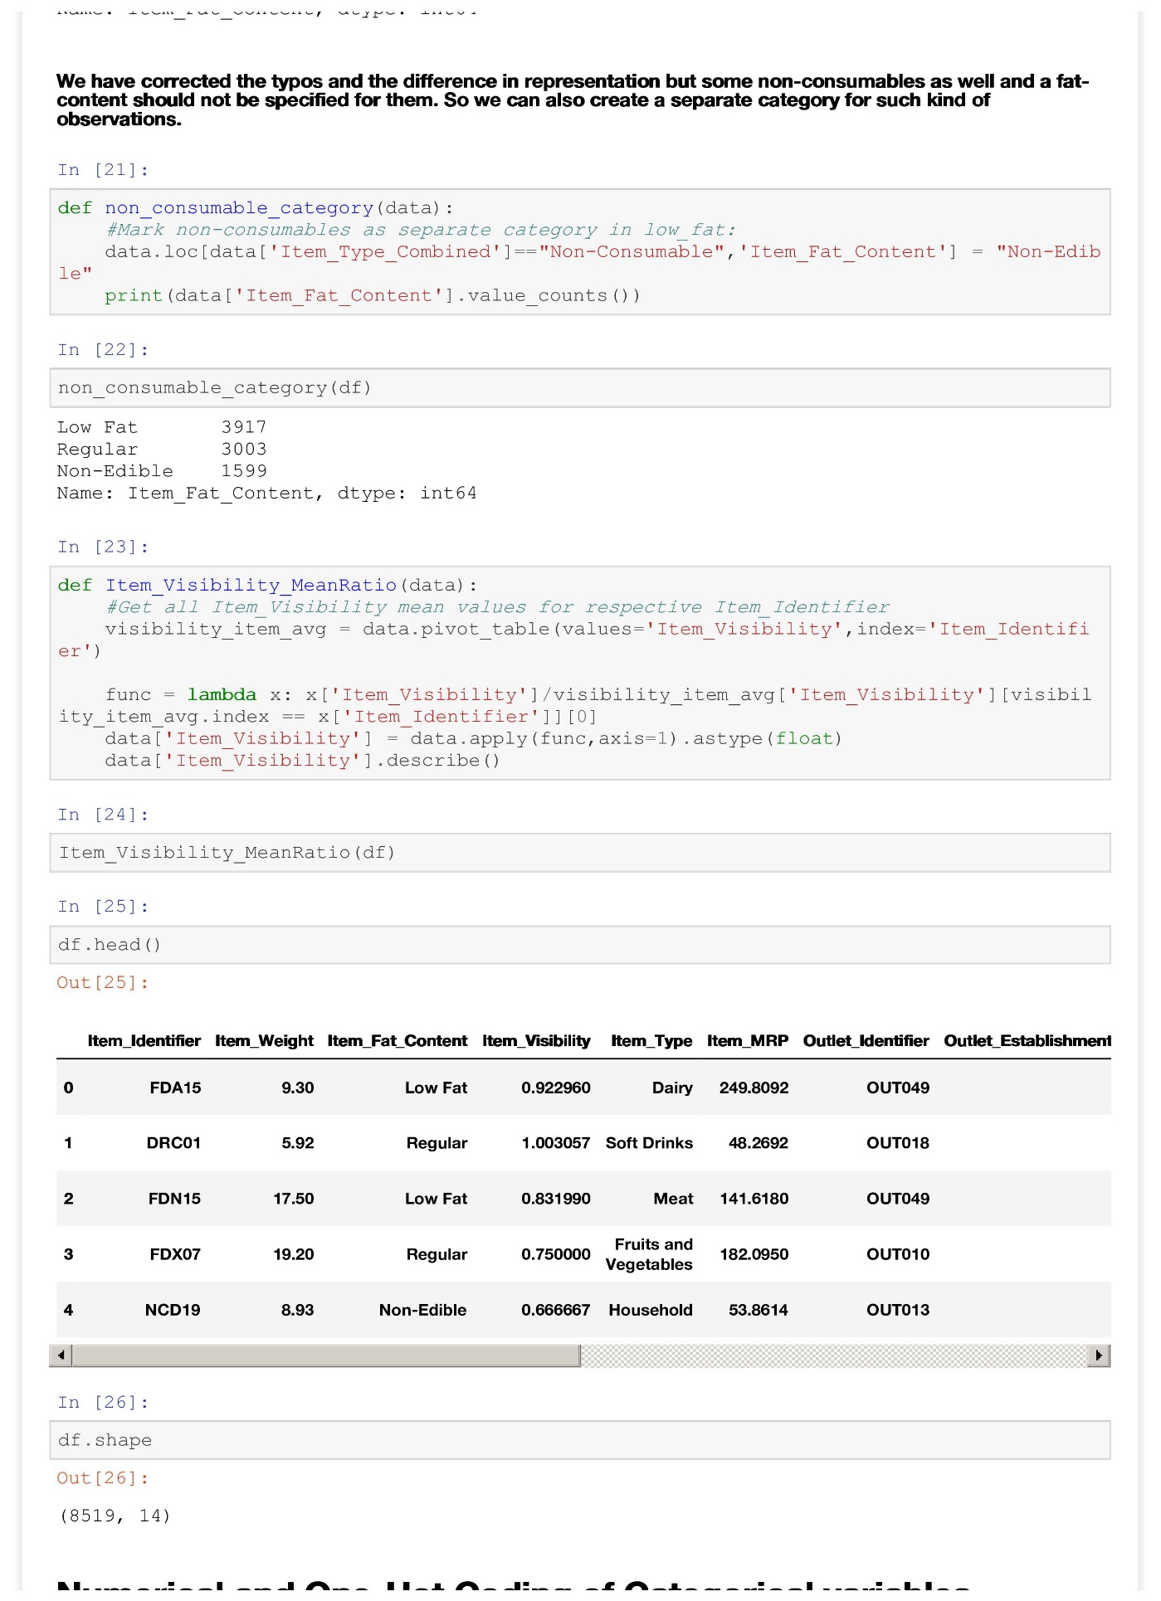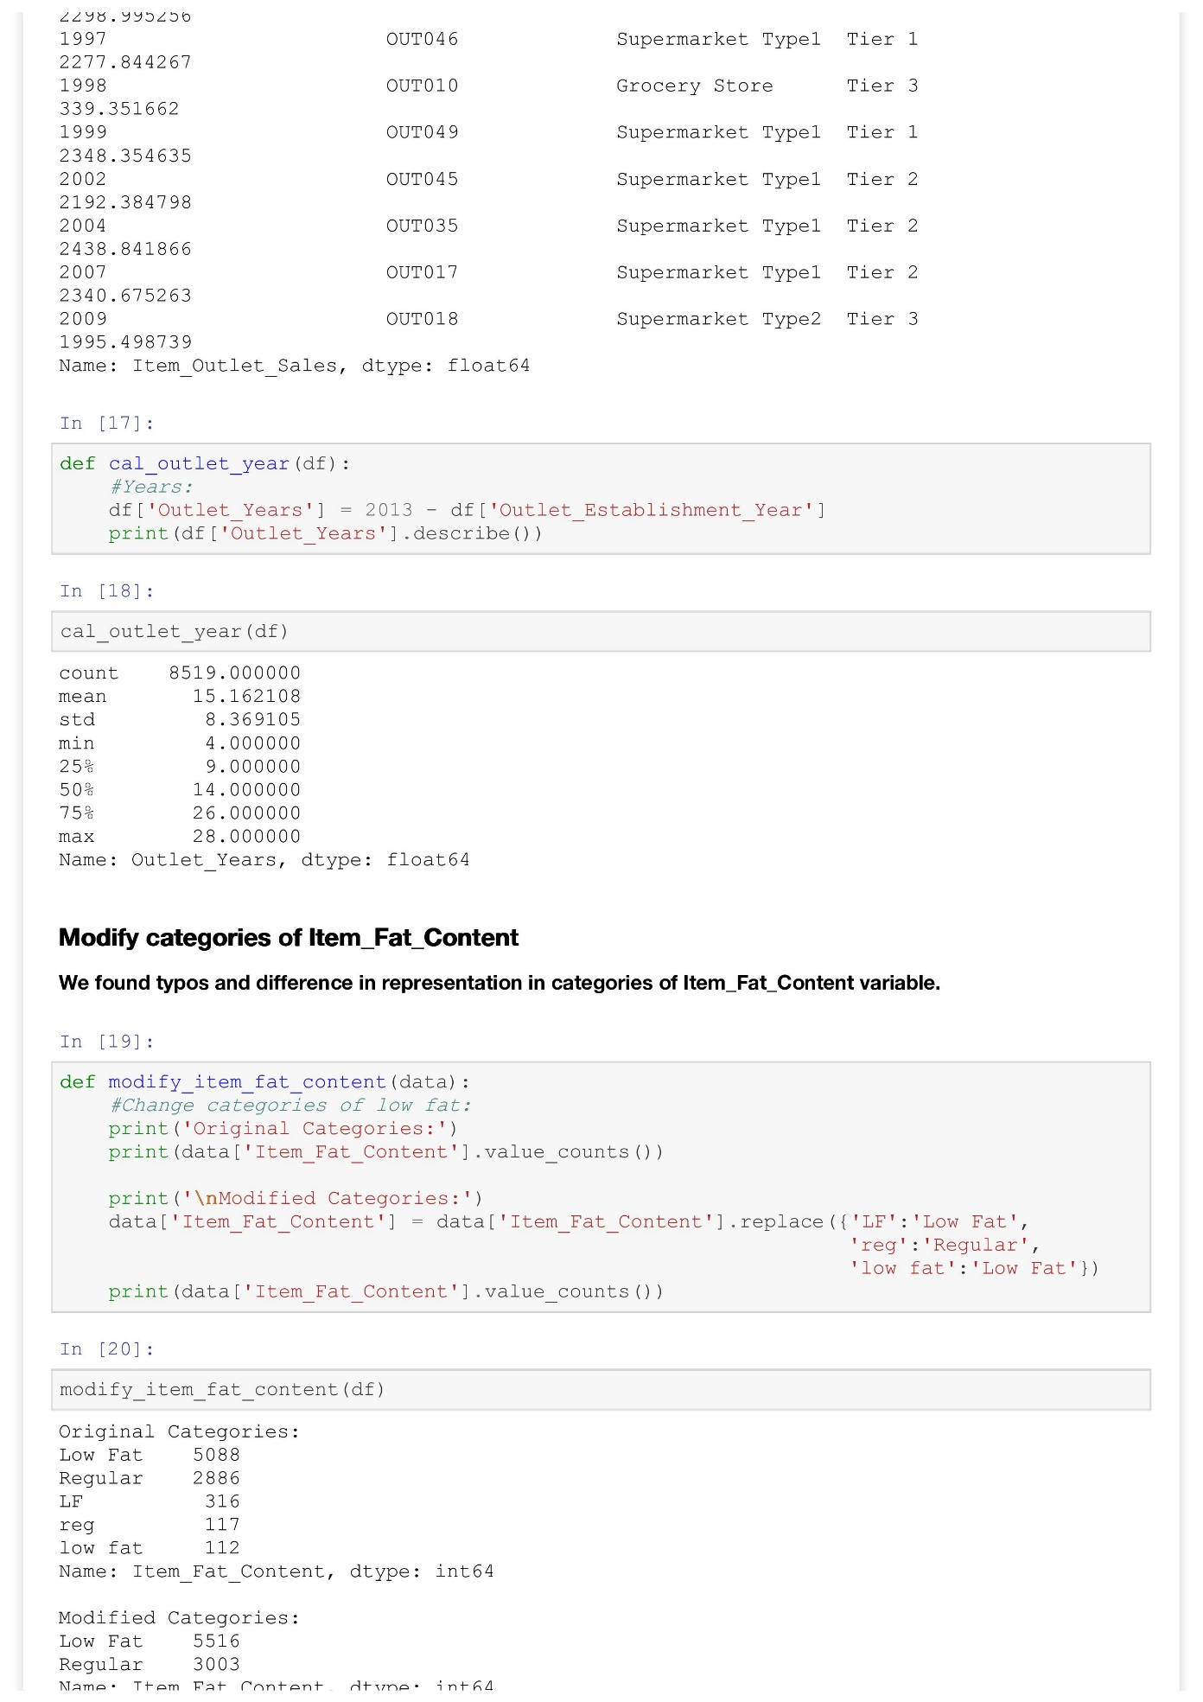

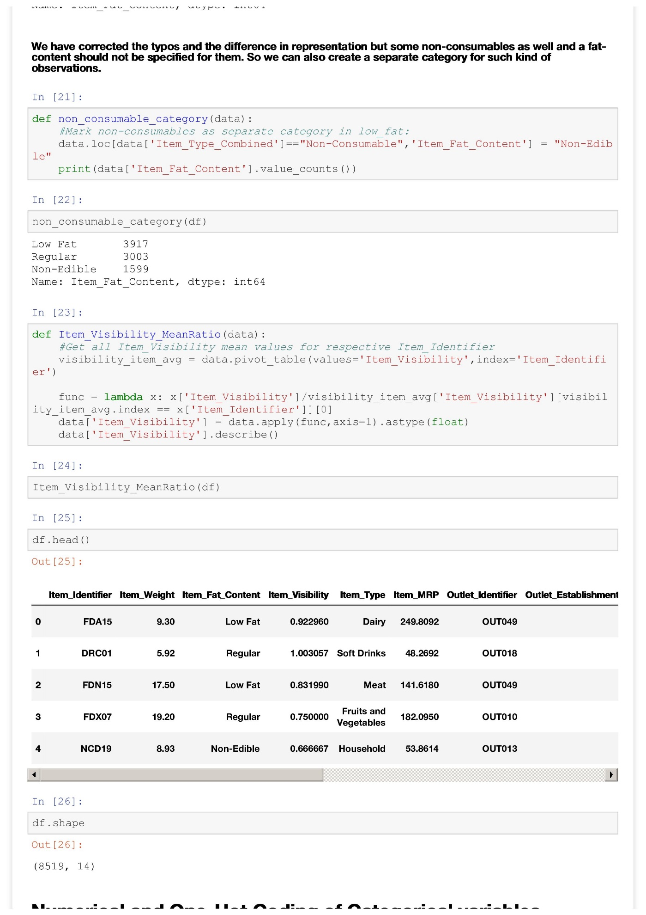

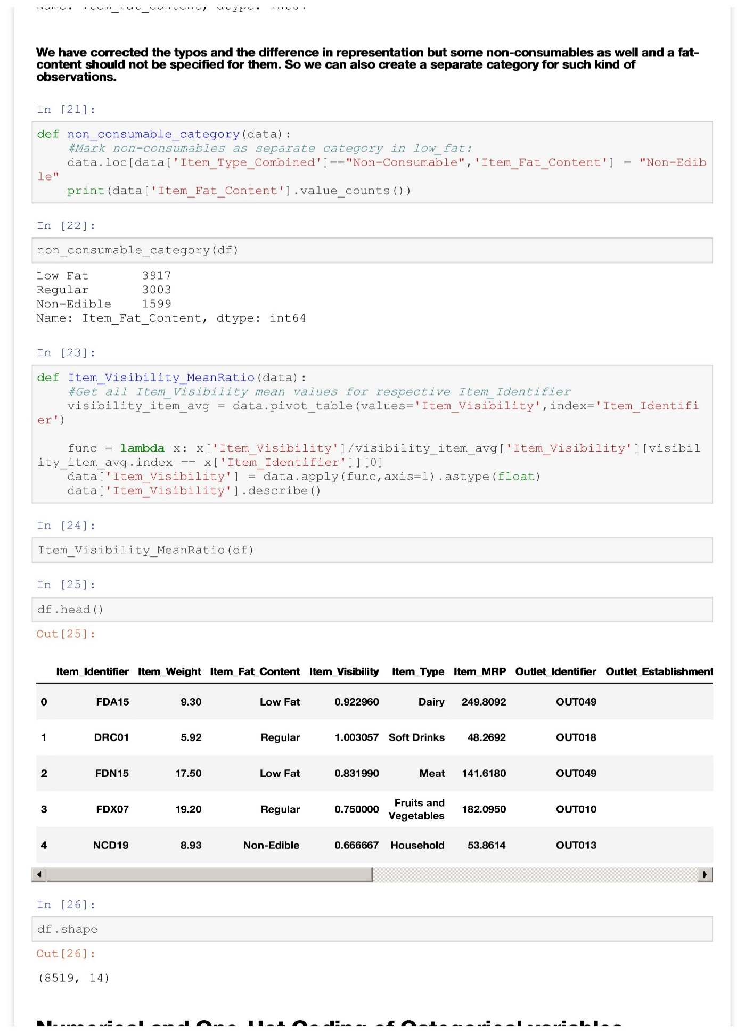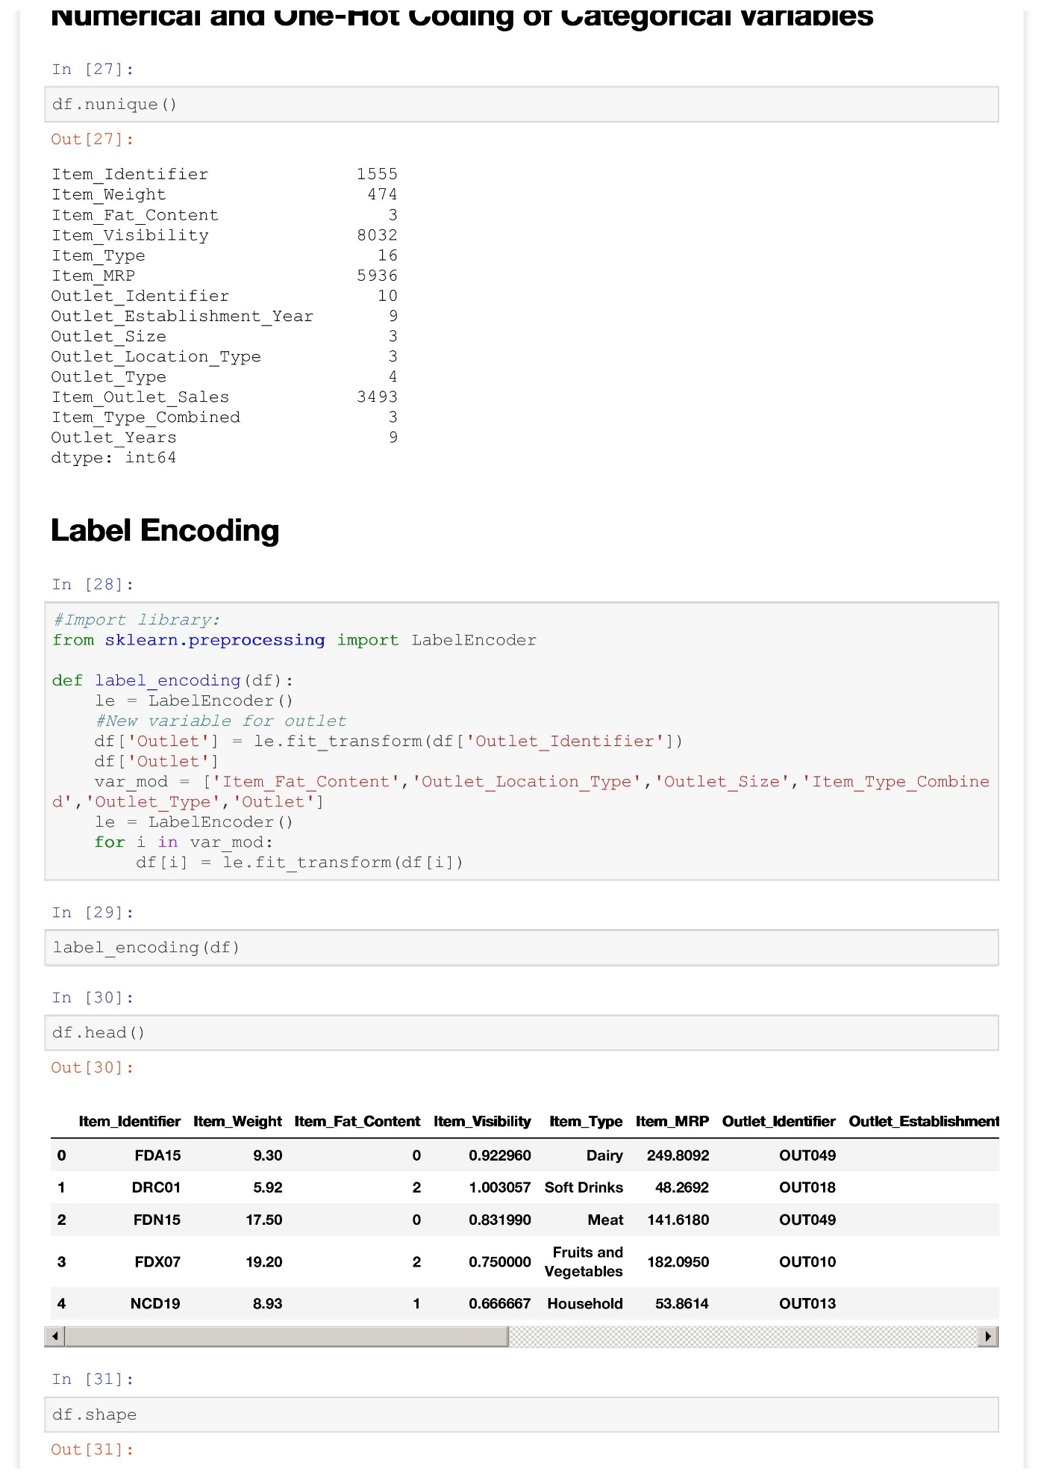

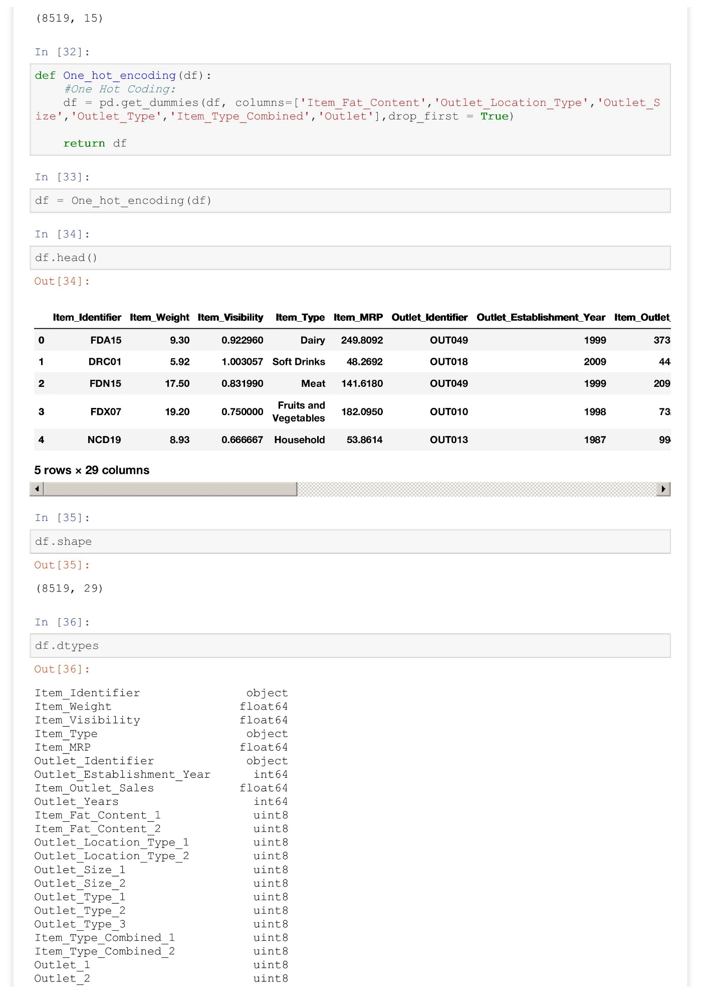

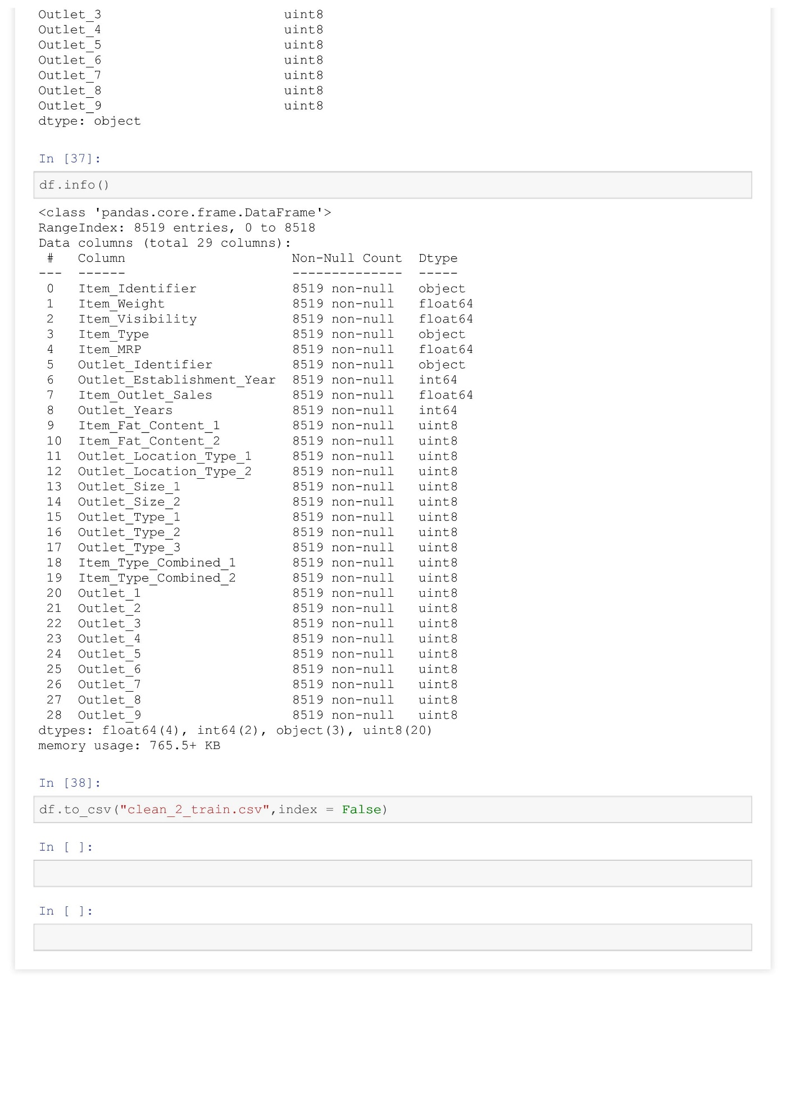

**Fitting a Linear Regression Model**

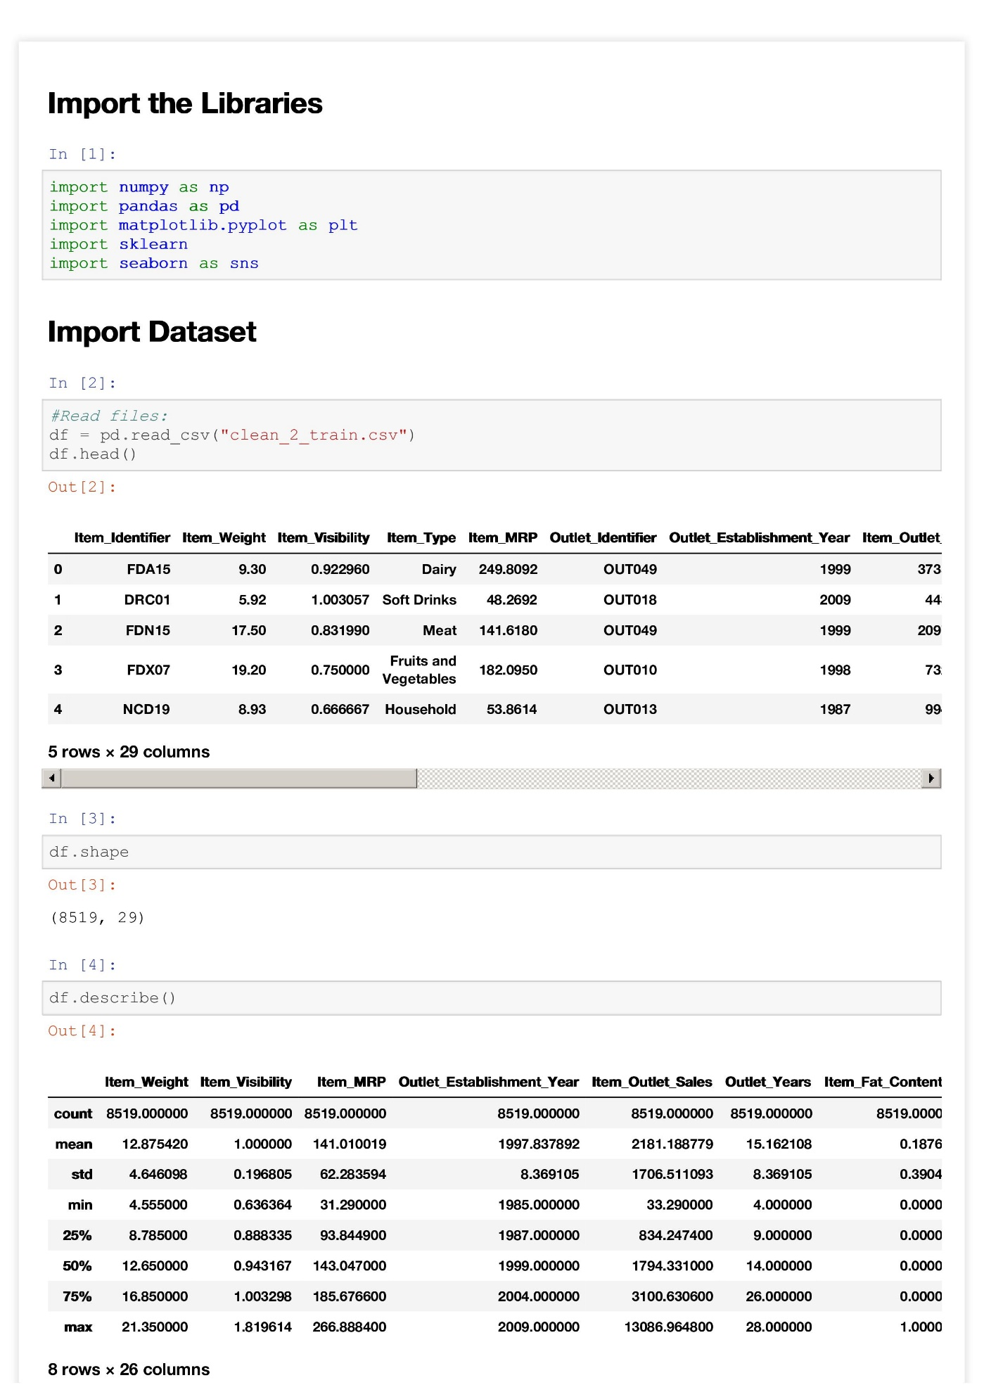

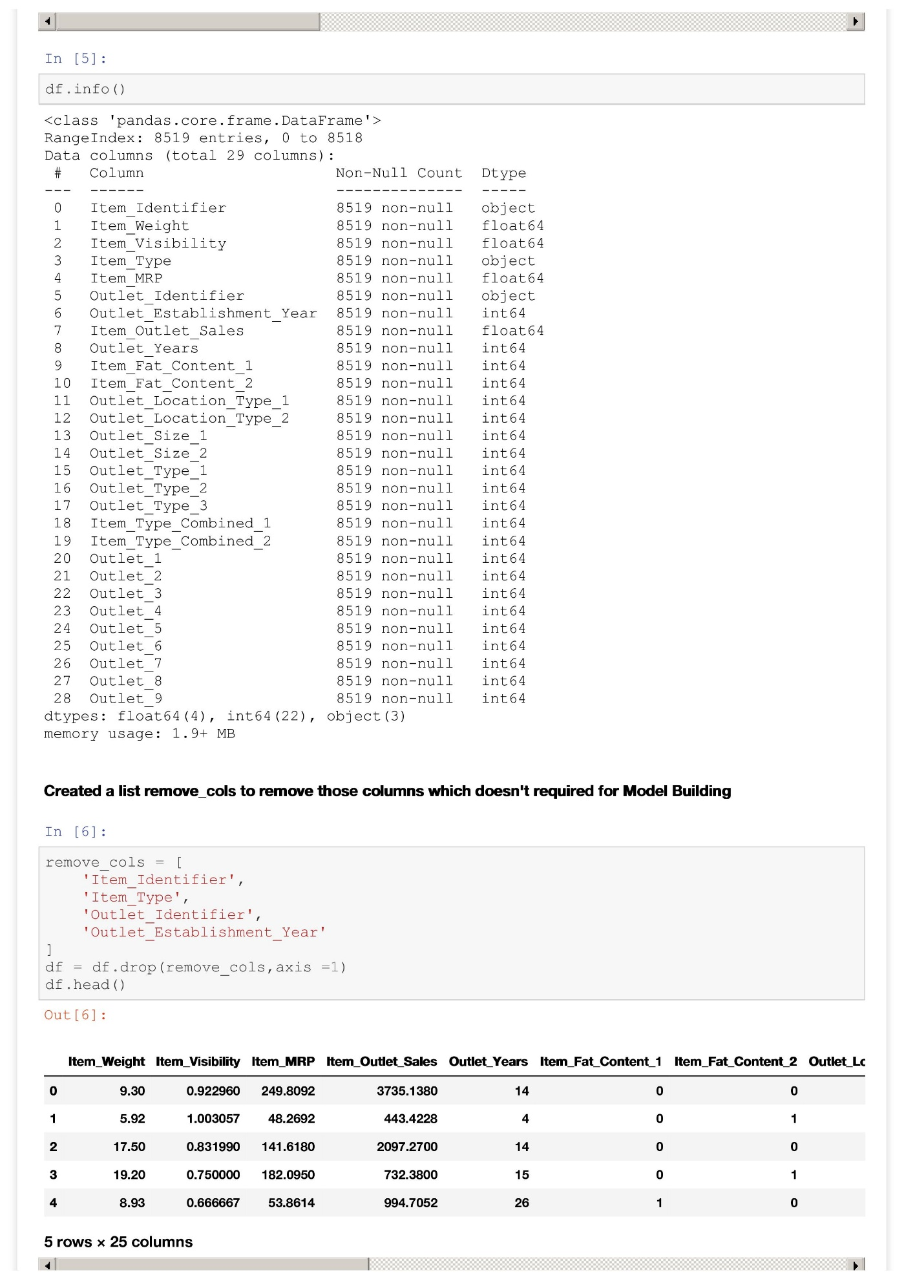

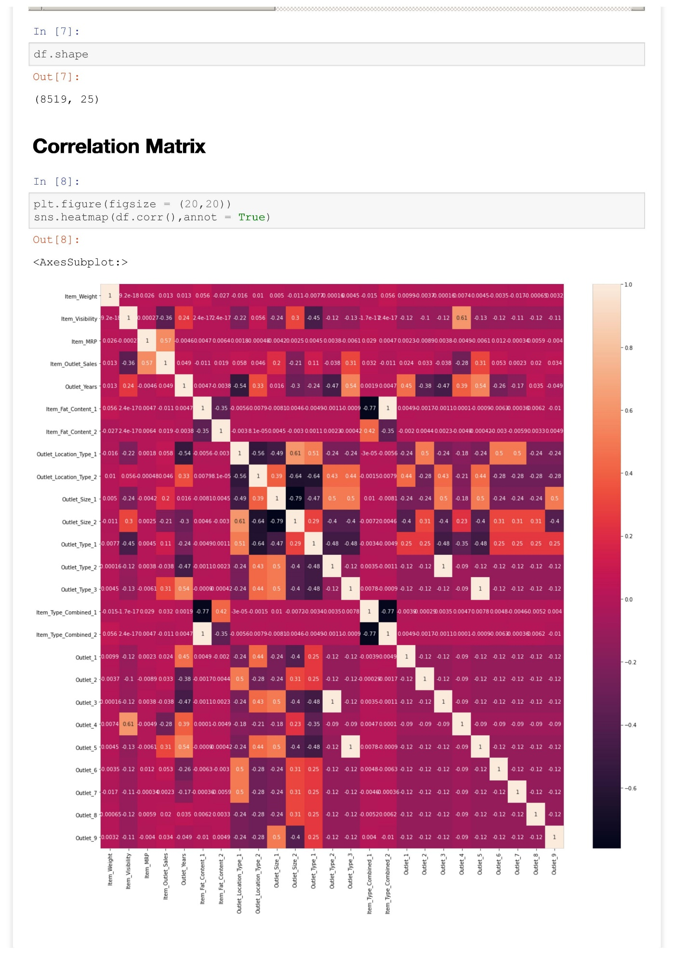

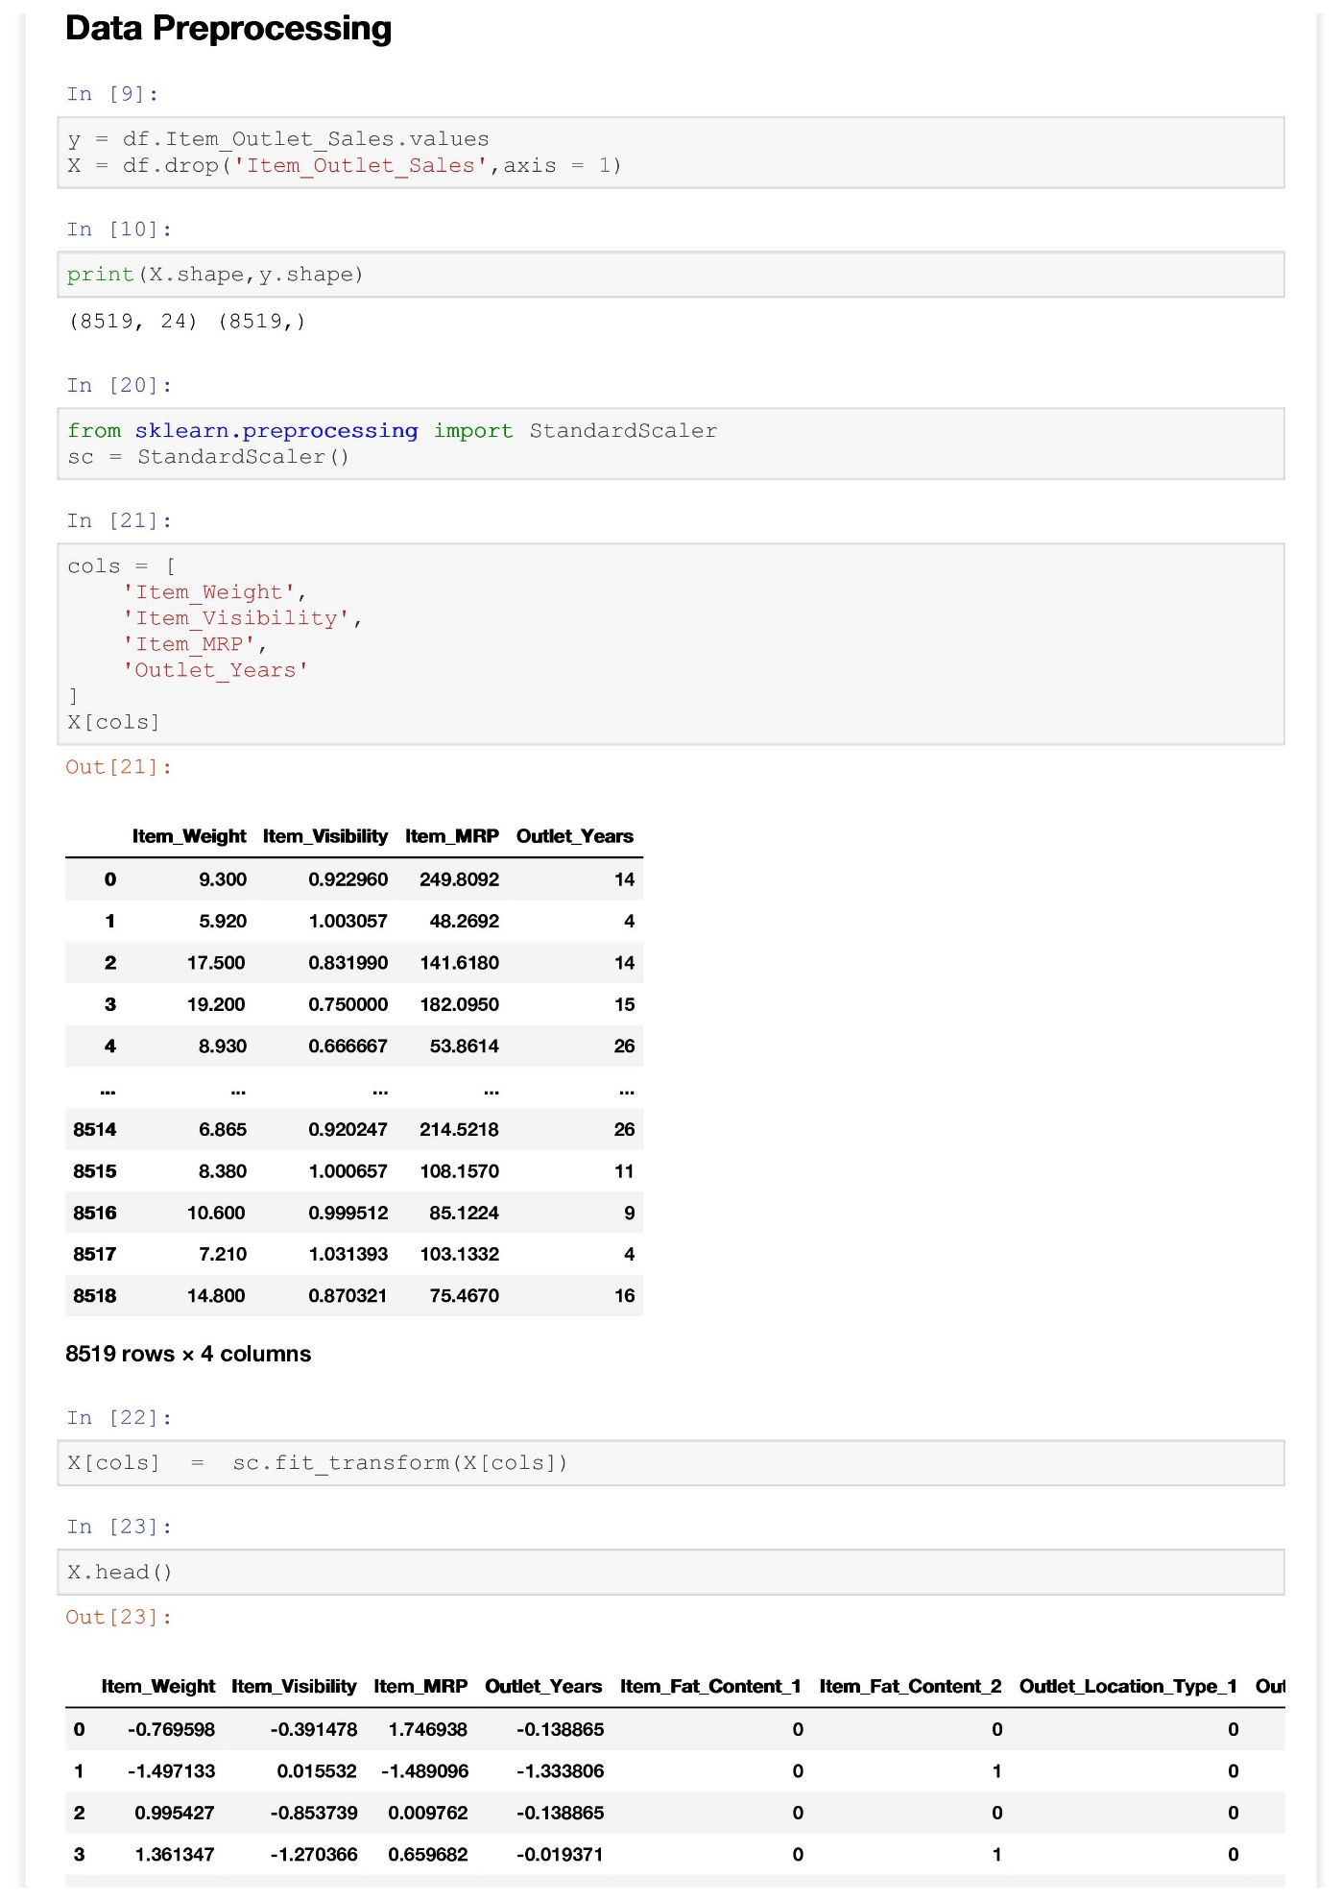

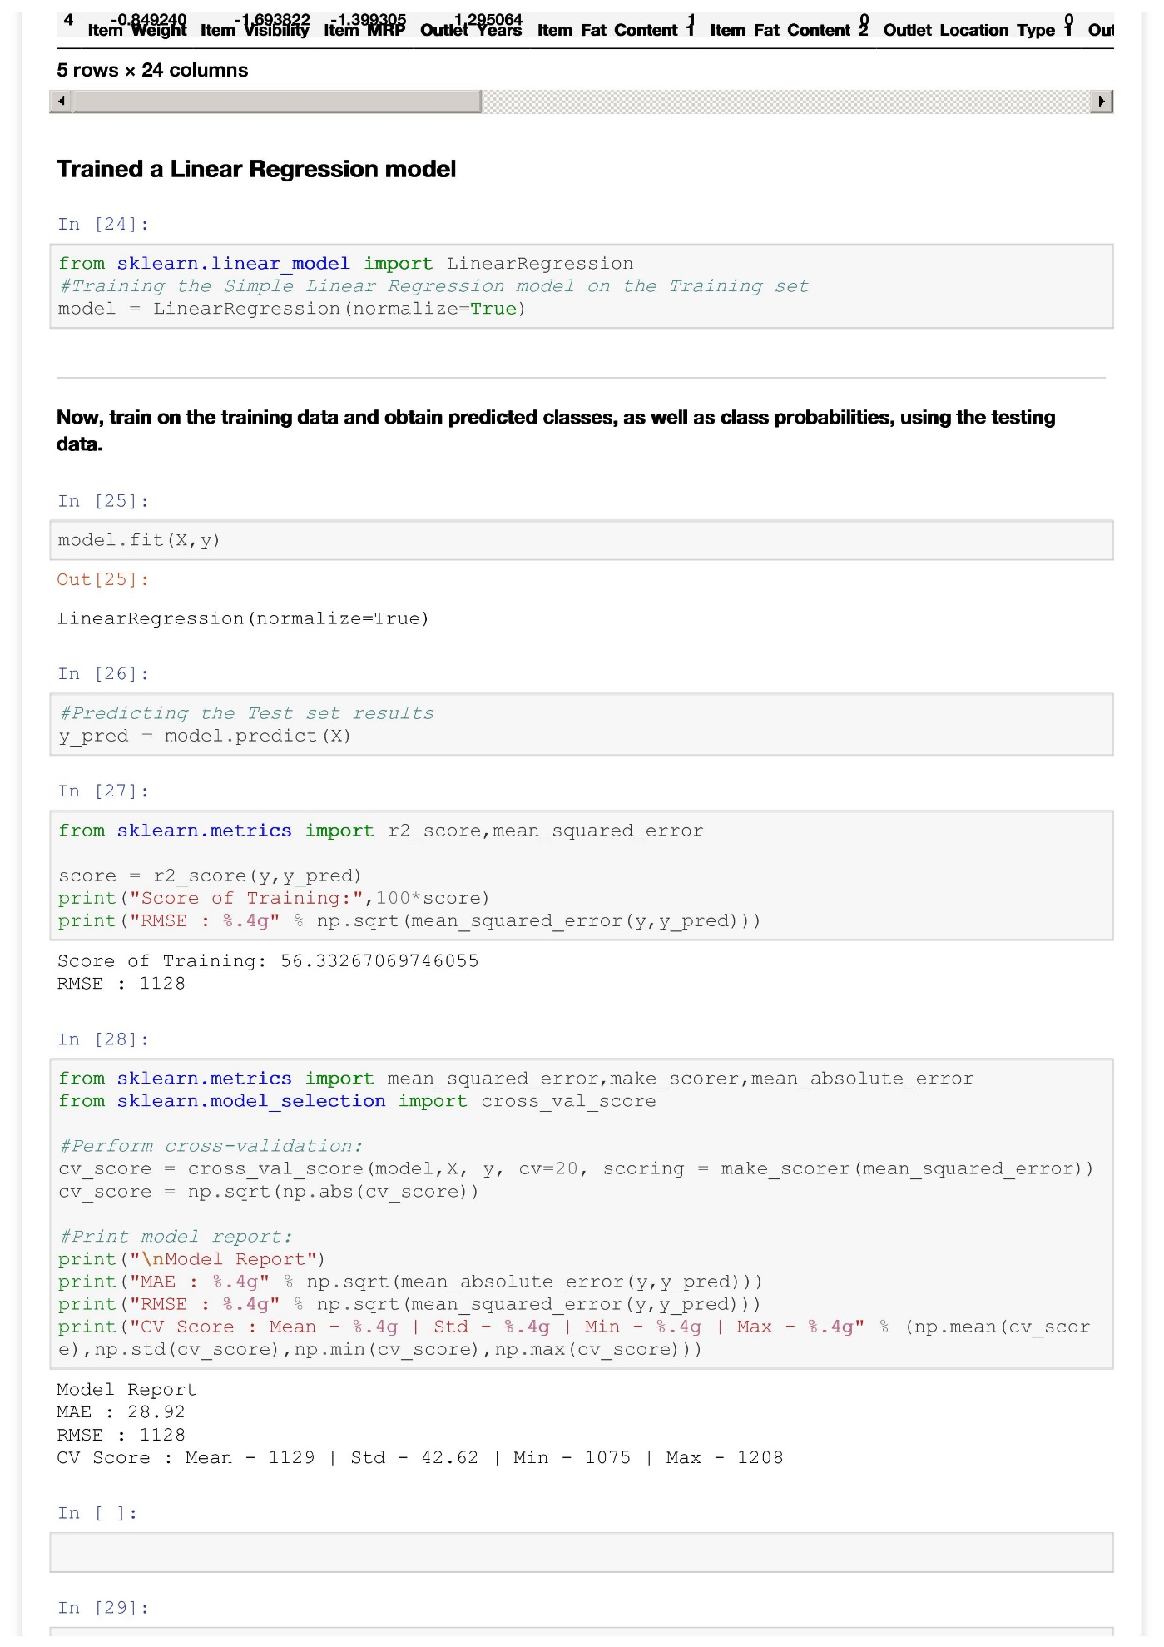

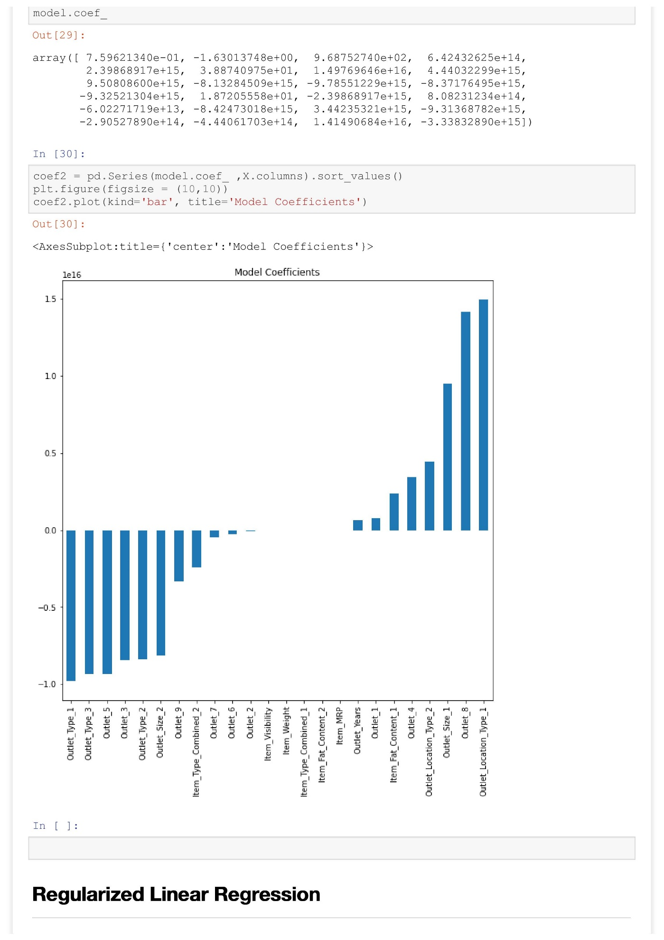

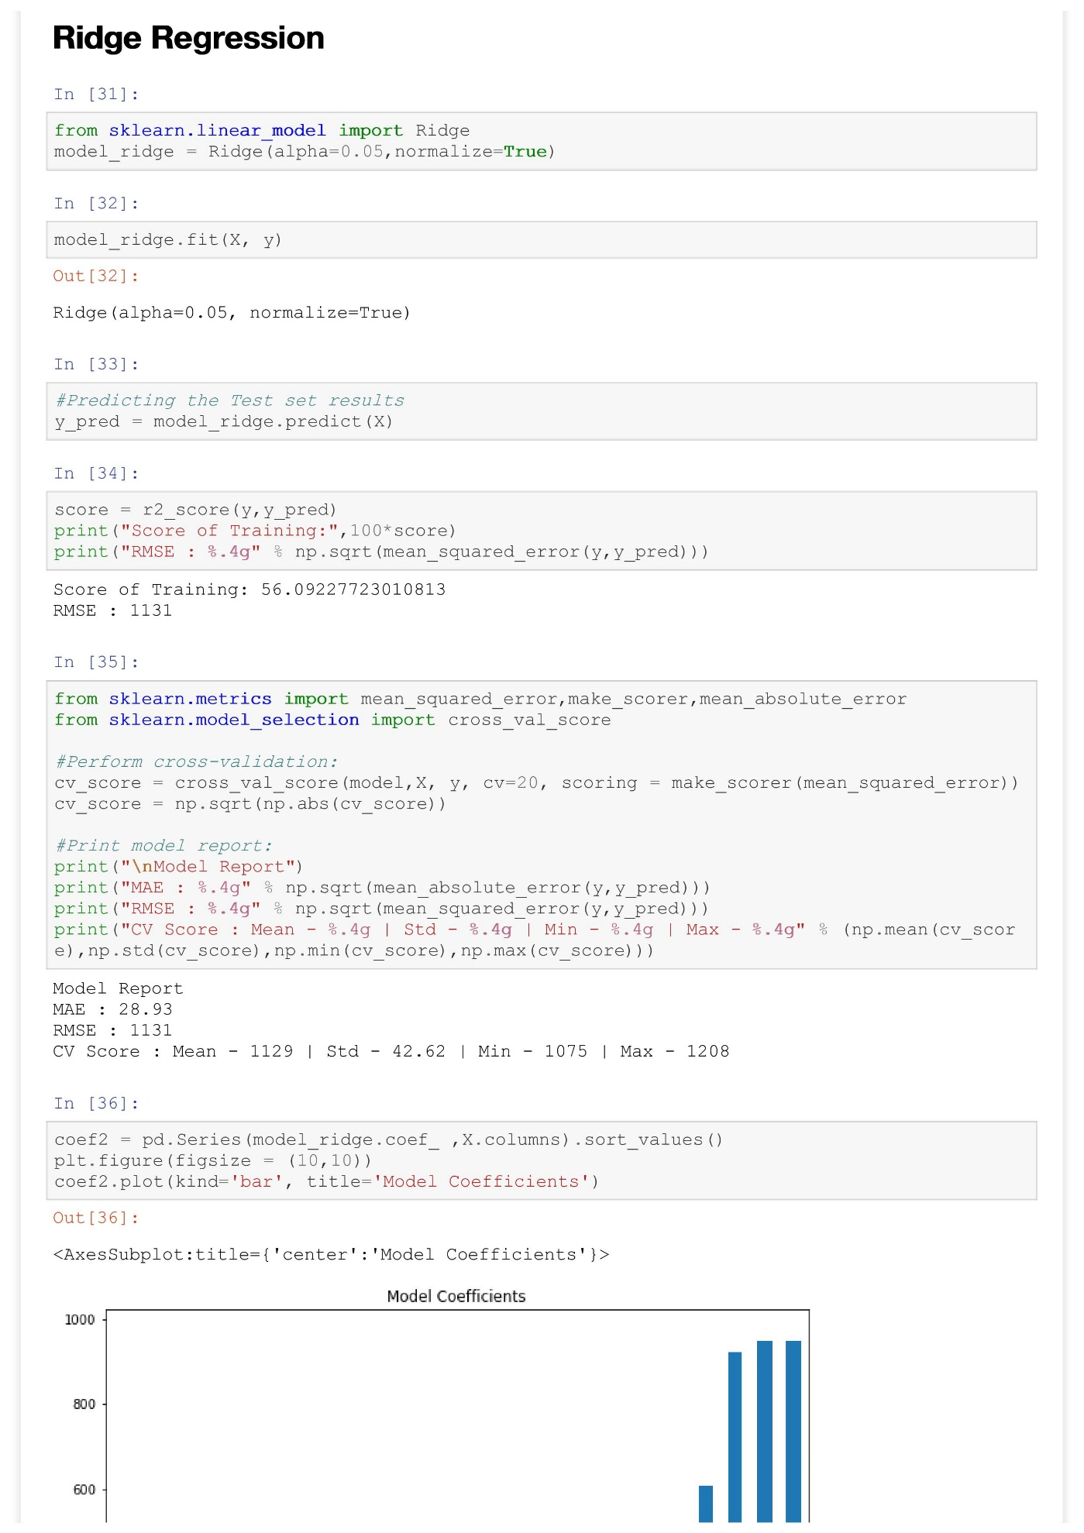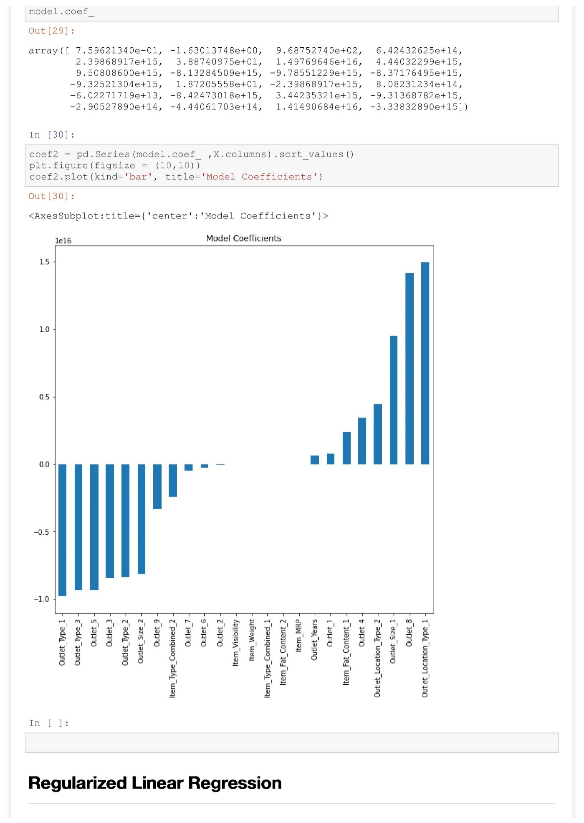

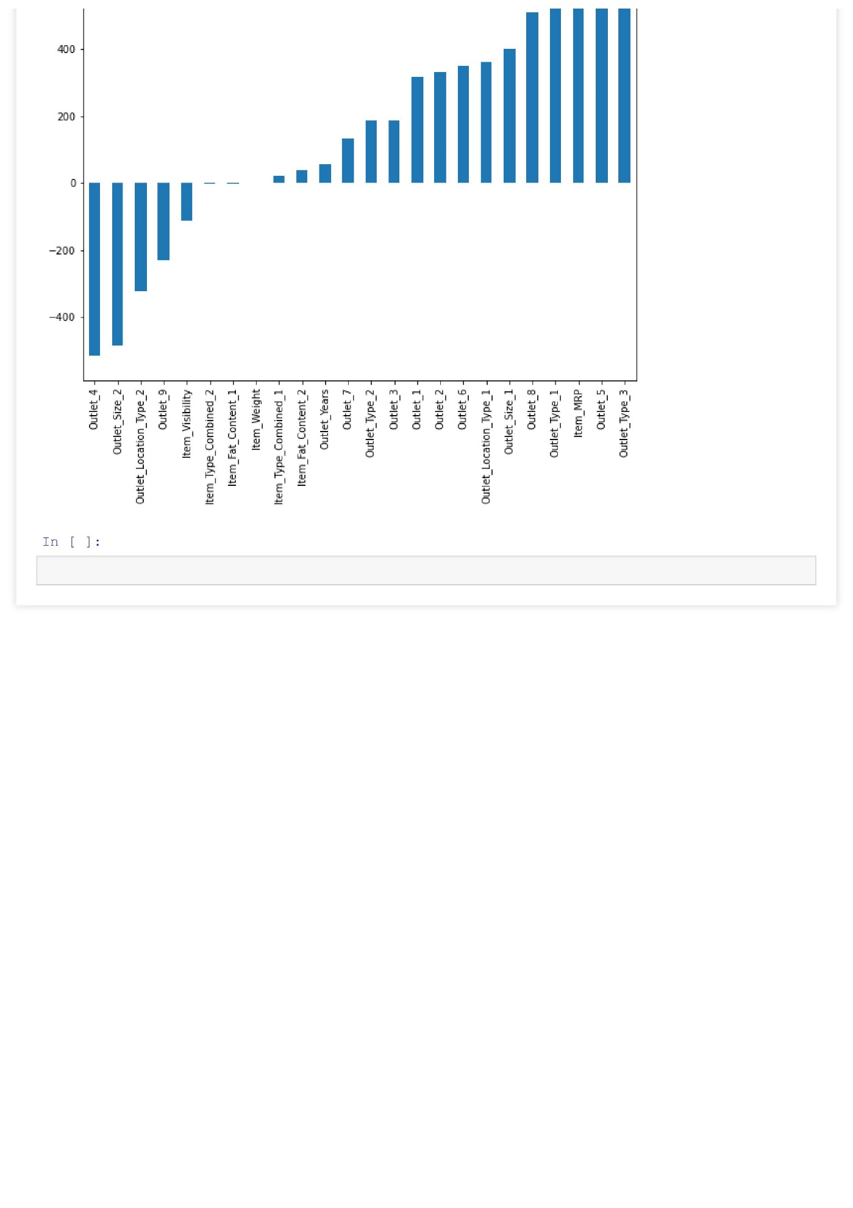

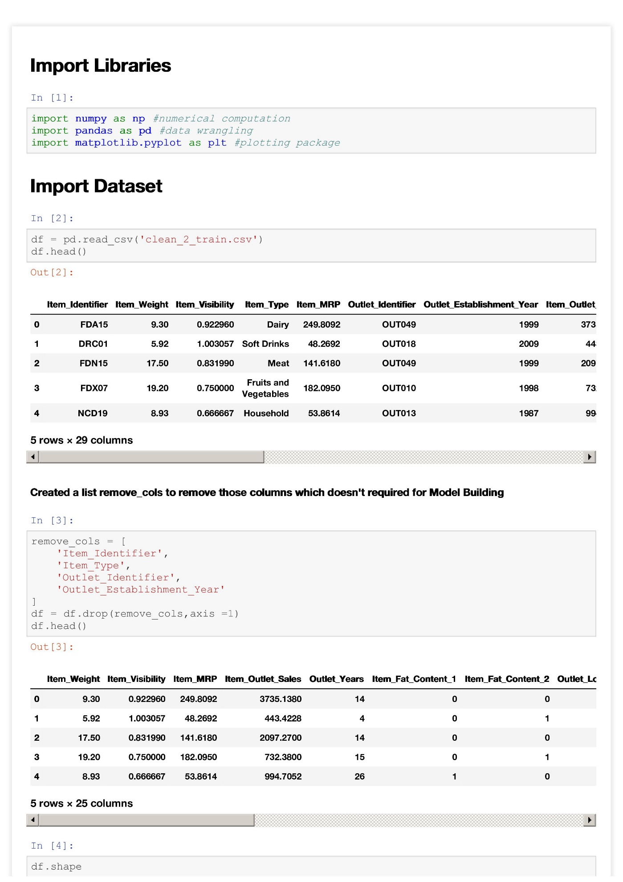**Decision Tree Regression Mod**

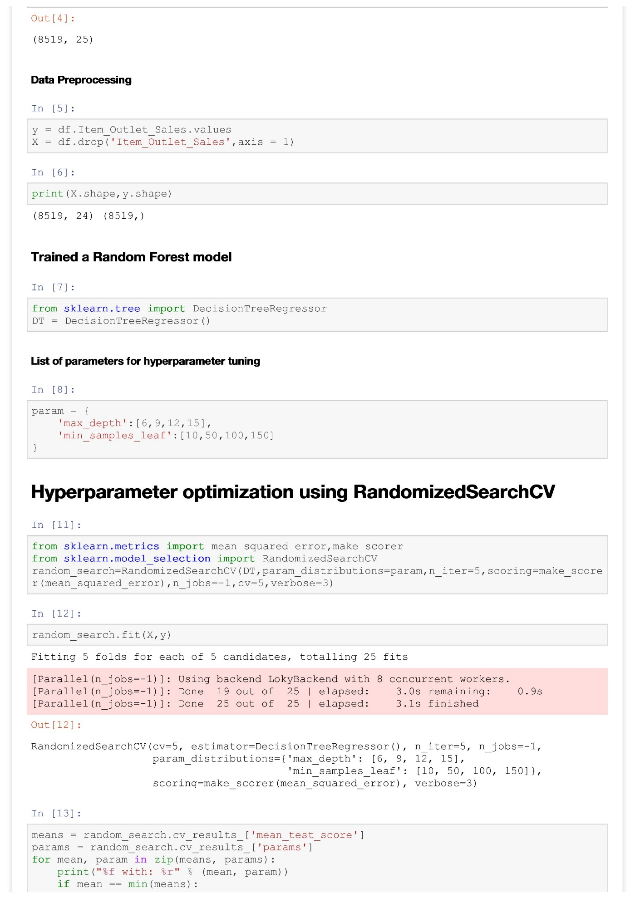

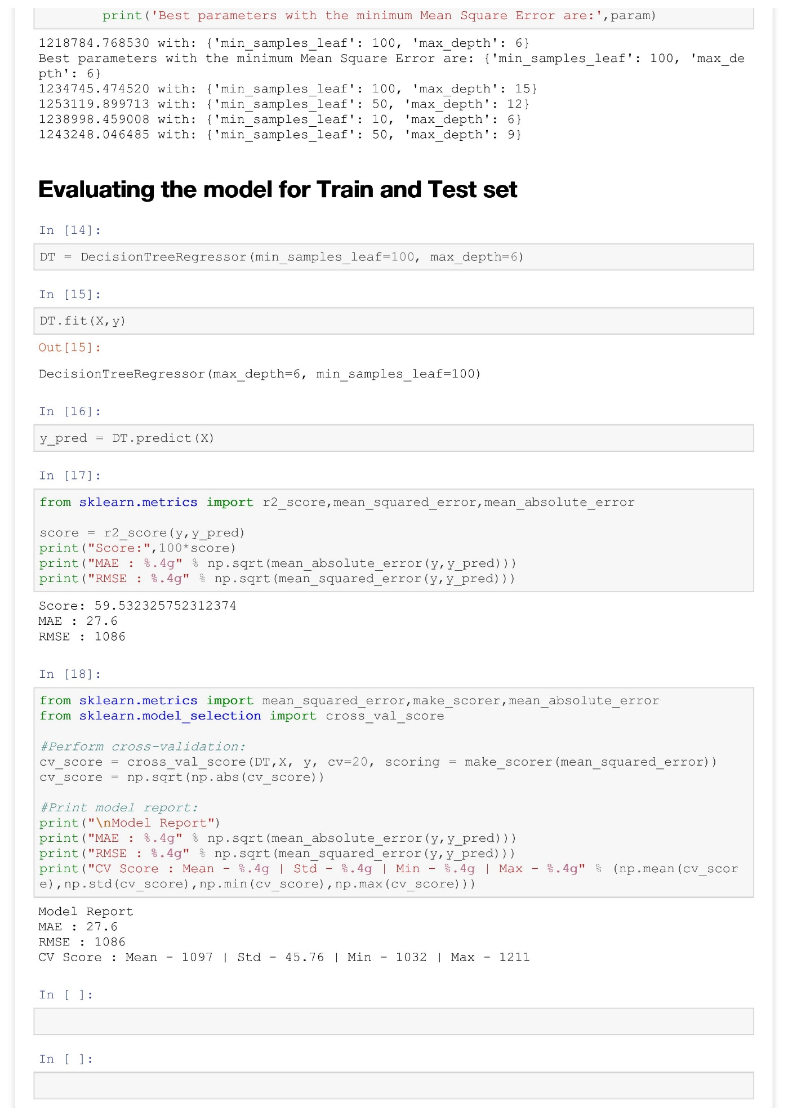

**Random Forest Regression Model**



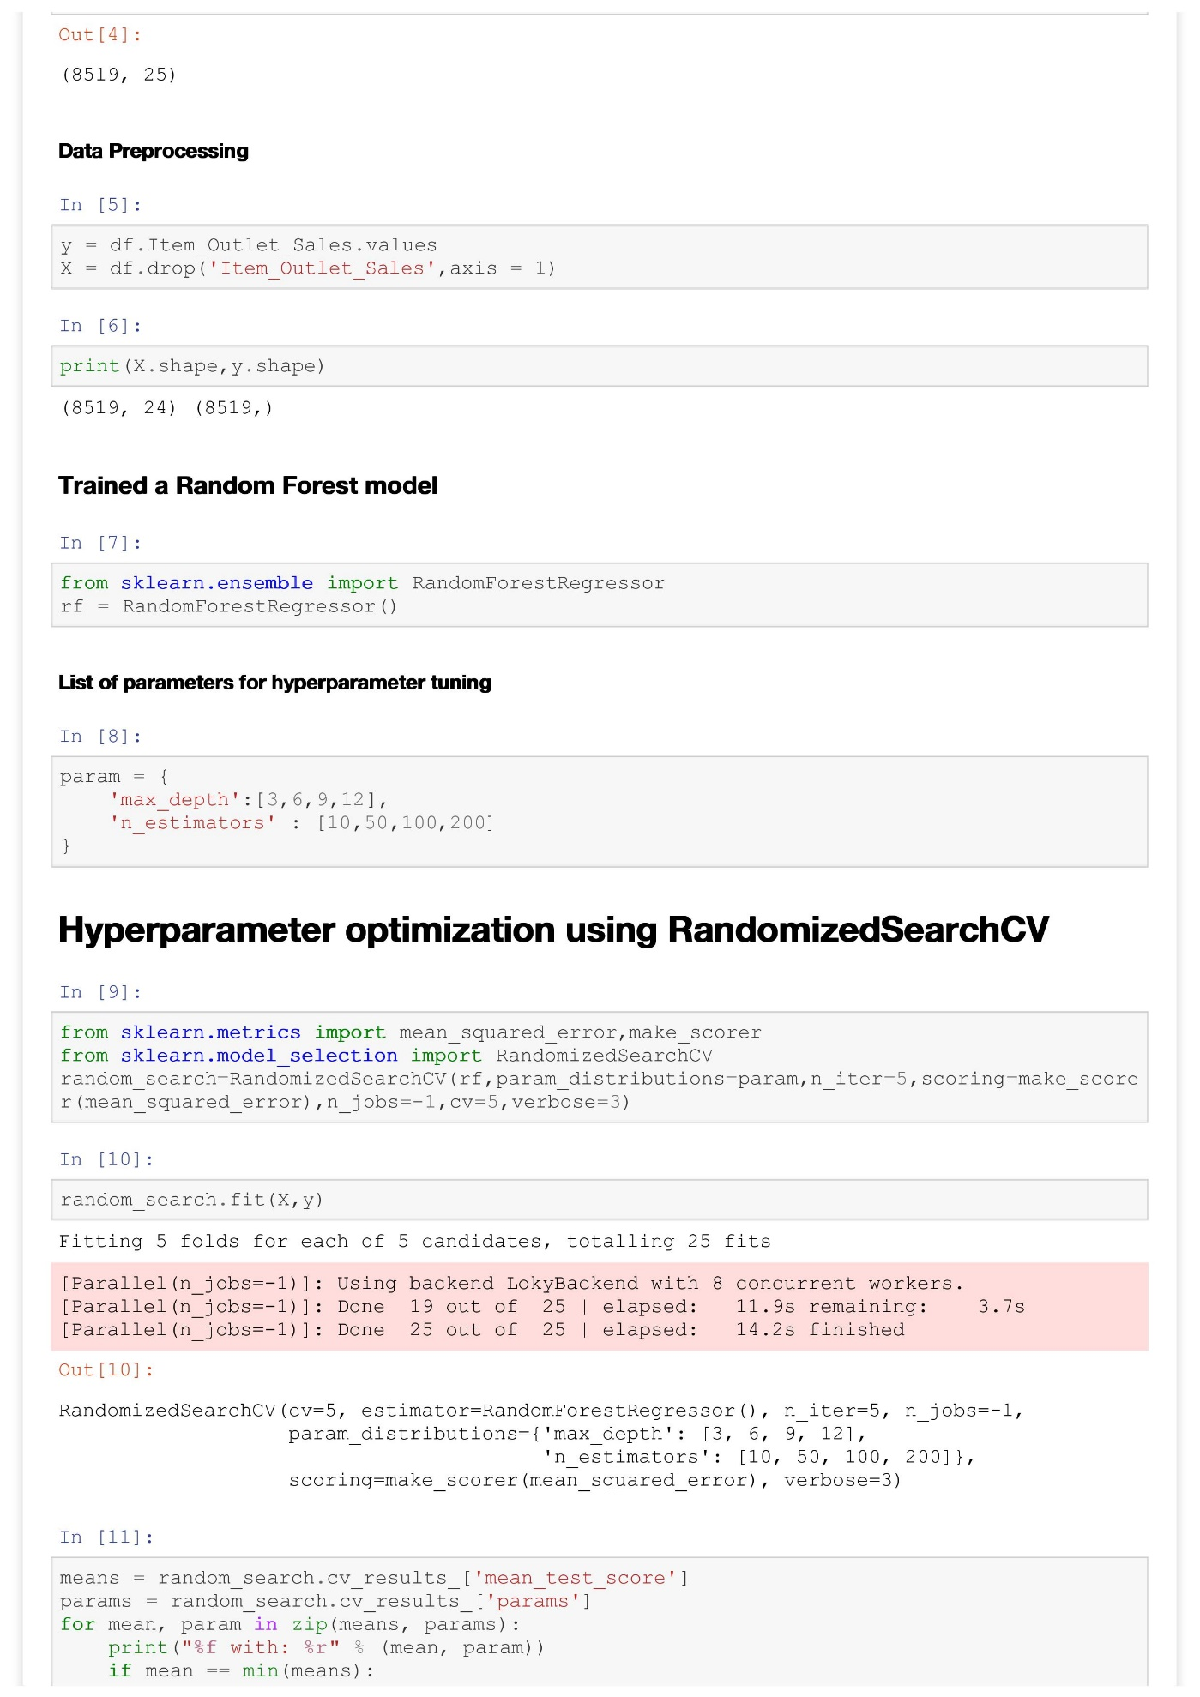

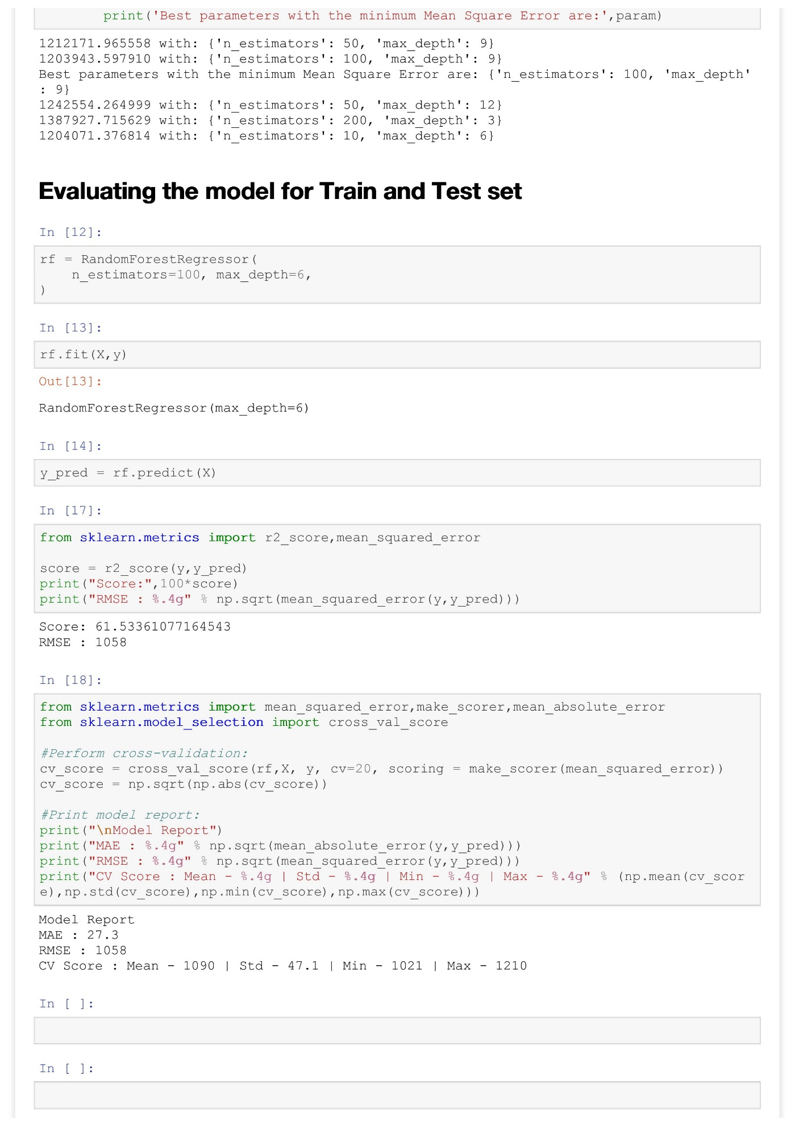

**XGBoost Regression Model**

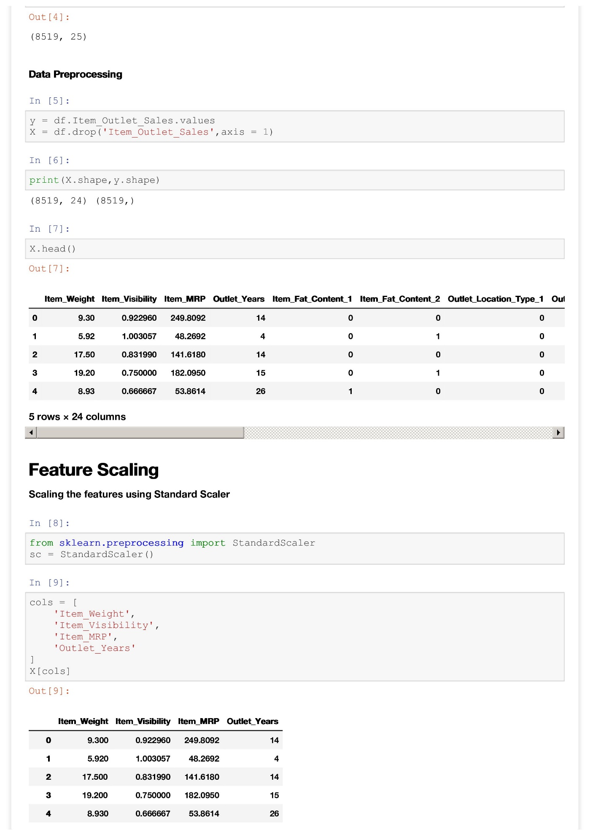

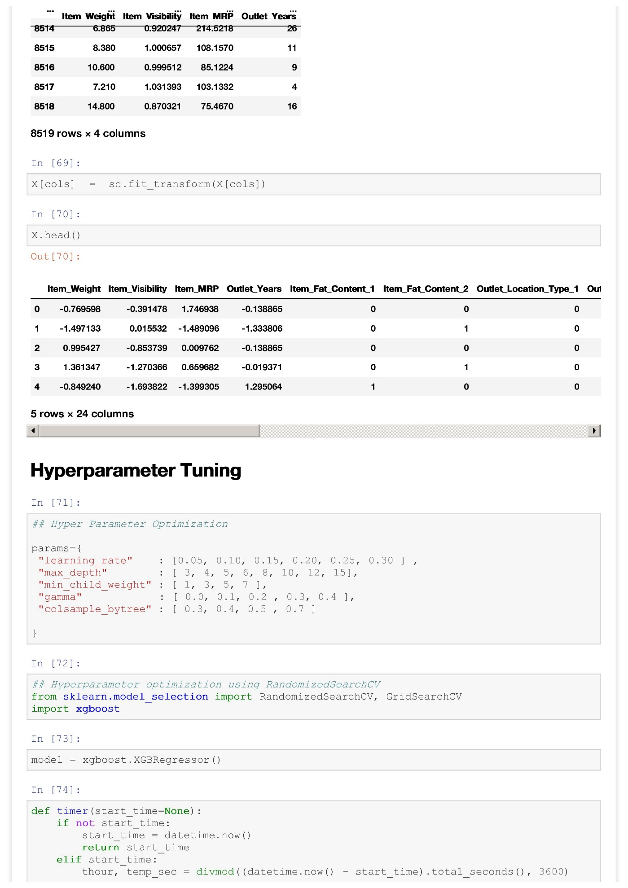

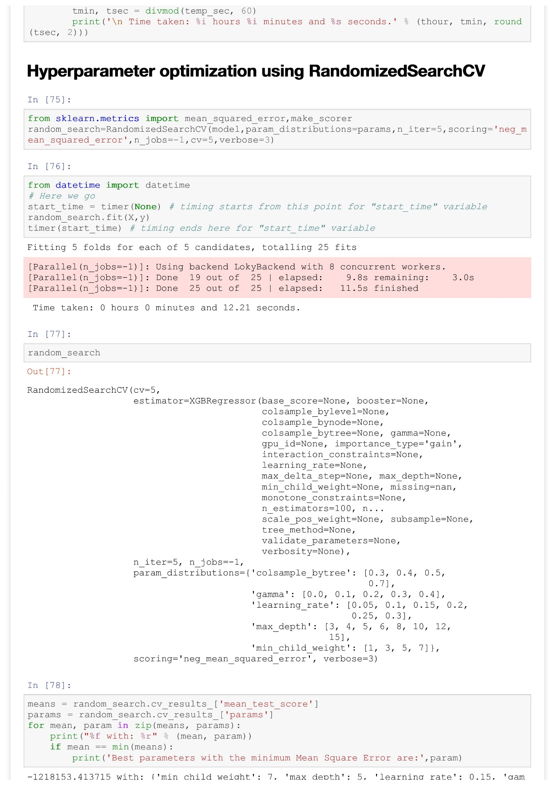

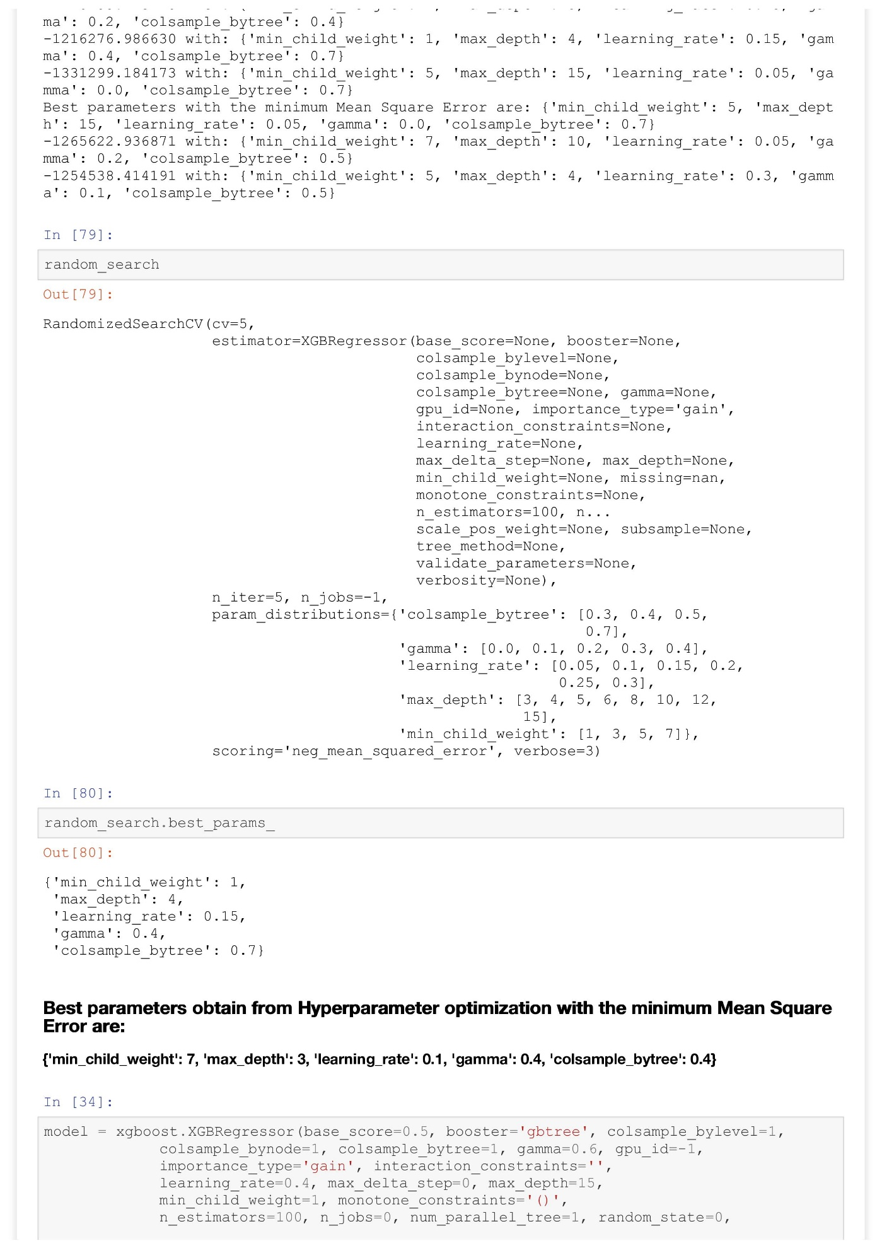

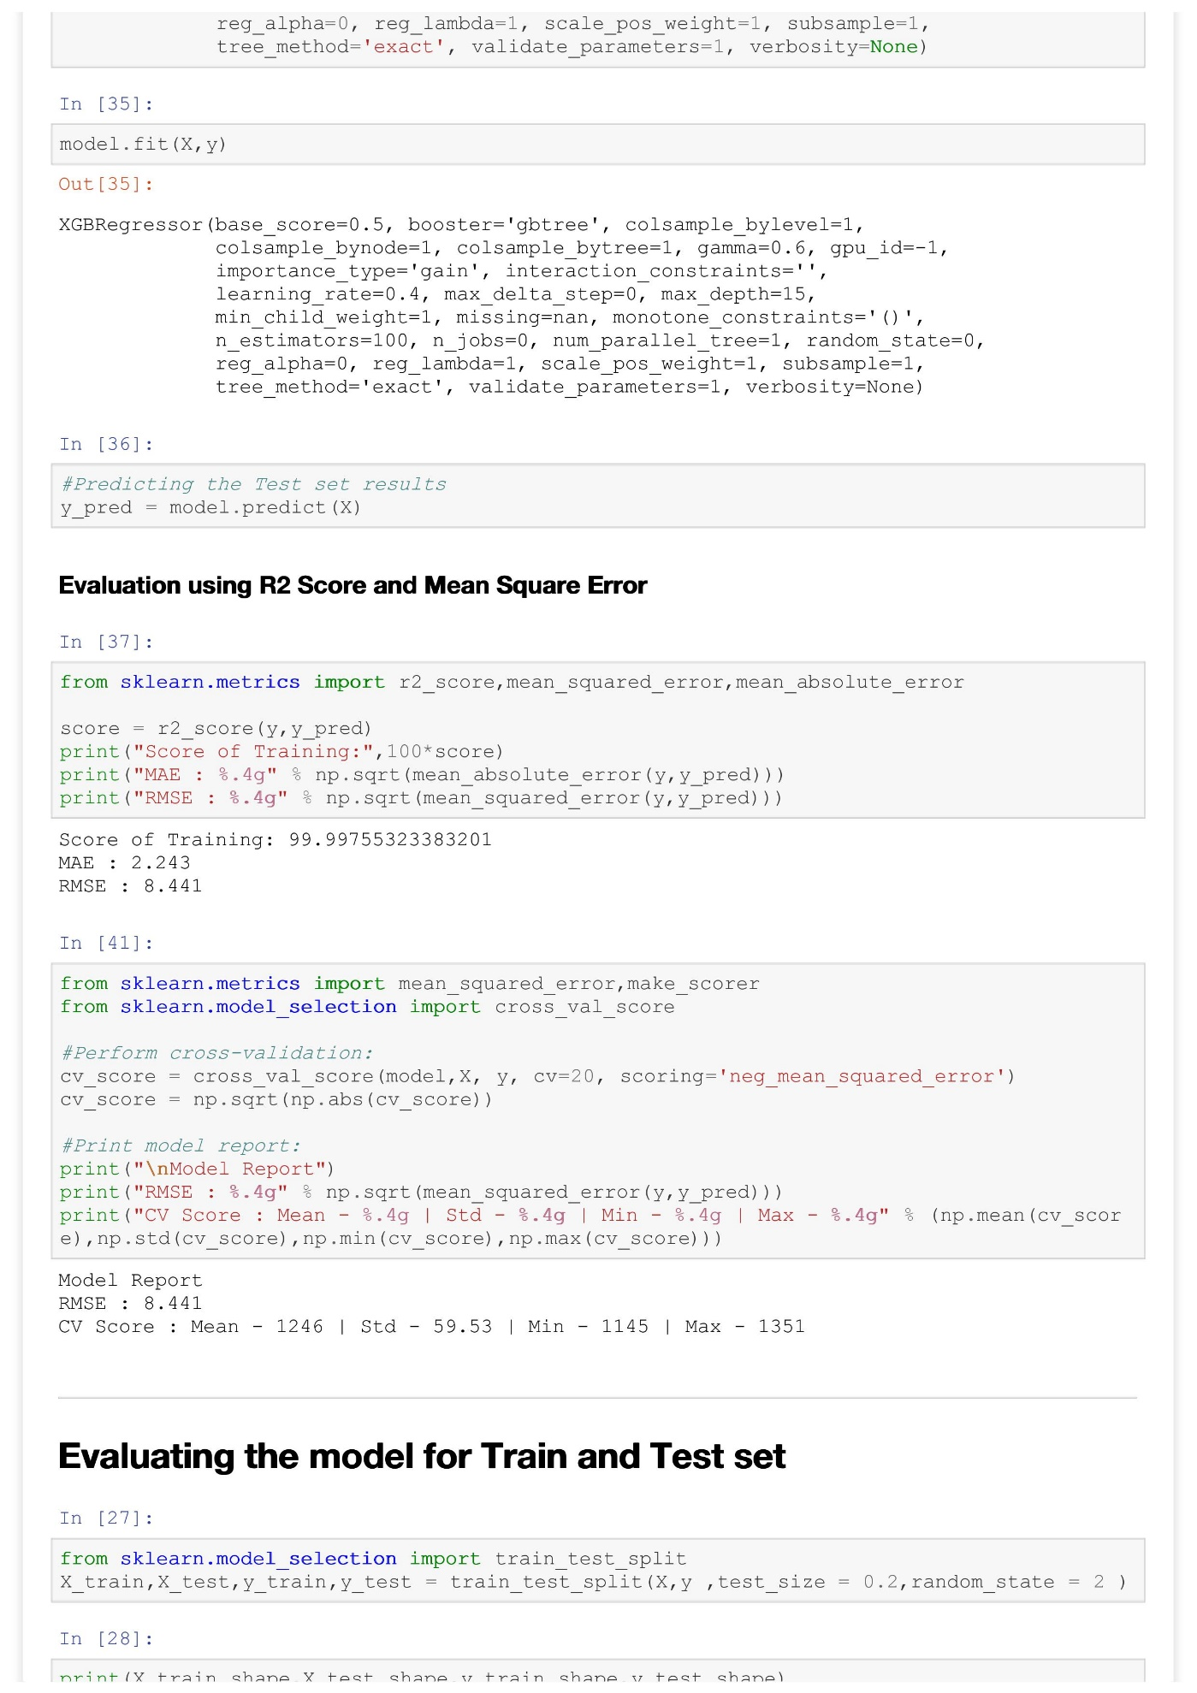

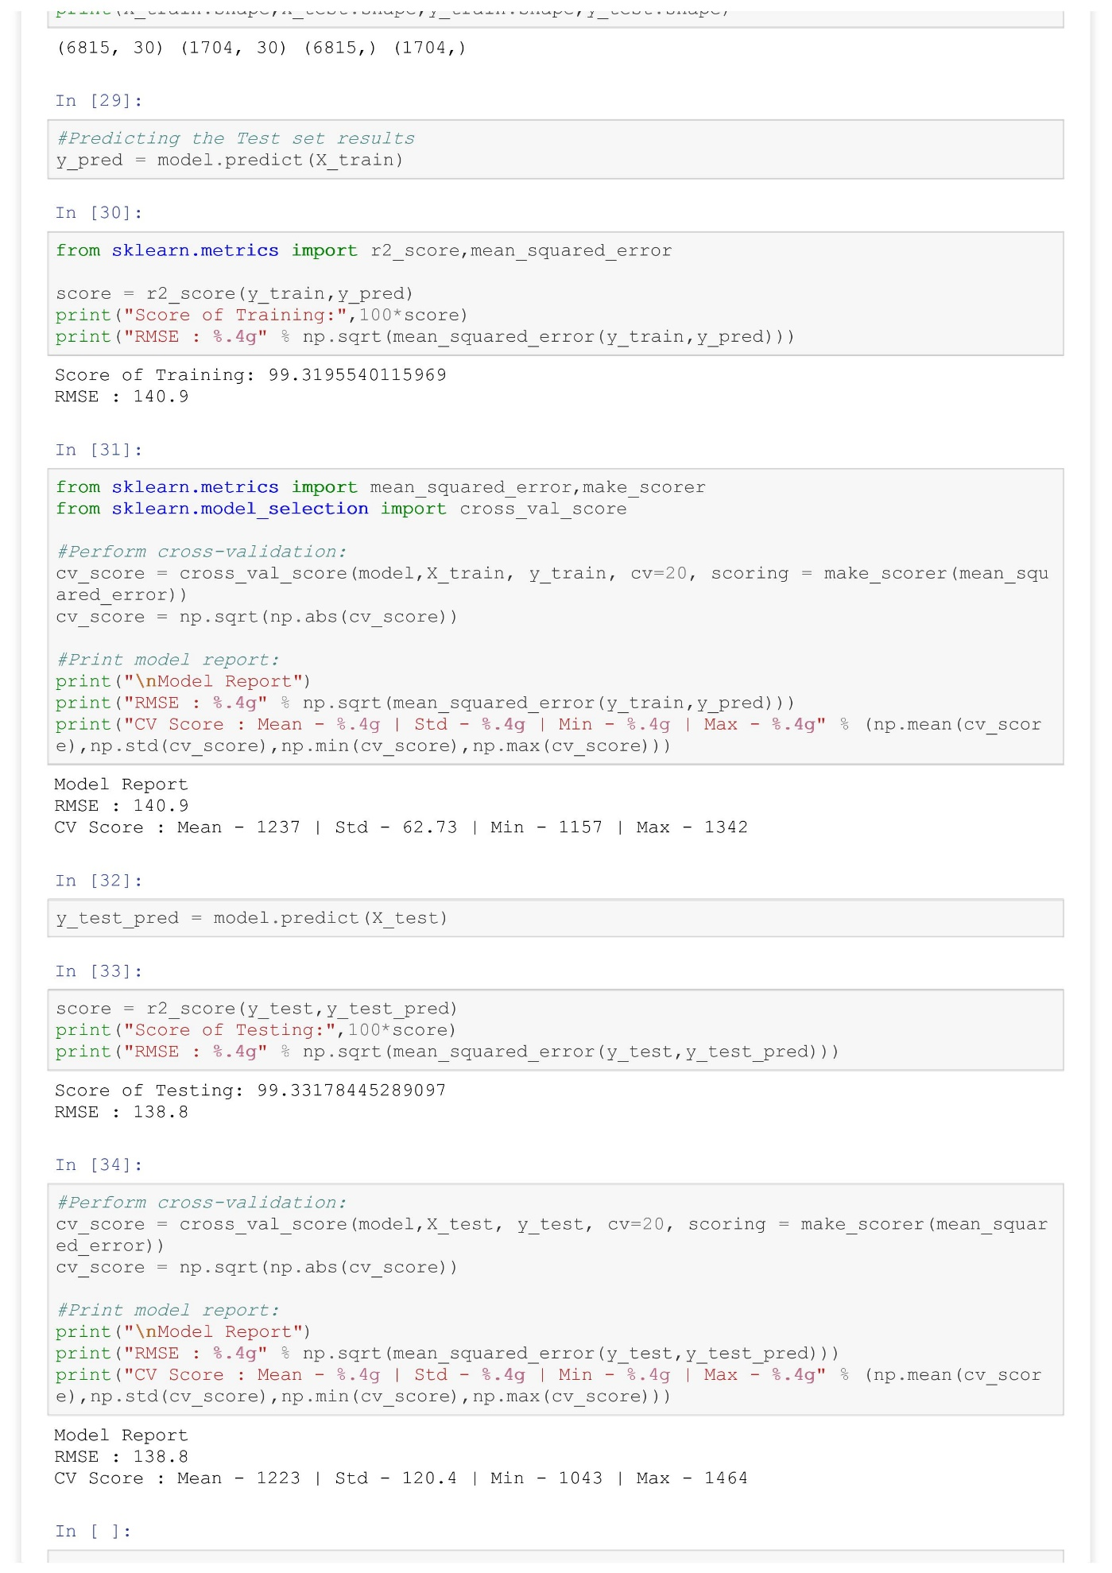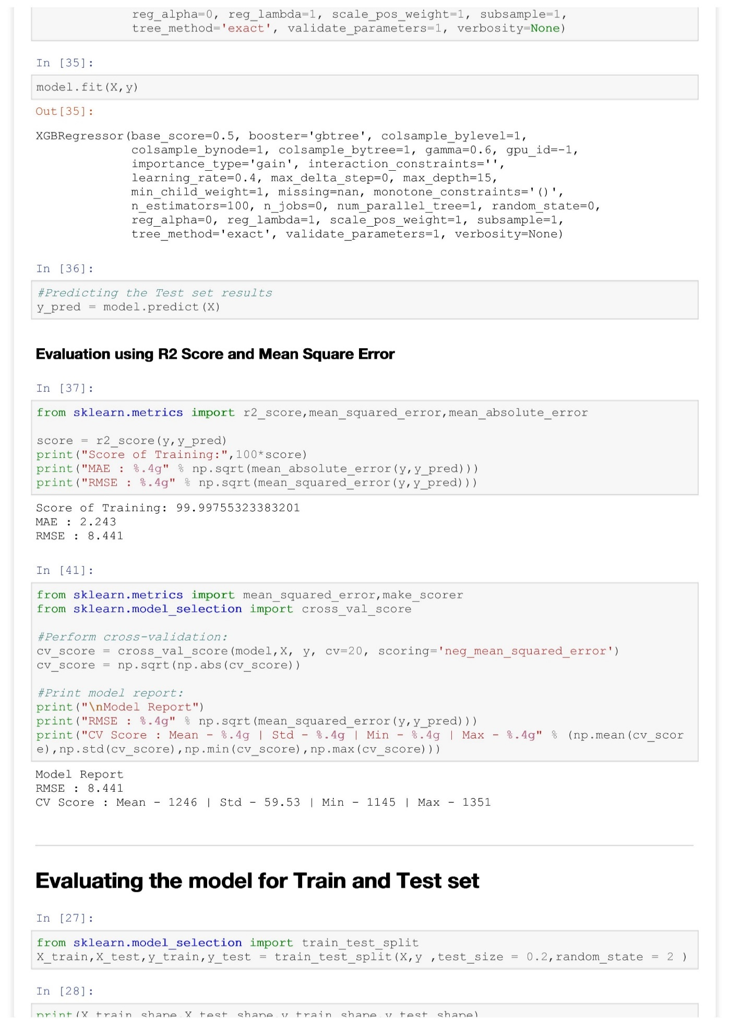

**RESULTS**

